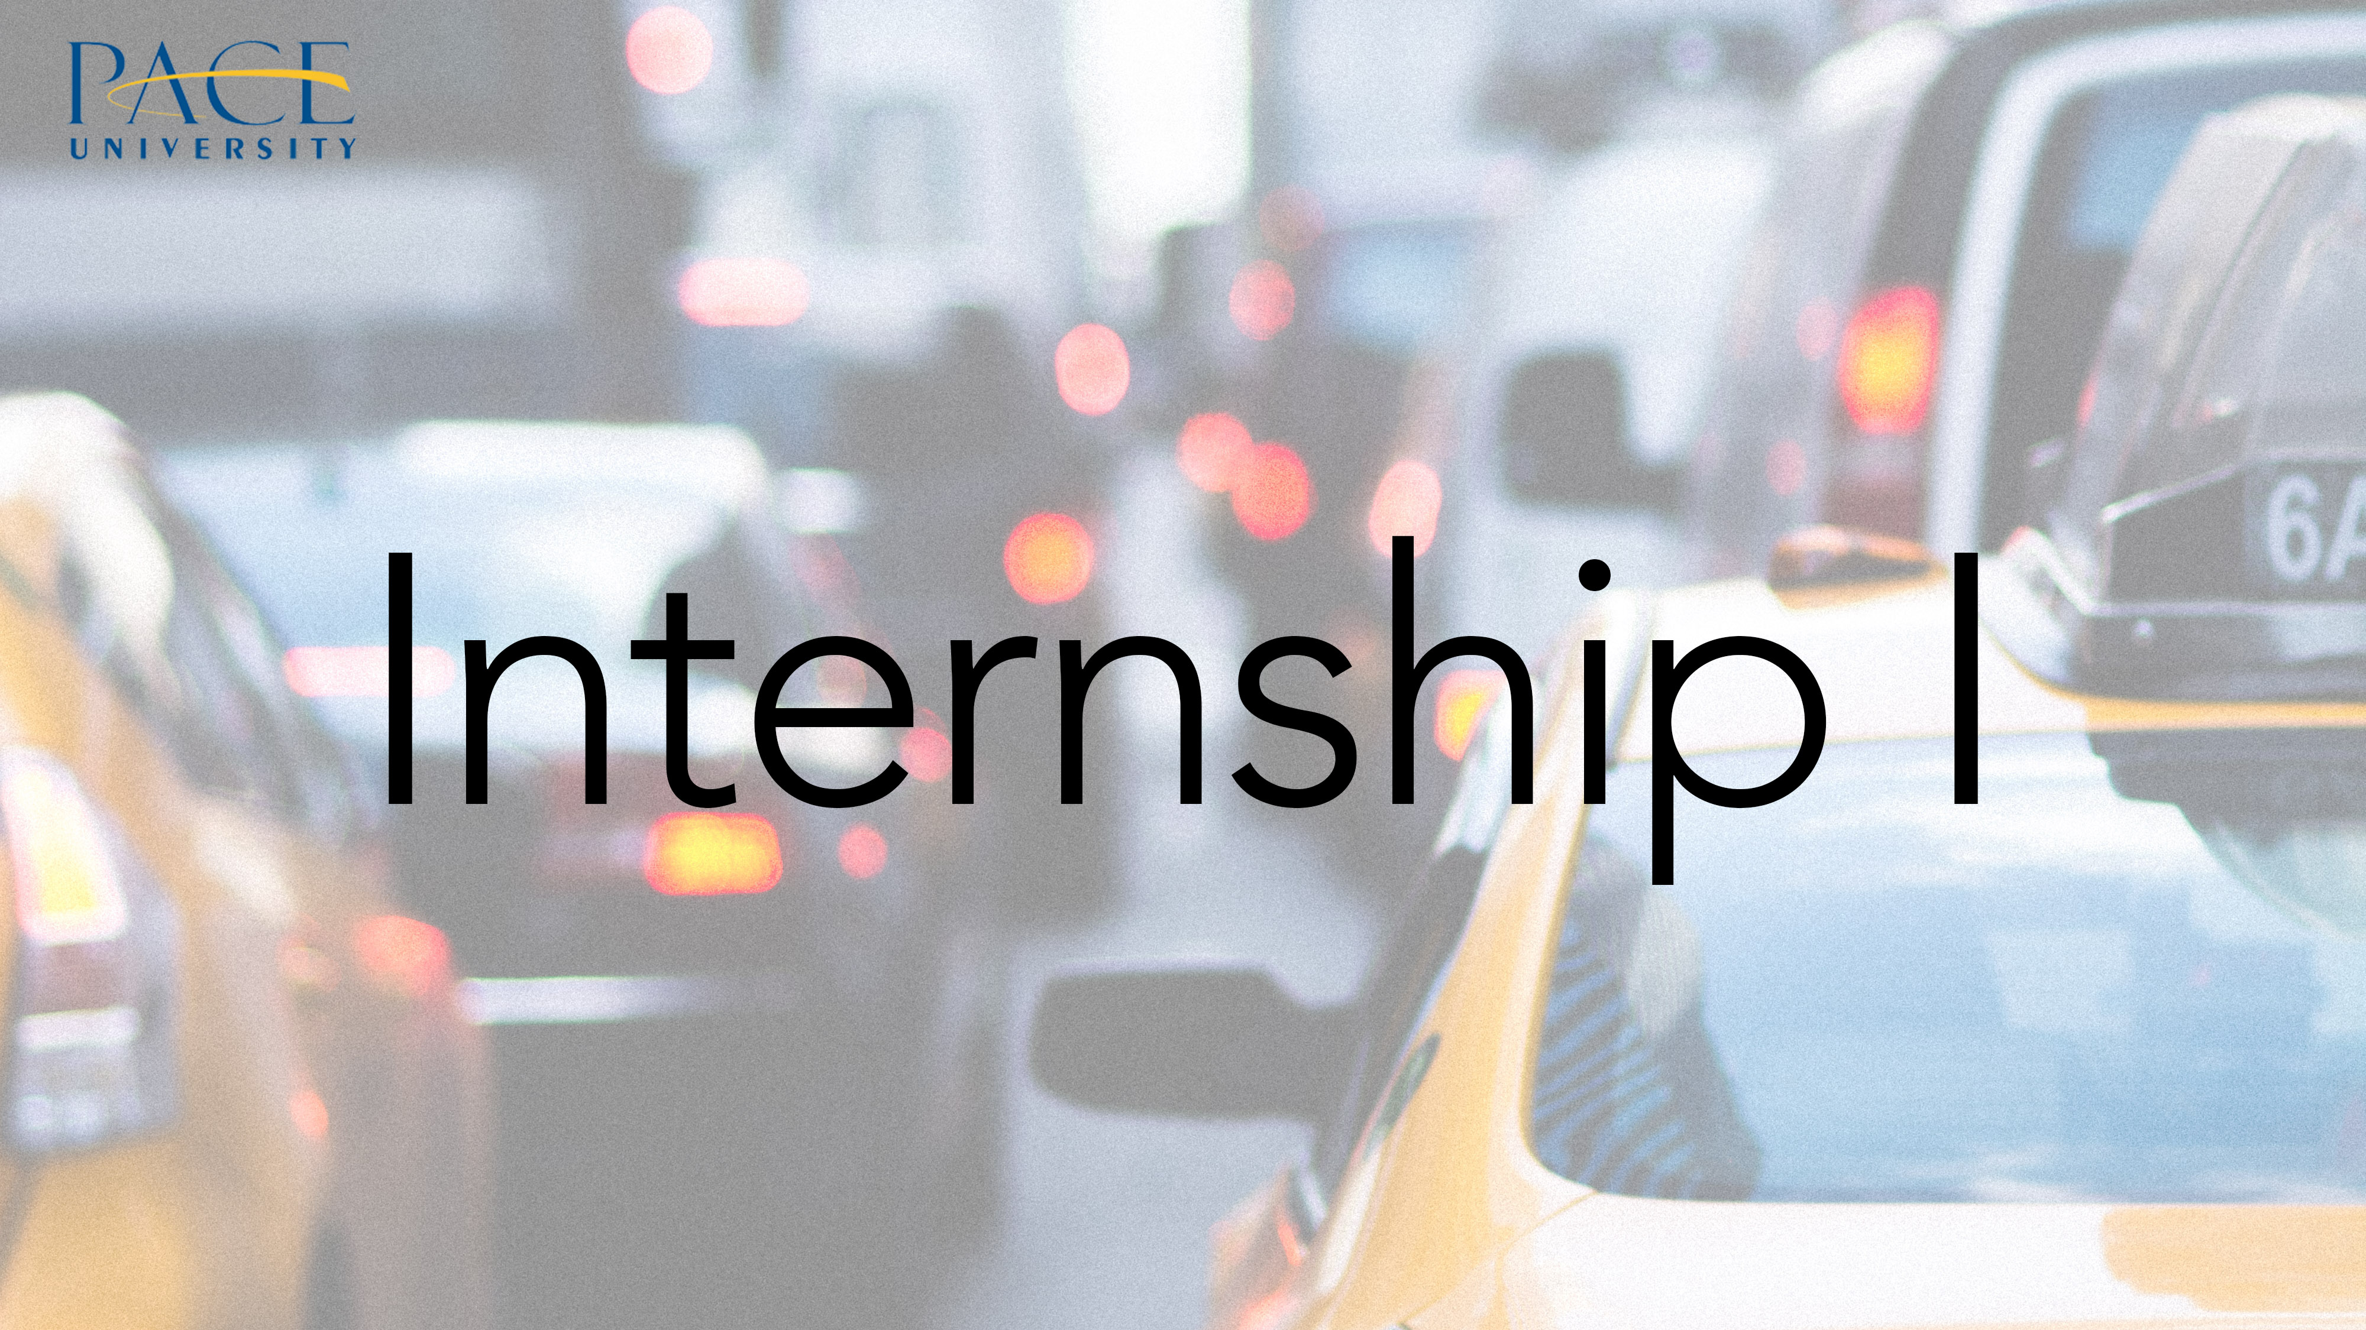

Course Description:
PUB 699A/PUB 699B Internship I and II
(1 semester internship and 1 semester writing thesis--Total 6 credits)

Jane Kinney-Denning
Executive Director of Internships and Corporate Outreach
Blog Editor
http://mspub.blogs.pace.edu/
Adjunct Professor
Pace University
MS in Publishing
551 Fifth Avenue
New York, NY 10176
212-346-1404
President WNBA-National
http://www.wnba-books.org
Offered during the Fall, Spring and Summer Semesters.

PUB 699A

If you are a full-time student not currently working in the industry and need to gain practical experience in the industry and to build your resume, PUB 699A is the course you register for (please note the graduate seminar 690A also results in the writing of a thesis paper but no internship is required-typically students in this class are online students or already working in the industry or have other responsibilities that prevent them from taking an internship)

Students enrolled in PUB 699A and will intern in responsible positions in either the book, magazine or media industries. Each student’s work will be evaluated by Professor Denning, the Executive Director of Internships and Corporate Outreach, over the course of the semester via scheduled seminar meetings, individual meetings and weekly postings in blackboard.

During the fall and spring semesters internships run the length of the semester and students are required to intern 16-24 hours a week. Summer internships are typically 35-40 hours a week and run from June through August.

The semester before registering for PUB 699A, students are required to meet with Professor Denning to finalize their resumes and cover letters and to discuss how to go about searching for an internship. Each student will be individually guided, advised and given leads by Professor Denning. In addition, each student is responsible for searching publisher’s websites and internship sites for possible positions, sending out his or her resume and cover letter, scheduling interviews and negotiating the final details of the internship position. The MS in Publishing blog is the best resource for beginning your internship search: http://mspub.blogs.pace.edu/

The process of finding an internship is similar to that of finding a job. Working on resume writing, preparing excellent cover letters and fine tuning interview and negotiating skills are all part of this course.

Upon securing an internship, students are required to fill out an Internship Assignment Report for Professor Denning. This report includes the title of the position secured, the name of the company where you will be interning, the name of your direct supervisor, a description of your responsibilities and other relevant information. Your supervisor will be contacted at some point in the semester to give feedback on your work.

During the semester, in addition to interning, students must communicate with Professor Denning and post a weekly update in Blackboard. Towards the end of the semester students must submit a Thesis Statement, Detailed TOC, Working Bibliography and a 3-5 page Essay on their Internship Experience. The thesis topics are either related to or developed out of the internship experience and must be approved by Professor Denning. Some sample topics include: The Impact of Technology on the Trade Book Publishing Industry, The History of Women’s Magazines, Sensationalism in Modern Publishing: How Clickbait, Competition and the Capitalization of Curiosity has restructured the Industry, Online Magazine Publishing and Ad Sales, The Implications of Banning Books, The Role of the Literary Agent and the Editor in Trade Books, Trends in Children’s Book Publishing etc.
At the end of PUB 699A, if the student has completed all of the course requirements, a “SAT” or satisfactory grade will be given. This grade will be changed to the grade on the final thesis paper when the student completes PUB 699B.

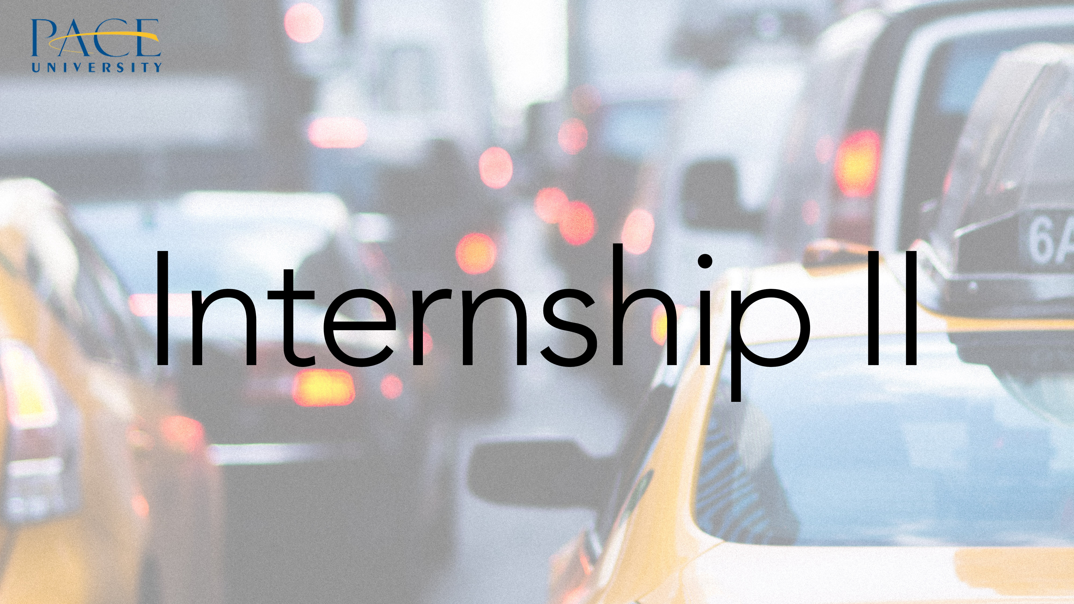

PUB 699B

PUB 699B is the second course in the Internship sequence and is usually taken the semester after a student completes PUB 699A. This course is an independent study. The preliminary work done in PUB 699A is done in preparation for this course. There students will have already determined their thesis topics and have had them approved by Professor Denning. Students are required to meet with Prof. Denning at the beginning of the semester and to submit a draft of the paper (the date for the first draft submission will be listed on the syllabus) before submitting the final draft at the end of the semester.
The grade that the student receives on the final thesis paper is the grade that the student will receive in both PUB 699A and PUB 699B.

