Summer Resources

All information given tonight and more available on
Mrs. Verrino’s ESL Blog

http://staff.socsdblogs.org/jverrino/

Local Library Information

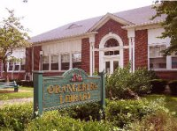
Orangeburg Library
20 Greenbush Rd Orangeburg, NY 10962
(845) 359-2244
www.orangeburg-library.org
*Bilingual Librarian*

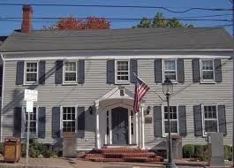

Tappan Library
93 Main St Tappan, NY 10983
(845) 359-3877
www.taplib.org

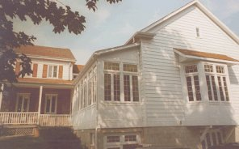
Blauvelt Library
541 Western Hwy Blauvelt, NY 10913
(845) 359-2811
www.rcls.org/blv/

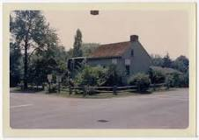

Palisades Library
19 Closter Rd Palisades, NY 10964
(845) 359-0136
www.palisadeslibrary.org

