**7th Grade Study Guide – Chapters 5-6 (The Spirit of Independence/The American Revolution)**

**People**

|  |  |
| --- | --- |
| General Burgoyne | British general defeated at the Battle of Saratoga. Turning point of war. French now encouraged to assist the Americans. |
| Nathaniel Greene | Replaced Gates as leader of the Continental forces. Split his army into two. Chased the British (Cornwallis) out of the Carolinas up to Yorktown, Virginia. |
| Hessians | German soldiers who fought for Britain |
| General Howe (British) | Made some terrible mistakes…like staying too long in Philadelphia and not pursuing Washington into New Jersey |
| [http://www.toriesfightingfortheking.com/Loyalist%20Corps_htm_m1286355e.png](http://www.google.com/url?sa=i&rct=j&q=&esrc=s&source=images&cd=&cad=rja&uact=8&ved=0ahUKEwiv7azm_8PKAhXFFz4KHebqDkcQjRwIBw&url=http://www.toriesfightingfortheking.com/ToryArmy.htm&bvm=bv.112454388,d.cWw&psig=AFQjCNHUmkCo2zEGMumOpbwWMcNo-fnV0g&ust=1453778119386974)Thomas Jefferson | Wrote most of the Declaration of Independence |
| Loyalists | American colonists who **sided with the British** |
| Sons of Liberty | Sam Adams, John Hancock, and Paul Revere were members – a secret group that organized attacks on the British |
| Thomas Paine | His pamphlet, ***Common Sense*,** convinced many colonists to support independence |
| Francis Marion | Patriot leader who defeated the British in the South. Known as the “Swamp Fox” – hit and run style. |
| [https://s-media-cache-ak0.pinimg.com/236x/b1/30/8c/b1308caeb4268927817e44233d4dfe1d.jpg](https://www.google.com/url?sa=i&rct=j&q=&esrc=s&source=images&cd=&cad=rja&uact=8&ved=0ahUKEwi2s7ea_8PKAhUCyT4KHbIkA0AQjRwIBw&url=https://www.pinterest.com/keysshimon/american-revolution/&bvm=bv.112454388,d.cWw&psig=AFQjCNHvhZA4I1JG01VAwxJIRrAib1GUyg&ust=1453777918156886)Patriots | American colonists who **supported independence and war against England**. They made statements such as “…give me liberty or give me death.” |
| Treaty of Paris | Americans and British work out a treaty in Paris after the war is ended. Signed in September 1783, Great Britain recognized the United States as an independent nation. |
| Baron Von Steuben | George Washington hired this German general to train Colonial troops at Valley Forge. |
| [https://upload.wikimedia.org/wikipedia/commons/b/b6/Gilbert_Stuart_Williamstown_Portrait_of_George_Washington.jpg](https://www.google.com/url?sa=i&rct=j&q=&esrc=s&source=images&cd=&cad=rja&uact=8&ved=0ahUKEwik5ISYgcTKAhUH4D4KHThABl8QjRwIBw&url=https://en.wikipedia.org/wiki/George_Washington&bvm=bv.112454388,d.cWw&psig=AFQjCNEKmfLfoa1bXlaaZD-L_DUVYGSBkg&ust=1453778523973636)George Washington | General of the Continental Army…will become the first President of the United States |
| Women in the war | Women helped plant crops, make war supplies and clothing. Many were nurses. |
| Yorktown, Virginia | Cornwallis is surrounded by American ground forces as well as Rochambeau’s French infantry. **Cornwallis surrenders to George Washington** – ends the war October 1781. |
| African Americans and Native Americans | Both groups helped both the British and colonists. |

[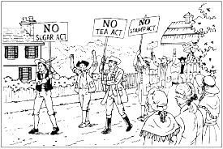](http://www.google.com/url?sa=i&rct=j&q=&esrc=s&source=images&cd=&cad=rja&uact=8&ved=0ahUKEwj3ua-wh9PKAhXMHB4KHQhbDyIQjRwIBw&url=http://jones.crms.schooldesk.net/MediaCenter/StudentResearch/DAREssay/tabid/35520/Default.aspx&bvm=bv.113034660,d.d2s&psig=AFQjCNGLzLriJcEqo6h7baH3s5v94IvdqA&ust=1454295577515666)**Causes of Tension**

|  |  |
| --- | --- |
| Boston Massacre | Redcoats fire into crowd, killing some…but are eventually found not guilty. |
| Boston Tea Party  [https://encrypted-tbn3.gstatic.com/images?q=tbn:ANd9GcSa_f9DajuCh31voIIBADNavIMpDQbxhMzfA41ljrrt4PBSGcu-](http://www.google.com/url?sa=i&rct=j&q=&esrc=s&source=images&cd=&cad=rja&uact=8&ved=0ahUKEwjX-K6Bh9PKAhXKHB4KHQO0A7IQjRwIBw&url=http://lilactearoom.com/2013/10/behind-the-original-boston-tea-party/&psig=AFQjCNEGd_pSjR3ZKSfojTER3fAwh3edaQ&ust=1454295448334273) | Colonists dressed up like Indians and threw British goods into the harbor. They were protesting the tax on tea. |
| French and Indian War | According to the English, this conflict between the French and English was the reason for increasing Colonial taxes. |
| Intolerable Acts | Designed to punish Massachusetts for violating previous acts –for example, the Boston harbor was closed. |
| [http://mitchell150.com/wp-content/uploads/2014/07/Screen-Shot-2014-07-21-at-10.48.19-PM.png](http://www.google.com/url?sa=i&rct=j&q=&esrc=s&source=images&cd=&cad=rja&uact=8&ved=0ahUKEwjkqcPvgNPKAhWKpR4KHV0UDVsQjRwIBw&url=http://mitchell150.com/the-proclamation-of-1763/&psig=AFQjCNFmJoj9I4wNxDzuZGLyZCCpc9VbDA&ust=1454293829699955)Proclamation of 1763 | Colonists were forbidden to settle west of Appalachian Mountains. |
| Quartering Act | Colonists forced to “house” British soldiers…a particularly hated act |
| Stamp Act | After this act (which taxed printed goods), colonists demanded “no taxation without representation.” |
| Sugar Act | Actually lowered the tax on molasses…encouraging colonists to buy more |
| Townshend Acts | Tax placed on essential items – tea, glass, lead…protests and boycotts result |
| Writs of Assistance | Allowed the British to search without warrants or probable cause |

**The American Revolution**

* The American colonists, especially Bostonians, showed their opposition to the British taxation and trade restrictions of the 1760s mainly by **boycotting products from Great Britain**.
* The **colonists felt restricted by laws/acts passed by the British government** such as the Proclamation of 1763, the Navigation Laws, the Stamp Act, and the Townshend Acts.
* [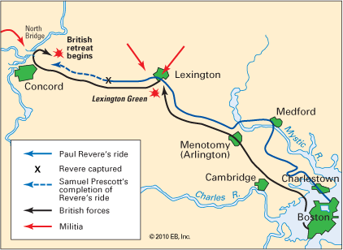](http://www.google.com/url?sa=i&rct=j&q=&esrc=s&source=images&cd=&cad=rja&uact=8&ved=0ahUKEwjVh5mP_MPKAhVCWD4KHcj5C0gQjRwIBw&url=http://kids.britannica.com/comptons/art-166455/Some-of-the-events-that-took-place-around-Lexington-and&bvm=bv.112454388,d.cWw&psig=AFQjCNGFUv6bqYVGyitzyMJ1AwBxraeXBg&ust=1453777162224748)The colonists felt they didn’t enough of a voice in their own government.
* The **American Revolution begins** with the battles at Lexington and Concord. At Lexington, the British win and the colonists flee. Next, at Concord, the colonists win, and the British are driven back to Boston.

***Strengths and Weaknesses of both sides***

|  |  |
| --- | --- |
| **America (colonists)** | **Great Britain** |
| Strengths | Strengths |
| * Ambush/guerilla style warfare * Fighting on their own ground * Greater motivation * George Washington – a great leader * France on their side   \***France began supporting America after the Battle at Saratoga (the British were defeated)** | * Powerful army (well-trained) and navy * Wealthy empire * Larger population |
| Weaknesses | Weaknesses |
| * Inexperienced soldiers * No regular army/weak navy | * Not familiar with the territory * Time and money to ship soldiers from England (home base is thousands of miles away) |

* **Timeline of Events** (in chronological order)
  + French and Indian War► passage of Stamp Act► Battle of Saratoga► Battle of Yorktown
* Even though the American soldiers ran out of ammunition and were defeated by the British at the **Battle of Bunker Hill**, the Americans showed the British that they would not be intimidated and could not be easily defeated.
* **Battle at Trenton, NJ** – George Washington orders a surprise attack on the British/Hessians at Trenton. Hessians were still drunk from Christmas festivities – not good.
* **Saratoga** (New York) – **Turning point of war**. British General Burgoyne is defeated. French decide to join with the Americans.
* **Yorktown, Virginia** – War is won by the Americans as Cornwallis is defeated.
* **Treaty of Paris** conditions:
  + Share fishing rights with the British in the North Atlantic
  + America gains its independence
  + Loyalists will be treated fairly by the American government
* [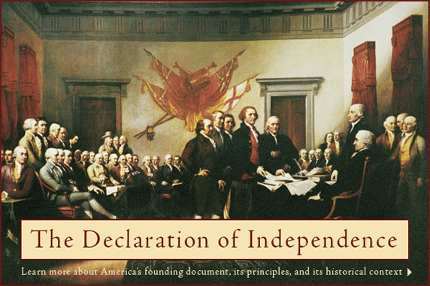](http://www.google.com/url?sa=i&rct=j&q=&esrc=s&source=images&cd=&cad=rja&uact=8&ved=0ahUKEwidi5SA_sPKAhUKHT4KHVUJDUIQjRwIBw&url=http://www.founding.com/&bvm=bv.112454388,d.cWw&psig=AFQjCNEFD53-tXaSYXq6AiE2fKwpJrDtjQ&ust=1453777659867664)The **Declaration of Independence** states that people have the right to alter or abolish a government if that government violates **peoples’ natural rights**. If these rights are not given, the people can rebel.