**Study Guide U.S. History – 7th Grade – Ch. 7-8: The Constitution**

**People/Terms**

|  |  |
| --- | --- |
| Anti-Federalists | People who supported a weak central government. They did not want a Constitution unless a Bill of Rights was added. |
| 1st Amendment | Right to free speech |
| 2nd Amendment | Right to bear arms |
| 4th Amendment | Right to be protected against unreasonable searches and warrants. **Evidence that is obtained illegally cannot be used in a court of law**. |
| 5th Amendment | If you get arrested, you get these rights – such as the right to remain silent and the right to an attorney |
| 7th Amendment | Right to a jury trial |
| Federalists | People who supported a strong central government. They liked the Constitution. |
| Judicial Branch | They interpret laws |
| Executive Branch | They enforce the laws |
| Legislative Branch | They make the laws |
| Daniel Shays | His rebellion (farmers) demonstrated a need for a stronger central government |

[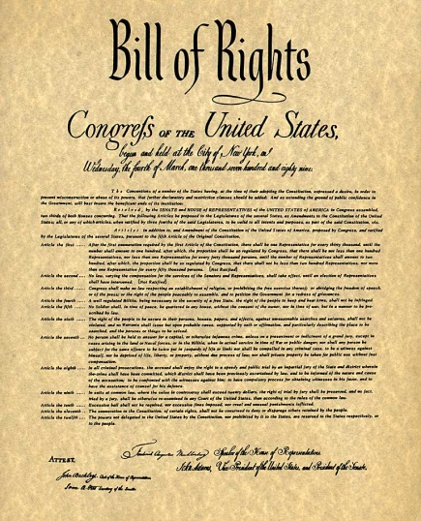](http://www.google.com/url?sa=i&rct=j&q=&esrc=s&source=images&cd=&cad=rja&uact=8&ved=0ahUKEwizgPSAjJ3LAhUCyT4KHTKEDNEQjRwIBw&url=http://www.chicagonow.com/quilting-sewing-creating/2015/10/quilters-bill-of-rights/&psig=AFQjCNF_yAXcjTwcxXALLNrZ5DKuYiOqUA&ust=1456839422962682)

**The Constitution**

* The **Articles of Confederation** – One weakness is that it ***created a weak central government.*** States kept most of their power. Congress had limited power. There were no branches of government.
* The **Constitutional Convention** in Philadelphia met between May and September of 1787 to address the problems of the weak central government that existed under the Articles of Confederation► led to the addition of the **Bill of Rights** and determined how states should be represented in Congress.
* In order to gain support for ratification (approval) of the United States Constitution, a **Bill of Rights** (first ten amendments) was added to the Constitution.
* The **Bill of Rights** protects the rights of individuals. It protects civil liberties.
* At the constitutional convention, there was debate over how the future government should be structured including how the states should be represented in Congress.
  + Virginia Plan (favored larger states): Two-house legislature; seats awarded by population
  + New Jersey Plan (favored smaller states): One-house legislature; liked by small states ► each state would have one vote.

The Great Compromise resolved the conflict between the Virginia Plan and the New Jersey Plan.

* + [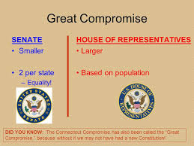](http://www.google.com/url?sa=i&rct=j&q=&esrc=s&source=images&cd=&cad=rja&uact=8&ved=0ahUKEwjkvZu9nLHLAhXJVyYKHQf0BnkQjRwIBw&url=http://slideplayer.com/slide/772198/&psig=AFQjCNFxWNfvOmV6jMUBDPyuWkf5urFjSQ&ust=1457531031346355)
    - Created a ***two house legislature or bi-cameral legisture***: **The Senate and the House of Representatives► Congress**
    - The **Senate w**ould have *two representatives from each state,* and representation for the **House of Representatives** would be *based on population*.
* [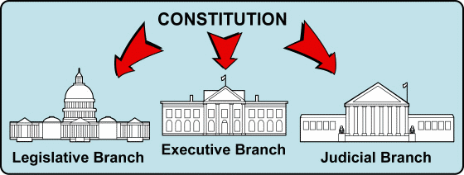](https://www.classmint.com/note/view/52f1a43ff329b9511400004e)The **Constitution** is different from the Articles of Confederation in that it ***created a national government having three branches.***

* The Constitution is based on ideas drawn from: John Locke and Montesquieu (natural rights come from God); Iroquois (representative government); Roman Republic (elected their leaders) and English Bill or Rights/Magna Carta.
* The **Three-Fifths Compromise**: Three-fifths of a state’s slaves would be counted with respect to representation.
* The U.S. government is considered a **federal system** because both national and state governments have the ability to create laws.
* [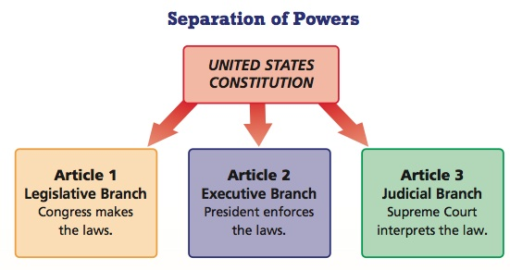](https://www.google.com/url?sa=i&rct=j&q=&esrc=s&source=images&cd=&cad=rja&uact=8&ved=0ahUKEwjIu__y0Z_LAhWLPT4KHSzNA18QjRwIBw&url=https://prezi.com/rkxjy_wm4zy1/how-does-the-separation-of-powers-and-the-system-of-checks-a/&psig=AFQjCNEcwrx_rwUuvcaxhgNDV0OO7am-9Q&ust=1456926847839383)**Separation of Powers**: Each of the three branches has defined abilities to check the powers of the other branches. Each branch has different responsibilities.
* **Checks and Balances**: Each branch has powers over the other. It prevents any one branch of government from becoming too powerful.
* According to the Constitution, the ***president is required to sign or veto bills passed by Congress.***
* **Amendments to the Constitution**: There are 27 amendments to the Constitution. The **amendment process** allows the Constitution to be changed when the needs of society changes.
* [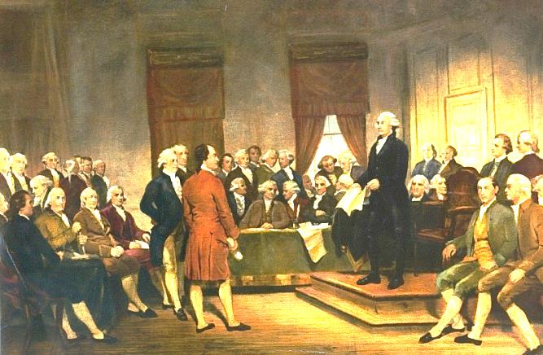](https://www.google.com/url?sa=i&rct=j&q=&esrc=s&source=images&cd=&ved=0ahUKEwiErZmqk6LLAhWBbz4KHcKkDB0QjRwIBw&url=https://en.wikipedia.org/wiki/Convention_to_propose_amendments_to_the_United_States_Constitution&psig=AFQjCNEmOSuAuPeXXHbSpX6I4AM_1lla-Q&ust=1457013135998331)**Elastic Clause**: The Constitution states: “Congress shall have the power…to make all laws which shall be necessary and proper for carrying into execution the foregoing powers…” ►allows constitutional flexibility (think of a rubber band).

**The Constitutional Convention (1787)**