**7th Grade – Study Guide U.S. History – The Origin of American Politics**

**People/Events**

|  |  |
| --- | --- |
| Barbary Pirates | President Jefferson refused to pay them a bribe, setting the precedent “We do not negotiate with terrorists.” |
| Alexander Hamilton | A Federalist, he supported a National Bank and a protective tariff |
| Andrew Jackson | Defeated the British at New Orleans even though the war was over |
| John Jay | His treaty with England angered many Anti-Federalists who thought America should have sided with France. |
| Thomas Jefferson | The first Anti-Federalist president, he dressed like a “commoner” to show his support for the regular American |
| Lewis and Clark | Explored the Louisiana territory |
| Napoleon | French leader who sold Louisiana to America |
| Oliver Hazard Perry | U.S. naval commander who defeated British at the Battle of Lake Erie |
| Sacajawea | Native American guide through the Louisiana territory |
| War Hawks | Congressmen who supported going to war with England |
| Primary Source | Original source of information: artifact, a document, a recording – created at the time under study |
| Whiskey Rebellion | People (especially farmers) protested the tax on distilled spirits such as whiskey. The federal army easily put an end to the rebellion. |

**War of 1812**

* **Reasons to go to war in 1812**:
  + The election of war hawks to Congress in 1810
  + A desire to acquire parts of Canada
  + British impressment of American soldiers
* The U.S. did not gain more land as a result of the war. The U.S. did maintain its independence from Great Britain. The war ended in a stalemate more or less. The U.S. did win more battles.
* At the **Treaty of Ghent** (**ended the War of 1812**), John Quincy Adams was quoted as saying “**Nothing was adjusted, nothing was settled**.” This means that everything pretty much went back to the way it was before the war. No new territory was gained. Neutrality of the seas was not settled. England did come to realize America’s military strength.

**Louisiana Purchase**

* Thomas Jefferson acquired the Louisiana territory from France (Napoleon). This demonstrated that **Jefferson believed in a “loose” interpretation of the Constitution**. The purchase is an example of the use of the **elastic clause**. Purchase of territory **was not** indicated in the Constitution.
* The Louisiana Purchase **doubled the size of the country** at that time.
* [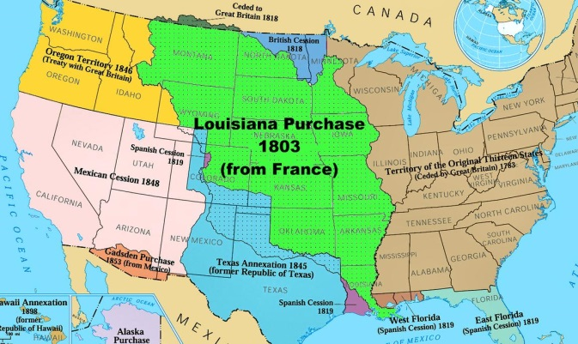](http://www.google.com/url?sa=i&rct=j&q=&esrc=s&source=images&cd=&cad=rja&uact=8&ved=0ahUKEwjD2KWWvKzMAhUGbT4KHbVgDkUQjRwIBw&url=http://www.ducksters.com/history/westward_expansion/louisiana_purchase.php&psig=AFQjCNGo-DN1eB2aGIc7Vw17Yxgum-S4Hw&ust=1461765813900700)By purchasing this territory, the U.S. **gained full control of the Mississippi River**.

**U.S. Government**

* **Anti-Federalists** – Didn’t want too much power centered with the federal government.
* **Protective tariffs** (tax added to goods imported into the country) **help U.S. manufacturers – protects domestic industries from foreign competition**. Foreign goods will cost more because of the tariff.
* **Unwritten constitution –** Ideas and processes not in the Constitution. Examples include the formation of political parties and the Cabinet.
* **XYZ Affair**: Unsuccessful meeting in which French officials tried to bribe American officials. American diplomats (named X, Y and Z) were sent to France in July 1797 to negotiate problems that were threatening to break out into war. French agents demanded bribes before formal negotiations could take place.
* **Judicial Review** - This gives the U.S. Supreme Court the power to decide on the constitutionality of laws.
* **Virginia and Kentucky Resolutions** – Passed by the legislatures of Virginia and Kentucky. The resolutions suggested that the states have the power to veto Federal law► more power to the states
* As President John Adams’ term was ending (he was our second president), he appointed “**midnight judges**” to the Supreme Court who would protect Federalist legislation (laws). Adams was a Federalist.