**Chapter 4 Study Guide – The Thirteen Colonies**

**People**

|  |  |
| --- | --- |
| Nathaniel Bacon | Backcountry farmer who led a rebellion against the “planter elite” in Virginia |
| Thomas Hooker | Settled Connecticut, where he established the Fundamental Orders of Connecticut, which gave everyone the right to vote (quite different from Massachusetts Bay) |
| [https://liturgyandmusic.files.wordpress.com/2011/02/annehutchinson-12226.gif](https://www.google.com/url?sa=i&rct=j&q=&esrc=s&source=images&cd=&cad=rja&uact=8&ved=0ahUKEwiqpMLX_t3JAhUE4iYKHfnqD7UQjRwIBw&url=https://liturgyandmusic.wordpress.com/2011/02/05/february-5-roger-williams-and-anne-hutchinson-prophetic-witnesses-1683-1643/&bvm=bv.110151844,d.eWE&psig=AFQjCNGlt7QWvwoo1zM1QhiqVTS80b1vVg&ust=1450273137068805)Ann Hutchinson | Banished from Massachusetts Bay for interpreting the Bible and holding church meetings in her house |
| Metacom | Wampanoag Native American Chief often at war with New England settlers |
| James Oglethorpe | In charge of Georgia, an experimental colony of prisoners, that was to be a “buffer” between the colonies and Spanish Florida |
| [https://upload.wikimedia.org/wikipedia/commons/6/6a/William_Penn.png](https://www.google.com/url?sa=i&rct=j&q=&esrc=s&source=images&cd=&cad=rja&uact=8&ved=0ahUKEwjbweuP_93JAhWF8CYKHT0fDAgQjRwIBw&url=https://en.wikipedia.org/wiki/William_Penn&bvm=bv.110151844,d.eWE&psig=AFQjCNHqLVb57VCxYFbmJPTlmGHzZnu9cA&ust=1450273236780090)William Penn | Obtained a charter to settle a colony based on the Quaker beliefs of toleration and goodwill to others |
| Puritans | Persecuted for their beliefs in England, they eventually settled in Massachusetts. |
| Peter Stuyvesant | Strict leader of New Amsterdam |
| Roger Williams | Kicked out of Massachusetts Bay, he started the colony of Rhode Island, which was founded upon the idea of religious tolerance. |
| John Winthrop | Governor of Massachusetts Bay |

**The Settlers**

* Most settlers came to the colonies of Maryland, Massachusetts, Pennsylvania, and Rhode Island to seek ***religious freedom***.
* [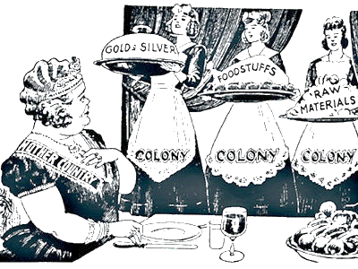](http://www.google.com/url?sa=i&rct=j&q=&esrc=s&source=images&cd=&cad=rja&uact=8&ved=0ahUKEwjmvovChN3JAhXBMSYKHdLUBWkQjRwIBw&url=http%3A%2F%2Fthehistoryvault.co.uk%2Fmercantilism-is-dead-long-live-mercantilism%2F&psig=AFQjCNEzqNYmoMwWIUiLhalnNcQ6wq7Hdg&ust=1450240352640071)The Quakers helped establish the colony of Pennsylvania.

**Colonial Economy**

* A cash crop economy in the Southern colonies led to the use of enslaved persons from Africa.
* **Mercantalism**: The original thirteen colonies would provide Great Britain with raw materials and markets to sell their goods.
* Many American colonists opposed mercantilism because it placed restrictions on trading.
* Colonial trade among the colonies, Africa, and the West Indies took place along the triangular trade route.
* [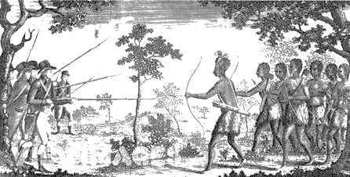](http://www.google.com/url?sa=i&rct=j&q=&esrc=s&source=images&cd=&cad=rja&uact=8&ved=0ahUKEwjD-K-G_d3JAhVGKCYKHW-MDuQQjRwIBw&url=http://www.sussexvt.k12.de.us/science/The%20History%20of%20the%20World%201500-1899/King%20Philip.htm&bvm=bv.110151844,d.eWE&psig=AFQjCNHaSH-i48yZDH7iomfWI9W9Bv039A&ust=1450272689643372)Africans on the **Middle Passage** journey experienced cruel treatment, poor sanitary conditions, starvation and disease, and overcrowding and imprisonment.

**Politics/Acts**

* **King Philip’s War**: Native Americans and New England colonists fought over control of land.
* **Voting rights** in the thirteen British colonies were **limited to men who owned property.**
* **Navigation Acts**: Allow England to benefit from trade with the colonies
* **Representative democracy** developed during the colonial period.
* **Maryland Toleration Act**: Gave religious freedom to all Christians, but no Jews

**Geography**

**\*Must know where these colonies are located on a map\***

* *New England Colonies: New Hampshire, Massachusetts, Rhode Island, and Connecticut*
* *Middle Colonies: New York, New Jersey, and Pennsylvania*
* *Southern Colonies: Virginia, North Carolina, South Carolina, and Georgia*
* The **warm and long growing seasons** influenced the **economic development of the colonial South.**
* **Rocky soil, vast timber resources, rich ocean fishing grounds, and single-family farms** were factors that contributed to the **economic development of Colonial New England.**
* Main reason for the **variety of products** in the different regions of the country was the **differences in geography and climate**.

[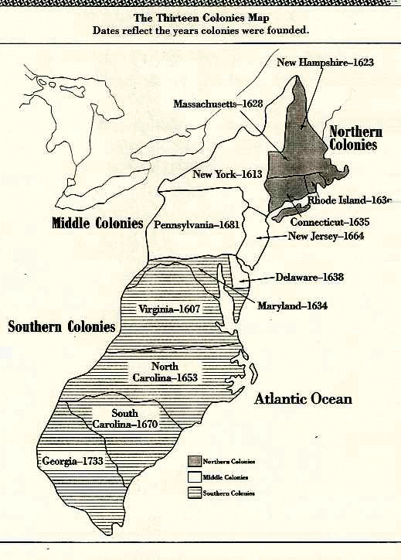](https://www.google.com/url?sa=i&rct=j&q=&esrc=s&source=images&cd=&cad=rja&uact=8&ved=0ahUKEwit152u_N3JAhWJOCYKHT45CuoQjRwIBw&url=https://www.pinterest.com/pin/58687601367313895/&bvm=bv.110151844,d.eWE&psig=AFQjCNErbos3yaVhAjYjkGeglK0qwE1pig&ust=1450272460614344)