8th Grade Study Guide – US History Chapter 25 “The 1920s”
People
Louis Armstrong | Jazz musician who was a symbol of the Harlem Renaissance
Al Capone | Chicago gangster who made his mark by dominating the bootlegging industry
Calvin Coolidge | President who believed in the “rich getting richer” and de-regulated America’s economy. He was very pro-business.
F. Scott Fitzgerald | Wrote the Great Gatsby, a classic novel about the highs and lows of living in the materialistic 1920s
Flappers | Young women who challenged the traditional roles of women through their appearance, social customs, ideas, and professional goals
Henry Ford | Developed the Model T…and the automobile industry boomed in America. Invented the assembly line.
Marcus Garvey | Supported the idea of segregation and suggested African-Americans move back to Africa
Ku Klux Klan | Discriminated against African-Americans and immigrants…often through violence
Charles Lindbergh | First to fly across the Atlantic; he became a national hero
Babe Ruth | Star of the New York Yankees who made baseball “America’s game.”
Nativism | Favoring native inhabitants as opposed to immigrants

The 1920s
- Warren G. Harding’s presidency was known for its scandals. The Ohio Gang represented politicians who were involved in wrongdoings during Harding’s term.
- Teapot Dome scandal: Harding’s secretary of the interior, Albert Fall, took bribes to lease/rent government oil reserves to two oil companies► dishonesty in the Harding govt.
- The 1920s are sometimes called the “Roaring Twenties” because of the many social and economic changes that occurred. Consumer borrowing increased, and the stock market was a “bull” market in which stock prices kept rising.
- Henry Ford invented the assembly line which allowed for cars to be mass produced in a quick, efficient manner. This helped reduce the prices of consumer goods such as automobiles.
- Prohibition (18th Amendment) banned the manufacture and sale of alcoholic beverages.
  - Prohibition resulted in an increase in organized crime
  - The American public disregarded Prohibition because it felt that public morality shouldn’t be legislated (laws).
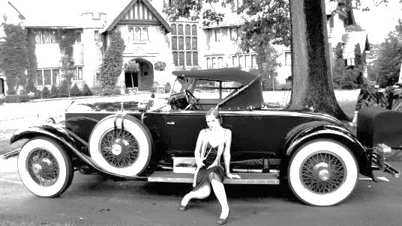
- Installment buying (buying on credit) and an unregulated stock market led to the economic boom/prosperity and financial speculation (investing in the stock market and hoping stock prices rise) of the 1920s. The Great Depression of the late 1920s was caused in part by the public buying stocks on margin (using credit to purchase stocks) and buying consumer goods on credit.
- Remember: This was a CONSUMER ECONOMY during the 1920s.
- After WWI, farmers did not share in the economic growth of the United States because overproduction and mechanization (machines replacing workers) caused falling crop prices.
- Harlem Renaissance – Period during which African Americans created noteworthy works of art, literature, and music. Started in Harlem (NY) and spread to other African American communities.
- The Great Migration during WWI and the 1920s refers to the movement of African Americans to northern cities to find work.
- During the 1920s, women began working outside of the home, became more politically active, and started to become “modern” with respect to their clothing and hairstyles. Young women who rebelled against traditional ways of thinking and acting were called flappers.
- Immigration Act of 1924 (limit # of immigrants coming into the U.S.) and Sacco-Vanzetti trial are examples of an increase in nativism and intolerance. Sacco and Vanzetti were two Italian immigrants wrongly accused of killing two men during a robbery. They were convicted and sentenced to death. Some felt they didn’t get a fair trial and that their beliefs and nationality played some part in their conviction.
- The Red Scare or Americans’ fear of communism led to the demand for limits on immigration.
- The Scopes trial – Scopes was a teacher in Tennessee who was arrested for teaching the theory of Evolution (scientific theory that humans and other species developed over vast periods of time) in school. There was a law in Tennessee in which it was illegal to teach evolution. Christian Fundamentalists supported the law as they believed in the Biblical story of creation. Scopes was found guilty of breaking the law later, the Tennessee Supreme Court overturned Scopes’ conviction.
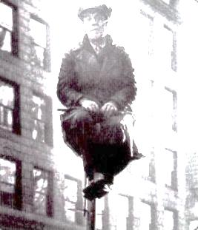
- There were different fads that developed during the 1920s – clothing styles changed, there were dance marathons etc… Another fad was flagpole sitting.
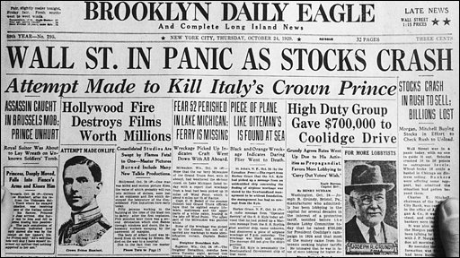
Flagpole sitting

The Great Depression

