7TH Grade U.S. History: Chapter 1 Study Guide
Terms: Ancient American Civilizations and Native Americans
Term | Definition
Aztecs | Invented chinampas and causeways. Lived in Tenochtitlan until conquered by Cortez and the Spanish.
Mayas | Lived in Southern Mexico and Central America. Innovations include a 365 day calendar, ability to predict eclipses, and development of a zero based number system.
Incas | Famous innovations include terrace farming and brain surgery. This civilization lived in the Andes Mountains.
Eastern Woodland Indians | Lived in longhouses and wigwams, such as the Iroquois and Pequots.
Northwest Indians | Had potlaches which were ceremonial dinners. Tribes include the Coos, Tlingits, and Kwakiutl.
Southwest Indians | Villages were made of adobe, and irrigation was a necessity. Tribes include the Apache, Hohokams, and Navajos.
Southeast Indians | Hunted, gathered, and farmed in the modern day states of Georgia, Alabama, and Florida. Tribes include the Cherokees, Natchez, and Seminole.
Arctic/Subarctic Indians | Nomadic hunters and gatherers, such as the Inuits and Aluets
Great Basin/Plateau Regions Indians | Hunted and gathered in small family groups. Tribes include the Nez Perce, Pomos, and Shoshones.
Plains Indians | Lived in what are now the states of South Dakota, Iowa, and Nebraska. Tribes include the Sioux and Blackfoot.

The Great Civilizations of Ancient America
- Study of the Maya, Incas, and Aztecs show that advanced American civilizations existed before Columbus arrived.
- Similarity between the Mayas and Aztecs: Both developed complex mathematical and calendar systems.
- Aztecs, Incas, and Mayan civilizations believed in government called a Theocracy in which religious leaders were the rulers.
- The Aztecs believed in human sacrifices to please the gods.
- Mound Builders built large mounds of earth to bury their dead.
- Native Americans who build homes on cliff walls were the Puebloans.
- Buffalo was the primary source of food, shelter, and clothing for the Native American Indians of the Great Plains.
- Native American Indians may have migrated to the Americas from Asia by crossing the Bering Strait land bridge.
- Native Americans often developed different cultures because they adapted to their environments differently.
- Differences in Native American clothing were probably a result of available natural resources.

Native Americans in New York
- Iroquois and Algonquin were two tribes in New York State.
- League of the Iroquois was made up of five tribes: Seneca, Cayuga, Onondaga, Oneida, and Mohawk. The League was started to keep peace among the tribes and promote a spirit of cooperation.
- Native Americans in New York tended to live near water.
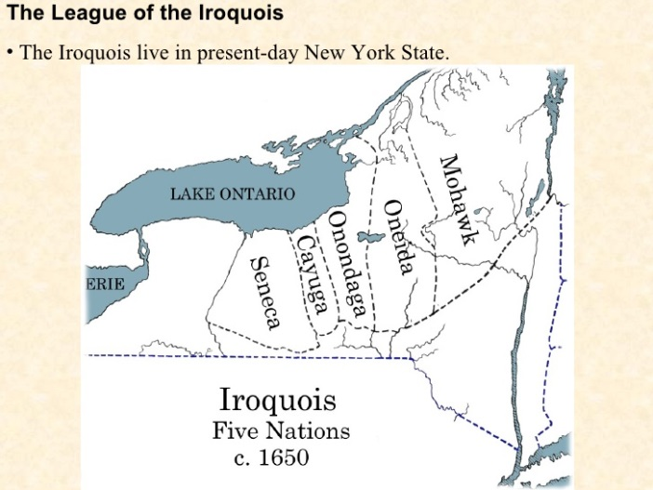
- The League of the Iroquois established a political union of member nations. The League’s government ran similar to that of a democracy.

