Study Guide – 8th Grade – The Great Depression (Chapter 26)
Terms
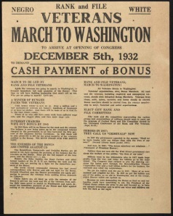  FDR (Franklin D. Roosevelt) | Believed in liberal government spending. Initiated the New Deal
The Bonus Army | WWI veterans who gathered in Washington D.C. and demanded cash payment of their service bonuses.
AAA (Agricultural Adj. Act) | Provided financial aid to farmers and bought goods that had been overproduced
CCC (Civilian Conservation Corps) | Provided employment for millions of uniformed young men, where they reforested areas, became firefighters, and controlled floods.
FDIC (Federal Deposit Insurance Corp.) | Insured bank deposits and eliminated bank failures
NRA (National Recovery Act) | Primarily designed to assist unskilled workers. Set maximum hours of labor, minimum wage standards, and more rights for labor unions.
PWA (Public Works Admin.) | Over $4billion was spent on more than 34,000 construction projects including highways, bridges, harbors, and schools.
SEC (Securities and Exchange Commission | Regulated the stock market
SSA (Social Security Admin.) | Set up a pension system for the elderly, the unemployed and the disabled.
TVA (Tennessee Valley Authority) | Built dams to provide cheap electric power to areas in the rural South
WPA (Works Progress Admin.) | Employed men and women to build hospitals, schools and parks. Also put artists, writers, and musicians to work.
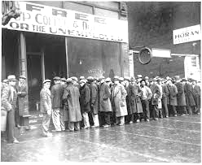
The Great Depression
CAUSES:
  - Stock market crash
  - Farming problems – Overproduction (prices▼) and Dust Bowl
  - “Buy now, pay later”
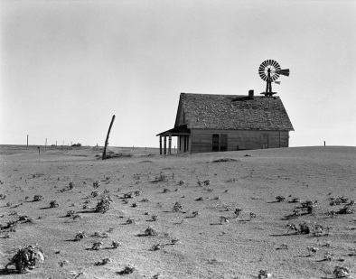
  - Purchase stocks on credit (buying on margin)
  - Uneven distribution of income
- Two major causes of the Dust Bowl:
  - Over-farming
  - Severe drought
- Many farmers of the Great Plains had to abandon their properties as a result of the Dust Bowl. They could no longer farm their land. They became migrant farmers and migrated to states such as California to find temporary work. These migrant farmers were also known as “Okies.”

FDR and The New Deal

- FDR was the opposite of Hoover. He believed that government should take care of the people. When FDR took office in 1933, he instituted the New Deal which was a series of programs/legislation developed to stimulate and stabilize the economy and provide jobs and relief to those who were suffering.
- The New Deal program demonstrated a belief that the Federal Government should concern itself with the people’s economic well-being.
- When Hoover (Republican) was president, he believed that the problems caused by the depression would correct themselves. He thought the economic crisis was temporary. FDR (Democrat), on the other hand, was more willing to use government intervention to solve economic problems.
- Some examples of programs:
  - The CCC (Civilian Conservation Corps) and WPA (Works Progress Admin.) were developed to help address the problem of high unemployment.
  - The FDIC (Federal Deposit Insurance Corp.) and SEC (Securities Exchange Commission) attempted to restore public confidence in financial institutions.
  - The NRA (National Recovery Act) and the NLRA (National Labor Relations Act) represent legislation that sympathized with the rights and interests of workers.

Criticism of the New Deal

- Many Republicans were not happy with the New Deal program. They thought that the Federal Government took too much responsibility for the welfare of the economy. Critics believed these programs made people dependent on the Federal Government. Some felt the New Deal was a danger to the free-enterprise system.
- At one point in his presidency, FDR tried to “pack” the Supreme Court (increase the number of justices) with judges who would support New Deal programs. FDR’s critics thought his plan to increase the number of Supreme Court Justices violated the constitutional practice of checks and balances.
Was the New Deal effective?
- It is difficult to measure the effectiveness of the New Deal. In the short term, at the very least, it appears successful. Long term, some of the programs just faded away; however, programs such as SSA (Social Security Admin.), FDIC, and the SEC are still in existence today.
- The New Deal did not actually take the country out of the depression – our involvement in WWII rapidly accelerated economic growth. Manufacturing was converted from consumer goods production to war time production and that put both men and women to work.
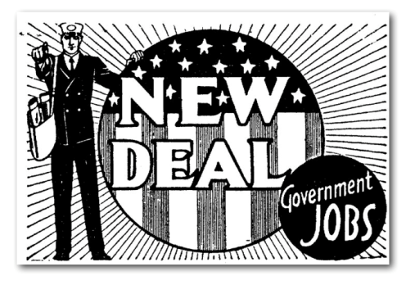
- A lasting effect of the New Deal is the belief that government should assume the responsibility for the well-being of its citizens.
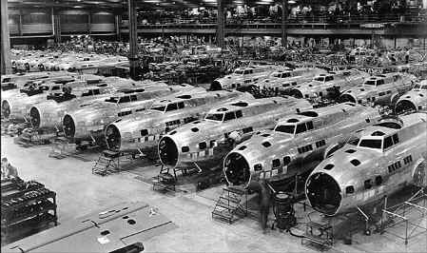

Manufacturing aircraft for the war

