**7th Grade U.S. History Study Guide – Ch. 2 Exploring the Americas**

**People**

|  |  |
| --- | --- |
| Jacques Cartier | Explored the St.Lawrence River Valley for France |
| Christopher Columbus  [http://www.josephsmithacademy.org/wiki/wp-content/uploads/1970/01/1519-christopher-columbus-01-200x273_flip.jpg](https://www.google.com/url?sa=i&rct=j&q=&esrc=s&source=images&cd=&cad=rja&uact=8&ved=0ahUKEwi_5OL7_J3JAhVEcD4KHaAoBLQQjRwIBw&url=https://www.codeavengers.com/c/martau/christophercolumbus.html&bvm=bv.107763241,d.cWw&psig=AFQjCNG5LAaavhYeEjZtIVlBVE2uxA_v_w&ust=1448051538204658) | First known European to land in the Americas. On the island of Hispaniola, he ordered his men to cut the hands off Natives if they did not produce gold. |
| Coureurs de Bois | French colonists who lived in the woods of New France as trappers and traders |
| Bartolome de Las Casas | Spanish priest sympathetic to the horrible treatment of Native Americans at the hands of conquistadores |
| Ponce de Leon | Spanish explorer who traveled to Florida looking for the Fountain of Youth |
| Leif Eriksson  [http://img05.deviantart.net/f17a/i/2012/218/f/b/mr_leif_eriksson_himself__by_ubersquish39-d5a0zmf.jpg](http://www.google.com/url?sa=i&rct=j&q=&esrc=s&source=images&cd=&ved=0ahUKEwjHgob0_Z3JAhUBHj4KHYUJBL0QjRwIBw&url=http://ubersquish39.deviantart.com/art/Mr-Leif-Eriksson-himself-319173207&bvm=bv.107763241,bs.1,d.cWw&psig=AFQjCNFBjYZcWJ6sMnMQdXp09_1PJYktLQ&ust=1448073804567973) | Viking leader who most historians recognize as the first European to discover the Americas |
| Ferdinand Magelllan    [https://encrypted-tbn2.gstatic.com/images?q=tbn:ANd9GcSMle1geMCboyrGe5TRvohDt5RAO4_iV9zNv5w7uu9ulM2jjOLI](http://www.google.com/url?sa=i&rct=j&q=&esrc=s&source=images&cd=&cad=rja&uact=8&ved=&url=http://mrshuntsclassroom.weebly.com/ferdinand-magellan.html&psig=AFQjCNGUOz42BXVrM6SvM4zBgE5kpNpxTw&ust=1448074075354922) | Given credit for sailing around the world…even though he died near the Philippines before the journey was completed. |
| Peter Minuit | Dutch leader of New Amsterdam |
| Francisco Pizarro | Spanish explorer who conquered the Incas |
| John Rolfe | Brought tobacco seeds to Jamestown which soon allowed the colony to become economically profitable |

[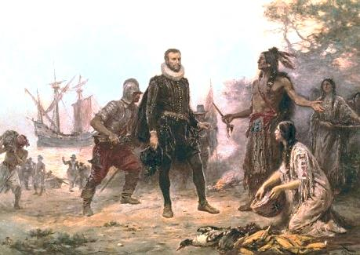](http://www.google.com/url?sa=i&rct=j&q=&esrc=s&source=images&cd=&cad=rja&uact=8&ved=0CAcQjRxqFQoTCO7sjr2pnckCFQnKPgodhOcHdg&url=http://forms5saintjohns.blogspot.com/2012/08/exciting-early-explorers-to-americas.html&bvm=bv.107763241,d.cWw&psig=AFQjCNE7wZu5GarU657_5oWHUWhk4eABIg&ust=1448051246377051)**Early Explorers**

* Early European explorers who came to the New World were looking for a northwest passage in order ***to find a quicker route to Asia***.
* Native American population was estimated to decrease by approximately 24 million from 1492 (when Columbus arrived) to 1608. This decline was primarily due ***to diseases that were introduced by the Spanish***.
* The Spanish left the ***legacy*** of the ***Spanish language*** after they conquered Latin America.
* [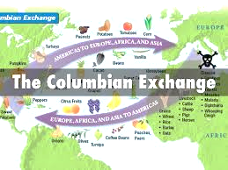](https://www.google.com/url?sa=i&rct=j&q=&esrc=s&source=images&cd=&cad=rja&uact=8&ved=0CAcQjRxqFQoTCKeQxIunnckCFYg5PgodzLoNXQ&url=https://www.haikudeck.com/bellringer--list-three-things-you-know-about-christopher-columbus-uncategorized-presentation-gp6mpaSRW6&psig=AFQjCNEH7aIMIdELcWVzAFpaYMP4cBoqgw&ust=1448050599920121)The Spanish conquistadors were able to conquer the Aztec and Inca Empires quickly because these empires had no standing armies.
* [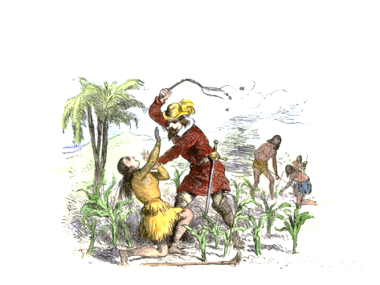](http://www.google.com/url?sa=i&rct=j&q=&esrc=s&source=images&cd=&cad=rja&uact=8&ved=0CAcQjRxqFQoTCLi0s4aonckCFQh6PgodPxoHvA&url=http://www.allposters.com/-sp/Cruelty-of-the-Spanish-Encomienda-System-on-a-Sugar-Plantation-Santo-Domingo-Posters_i2877159_.htm&bvm=bv.107763241,d.cWw&psig=AFQjCNFjc2judQY160-PWQkvigSBp8poGQ&ust=1448050809035242)The ***Columbian Exchange*** refers to the transfer of goods/ideas between Europe and the New World.
* The Spanish used the ***Encomienda System*** to force Native Americans to work for them.
* When the Europeans explored the Americas, new diseases were introduced, Native Americans lost their lands, and the African slave trade grew.
* Spanish law (Laws of the Indies) set up three kinds of settlements in the Americas (New Spain): **pueblos, presidios, and missions.**
* Since **advances in learning and technology** made long ocean voyages possible, **Europeans** were eager to explore unknown lands. They were able to **bring food, animals, and ideas from one continent to another**. They also **brought diseases that affected the native population** of new territories, and **warfare increased** among the European nations as they competed for land and power.

[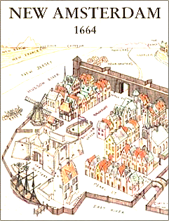](https://www.google.com/url?sa=i&rct=j&q=&esrc=s&source=images&cd=&cad=rja&uact=8&ved=0CAcQjRxqFQoTCIyI7NyonckCFYasPgodi1IIwg&url=https://www.interexchange.org/articles/career-training-usa/2012/03/29/nieuw-amsterdam-ny/&bvm=bv.107763241,d.cWw&psig=AFQjCNHiXr7cyLfggV-tOnyQYsLsKVrGEQ&ust=1448051038891080)**French and Dutch Settlements**

* Both groups were interested in the rich natural resources of North America.
* The **Dutch** were the first group of Europeans who settled the Hudson Valley and established New Amsterdam.
* [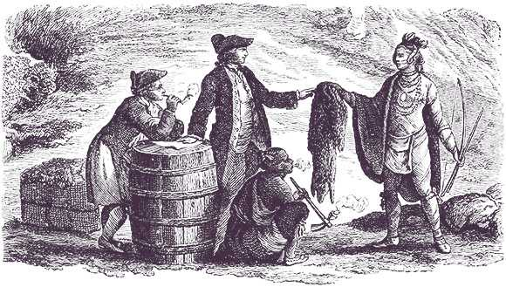](http://www.google.com/url?sa=i&rct=j&q=&esrc=s&source=images&cd=&cad=rja&uact=8&ved=0ahUKEwj396P5hp7JAhXLcj4KHV5qCuwQjRwIBw&url=http://oregonquarterly.com/french-twist&psig=AFQjCNHaNmYZlGJkuPiLlxbYx3Id7QcUVw&ust=1448076323726061)The French were friendly with the Native Americans. They taught the French how to survive in the woods and trap animals.