Chapter 21 Study Guide An Urban Society (pp. 576-594)
People
Jane Addams | Organized the Hull House, a settlement house in Chicago
Horatio Alger | His “dime” novels told a familiar story: poor, city kid becomes rich through honesty, hard work, and a bit of luck.
Jewish immigrants | Arrived from Eastern Europe and Russia, often because of religious persecution
NYC Police | Used mugshots and developed a criminal database to combat growing crime and corruption
Nativists | Americans of English and Protestant heritage who resisted immigrants…especially New Immigrants
New Immigrants | Arrived in America during the 1880s-1920s mainly from Italy, Greece, Russia, and Slavic regions of Europe
Old Immigrants | Arrived in America during the 1840s-1860s mainly from Ireland and Germany
Frederick Law Olmstead | Created many of America’s most famous urban parks such as Central Park in NYC
Babe Ruth | Perhaps America’s most famous baseball player of the early 1900s, he made the Yankees America’s team.
White Ducks | One of America’s first sanitation departments, they cleaned the streets of New York City.

Immigration
- The following are PUSH factors (“pushed” people from Europe to come to America): 1) Religious persecution; 2) Famine; 3) War
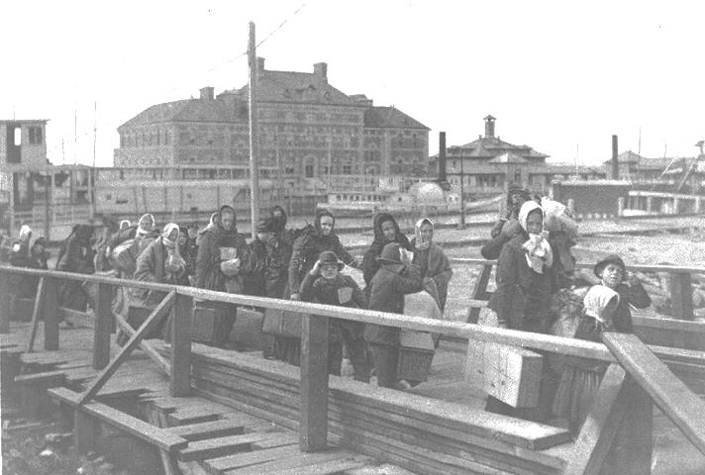
- Immigrants passed through Ellis Island in order to be processed and to check their health.
- Melting Pot Theory► Different cultures will blend to form a uniquely American culture.
- People emigrated to America because industrial growth led to a demand for cheap immigrant labor ► a PULL factor.
- In the late 19th century (late 1800s), most immigrants came from eastern and southern Europe.

Immigrants and Discrimination

- The quota system was mainly designed to limit the number of immigrants from certain nations. Quota = limits
- Quota system, Gentlemen’s Agreement, literacy tests► restrict immigration.
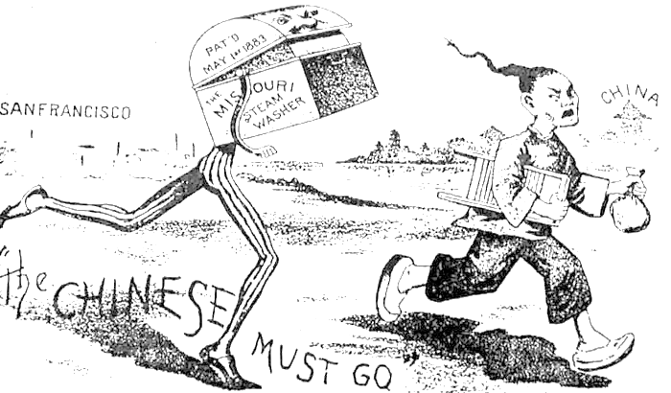
- In the late 19th century, labor unions argued that immigrants took jobs from United States citizens.
- Nativists► Americans against immigrants. Wanted to keep foreigners/immigrants from coming to the United States
- “New” immigrants were prejudiced against during the late 1800s/early 1900s because they came from cultural backgrounds very different from that of the majority of Americans.
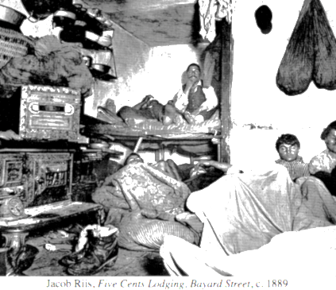
Immigrants and Life in the Cities
- Because of rapid industrial development in the U.S. in the late 1800s, there was an increase in the rate of urbanization/growth of cities.
- The following contributed to the growth of cities in the late 1800s: 1) large numbers of immigrants to the U.S.; 2) demand for factory labor; 3) segregation and poor working conditions for African Americans in the South.
- An urban immigrant family in the late 1800s was most likely entertained at a vaudeville show.
- By 1920 more people lived in urban areas than in rural areas.

