U.S. History 8th Grade Study Guide – Chapter 22 (The Progressive Era)
Progressivism is the term applied to a variety of responses to the economic and social problems rapid industrialization introduced to America. Progressivism began as a social movement and grew into a political movement. Urbanization► Progressive Reforms
People
Susan B. Anthony  *Suffragist – supporter of a woman’s right to vote | A suffragist, together with Elisabeth Cody Stanton, she pushed for women’s right to vote and other women’s rights.
“Fighting” Bob LaFollette | Governor of Wisconsin responsible for the “Wisconsin Idea” – a direct primary election in which voters chose candidates to appear on the ballot
Carrie Nation | Radical temperance crusader…stormed into saloons smashing kegs and bottles
Thomas Nast | Cartoonist who exposed the corruption of Boss Tweed
Gifford Pinchot | Head of the National Parks Service. His firing by Taft angered many Progressives in the Republican Party.
Teddy Roosevelt | Active and energetic President who supported the “common man”…later became the presidential candidate of the Bull Moose Party
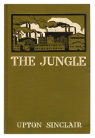  Upton Sinclair | Author of The Jungle. Exposed health violations and unsanitary practices in the meat packing industry in the early 20th century
Elisabeth Cady Stanton | A suffragist, she organized the women’s rights convention in Seneca Falls, NY in 1848. In 1869, she founded the National American Woman Suffrage Association.
William Howard Taft | Hand-picked by Roosevelt to become the next Progressive President…but soon turned conservative
Boss Tweed | Controlled Tammany Hall, the political machine of New York City. He was a corrupt politician.
Woodrow Wilson | President who offered Americans a New Freedom. He won the 1912 presidential election as a Democrat over Taft (Repub.) and Roosevelt (Bull Moose Party)
16th Amendment | Ratified (approved) in 1913 under Pres. Taft, this amendment provided for a graduated income tax – higher incomes were taxed at a higher rate than lower incomes.
17th Amendment | Provided for the direct election of senators by voters – gave citizens a greater voice in their government
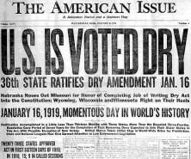  18th Amendment | Approved in 1918, the Prohibition Law declared it illegal to make, transport, or sell alcohol in the United States.
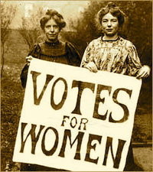  19th Amendment | Gave women the right to vote. Approved in 1920, this amendment prohibits any United States citizen from being denied the right to vote on the basis of sex.

Progressive Era/Reforms
- Political machines (corrupt politicians) were often accused of accepting bribes in return for favors.
- In order to reduce corruption in government, reformers of the Progressive Era looked to adopt a constitutional amendment that provided for the direct election of U.S. senators.
- Reform movements throughout United States history have led to long-lasting changes in society.
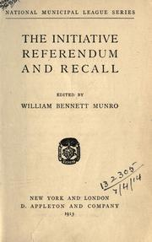
- The initiative, referendum, recall, and direct primary are all intended to increase participation in government by citizens.
- A major purpose of the Progressive movement (1900-1917) was to correct the economic and social abuses of urbanization.
- Progressive Era reformers supported the use of a graduated income tax because they argued that people who earn more money should pay taxes at higher rates.
- Muckrakers exposed widespread corruption in business and government. Muckrakers (investigative reporters) led the effort to pass the Meat Inspection Act.
- Investigative reporter Arnold Diaz (“Shame, Shame, Shame”) and the show 60 Minutes are similar to the muckrakers of the Progressive Era as they attempt to expose societal problems.
- The purpose of passing legislative acts such as the Meat Inspection Act and the Pure Food and Drug Act as well as establishing the United States Forest Service and the Department of Labor was to promote the general welfare of the American public.
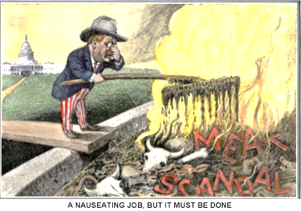
- The Interstate Commerce Act (1887), the Sherman Antitrust Act (1890), and the Clayton Antitrust Act (1914) eliminated unfair trusts and monopolies.

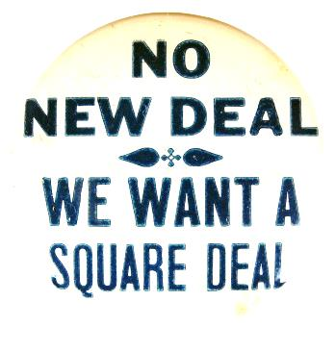

Theodore Roosevelt/Politics

- President Theodore Roosevelt was known as the “trust buster” because he wanted to limit the power of monopolies.
- Roosevelt’s trustbusting policies were intended to encourage competition in business.
- Roosevelt felt very strongly about conservation and the environment because he felt that wilderness areas and their resources should be protected for the public good.
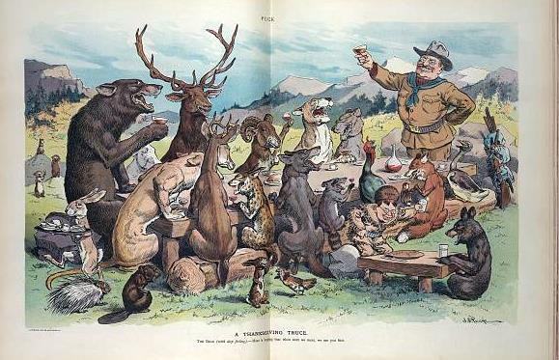
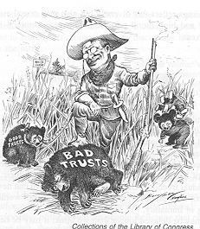
- Roosevelt’s Square Deal included 1) policies to increase railroad regulation; 2) an increase in consumer protection and 3) making a distinction or difference between good and bad trusts. Mak

Roosevelt as “trust buster”

Roosevelt as conservationist
- In the election of 1912, Roosevelt decided to run again because he was disappointed that Taft didn’t carry on as a true Progressive president. Since Taft was a Republican, Roosevelt (also a Republican) had to form a third party. This was called the Bull Moose Party. Woodrow Wilson, a Democrat, won the presidential election because the Republican Party vote was split between Taft and Roosevelt. *Third political parties tend to focus on one person or one issue.

