8th Grade Study Guide – Chapter 20 – Industrialization
People
Alexander Graham Bell | Invented the telephone
Andrew Carnegie | Monopolized the steel industry
Henry Bessemer | Developed a way to make steel faster, cheaper, and stronger
Henry Ford | Invented the assembly line which allowed for mass production
JD Rockefeller | Monopolized the oil industry
Samuel Gompers | Founder of the AFL (American Federation of Labor)
Samuel Morse (“Morse” code) | Invented the telegraph
Scabs | Hired as “replacement” workers during a work stoppage
The Wright Brothers | Developed the first airplane in Kitty Hawk, North Carolina
Thomas Edison | Invented the phonograph, movie camera, and light bulb

Railroads
- In order for railroads to be more efficient, the gauges of all railroad tracks were standardized (made tracks the same size) in 1886.
Industrialists/Big Business
- Critics claimed that monopolies most harmed the economy by limiting competition.
- Andrew Carnegie used vertical integration in which he controlled all aspects of the steel business► mining the ore, owning the suppliers, railroads etc..
- In the late 1800s, new production techniques that increased efficiency directly contributed to the growth of the steel industry.
- The theory of Social Darwinism (“survival of the fittest”) was used by many wealthy American industrialists of the late 19th century to justify monopolistic actions.
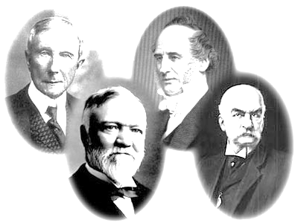
- The term robber baron was used to describe some owners of big businesses because they eliminated competition using ruthless methods.
- John D. Rockefeller and Andrew Carnegie supported philanthropic activities (donated to the arts, education…) to benefit society (for ex., Rockefeller Center, Carnegie Hall in NYC, Carnegie Mellon Univ.).
- Standard Oil Company has been portrayed in cartoons as a monster or an octopus having a grasp or hold on banks, smaller oil companies, insurance companies, railroads, and shipping► a monopoly.
- In order that efficiency in production methods could be increased, many business organizations in the U.S. combined into large corporations during the latter half of the 19th century.
- Organized labor motto ► “Eight hours for work, eight hours for sleep, eight hours for what we will.”
- Assembly line► Cars were produced faster and cheaper.

Unions/Organized Labor
- Main benefit that labor unions of the late 19th century gained for their members ► improved wages and hours.
- The AFL (American Federation of Labor) represented skilled workers in a large number of trades and crafts.
- Haymarket Riot ► led to anti-labor feelings across America
- Triangle Shirtwaist Company Fire (deadliest industrial disaster in the history of New York City) ► new safety laws
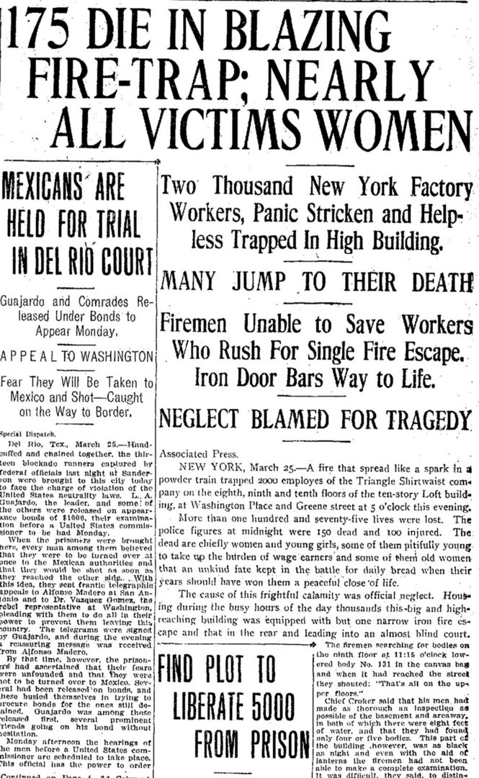
- Blacklists and yellow-dog contracts were used by employers against workers during the late 19th century. Companies “blacklisted” workers who were pro union. “Yellow dog contracts” were agreements between the employer (owner) and the employee (worker) stating that the worker would not join a union.
- Children lied about their age to keep their jobs because they needed the money to support their family. Children worked long hours in the factories and often came from poor families. Working children had no time to play or go to school
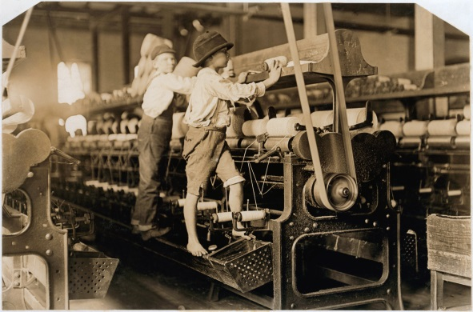

Child Labor

