8th Grade U.S. History: Chapter 19 Study Guide
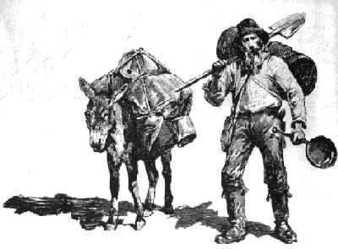
Westward Expansion
- Miners
  - People moved out West in search of gold and silver
  - California Gold Rush of 1849
  - Miners hoped that “boomtowns” didn’t turn into “ghost towns.”
  - Comstock Lode (along Carson River in Nevada) ► rich “vein” of silver found ► miners and others moved out West
- Settlers
  - People moved out West to become farmers and ranchers.
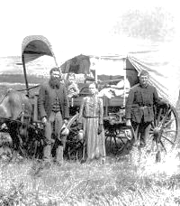
  - Passage of The Homestead Act (providing free land to settlers), the gold rush, and completion of the Transcontinental Railroad further encouraged Westward settlement.
  - Westward settlement eventually led to Native Americans being moved to reservations, a decrease in the number of buffalo, and conflicts with Native Americans.
  - Buffalo were “sacred” to the Native Americans. Used all parts of the buffalo (food, made tools, made tepees..).
  - Settlers of the Great Plains were known as “sodbusters.”
  - “Sooners” would get to the unclaimed land in Oklahoma before the official start of the race.
- Railroads
  - Benefits:
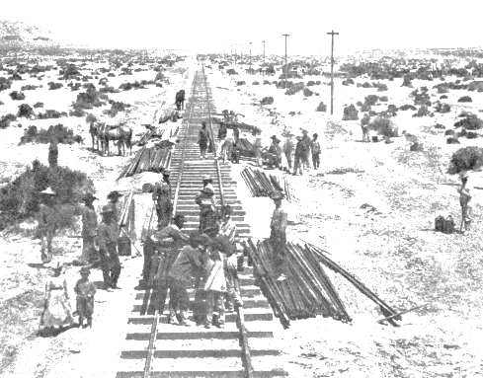
    - Faster transportation of goods and supplies from East to West
    - Contributed to westward expansion
    - The “frontier” began to disappear as cities and towns sprang up.
    - Nationwide rail network united Americans in different regions.
    - The federal government supported railroad construction with “subsidies.”
**Passage of the Homestead Act (government distribution of land on the Great Plains to encourage settlement) and creation of the railroad both contributed to the notion of “Manifest Destiny” – that American settlers were destined to expand throughout the continent.
Cowboys and Farmers
- Cowboys led cattle drives
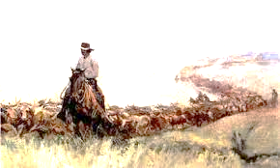
- Cattle were moved or driven from the South up to railroad towns or markets. The cows were then transported by railroad to major cities such as Chicago to be slaughtered. With the invention of the refrigerated rail car, meat could then be distributed further East to accommodate the growth of cities/population.
- The steel plow helped farmers cut through tough layers of soil. With further improvements in equipment, farmers could produce more crops.

Native American Experience
- Most Native Americans were forced to live on reservations from the period 1860-1890.
- The Plains Indians’ lives depended on the buffalo. Conflict with Americans moving West became unavoidable.
- The Federal Government wanted to take away the Native Americans’ land. The Federal Government broke treaties with the Native Americans and destroyed tribal bonds.
- The Indian Wars were a result of settlers moving onto the Great Plains.
- Crazy Horse led the Sioux against the U.S. Army at Little Big Horn.
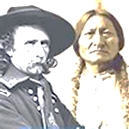
- General Custer and all of his troops were killed at Little Big Horn because Custer underestimated the number/strength of Native American forces.
- Colonel Chivington and his troops massacred Cheyenne Indians outside their reservation near Sand Creek, Colorado.
- Geronimo led Southwest Indians against the U.S. Army during the Apache Wars.
- The Dawes Act tried to “Americanize” Native Americans, turn them into farmers. The Dawes Act did not succeed because the Indians believed their land should not be divided into individual farms. They didn’t have the background to become farmers.

