8. Picture and Theater

1. Consider once more the jewlry-encrustred skeleton of St. Clemens, in Rott am Inn (Fig. 1).

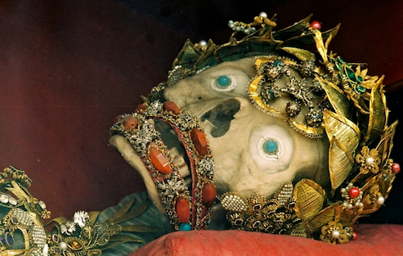

Fig. 1. Rott am Inn, St. Clemens

It makes me think of Ariel’s Song from Shakespeare’s Tempest:
Full fathom five thy father lies;
Of his bones are coral made;
Those are pearls that were his eyes:
Nothing of him that doth fade,
But doth suffer a sea-change
Into something rich and strange.
Sea-nymphs hourly ring his knell:
Ding-dong.
Hark! now I hear them—Ding-dong, bell.
Why did Shakespeare name his airy spirit Ariel? Ariel is also the archangel associated with healing and new beginnings; also with the earth. Shakespeare’s sea-change makes us think of death and of transformation. So does the jewel-encrusted relic.
Inseparable from thoughts of death are thoughts of the insubstantiality of our lives, of their dreamlike character. Again we can cite Shakespeare’s Tempest: This time it is Prospero who is speaking (Act IV, Scene i):
Our revels now are ended. These our actors,
(As I foretold you) were all spirits, and
Are melted into air, into thin air:
And, like the baseless fabric of this vision,
The cloud-capp'd Towers, the gorgeous Palaces,
The solemn Temples, the great Globe itself,
Yea, all which it inherit, shall dissolve
And, like this insubstantial pageant faded,
Leave not a rack behind. We are such stuff
As dreams are made on, and our little life
Is rounded with a sleep.
Prospero’s words also remind us of how closely connected these typically Baroque metaphors, “dream” and “theater,” are. And here it is important that the word “dream” requires the contrast with reality: it loses its meaning when you say everything is a dream. The same goes for theater. If our life is a dream, what then is reality?

2. I pointed out last time that the anticipation of our inevitable death lies at the very origin of religion, and more especially of Bavarian Baroque spirituality. This finds one expression in a remarkable chapel for meditation and reflection that the aged Bavarian Elector Max Emanuel, concerned about the afterlife, worried about his sins, and there had been many, had his architect Effner build him in the park of Nymphenburg Castle, the Magdalenenklause. I introduced you to him in our third session (Fig. 2). I spoke of the significance that death had in the Elector’s life. Remember that the Blue Elector, as he was known, had become a European celebrity as a result of his victories over the Turks. Marriage to the Emperor’s daughter gave him not altogether unjustified
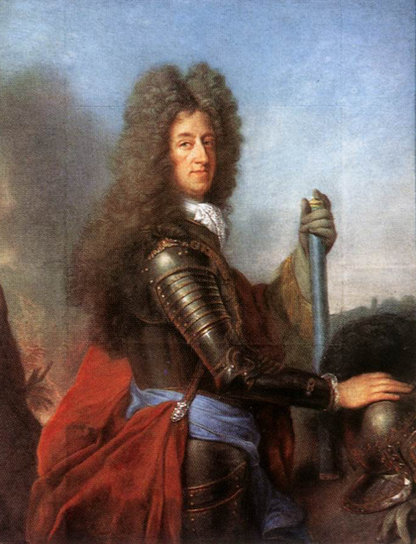

Fig. 2. Elector Max Emanuel by Joseph Vivien

hope that some day his son and perhaps he himself as his son’s regent might ascend to the Spanish throne, perhaps even become Emperor. But in 1692 the Emperor’s daughter died in childbed; the child, however, survived and with him the elector’s hopes. The Spanish King did indeed declare the child the heir of all Spanish possessions. But in 1699 that child died in Brussels. Max Emanuel did not quite give up his imperial ambitions. In 1701 he began work on a huge new palace in Schleissheim in keeping with his dreams. The quarrel concerning who now would rule the Spanish possessions led to the war of the Spanish succession, which pitted Austria, the Dutch, and England against France and Bavaria. This time the Elector sided with the French, who in 1702 had lured him with promises of royal or perhaps even imperial status. All these hope were dashed with the battle of Blenheim in 1704, when the Austrians and English under Prince Eugene of Savoy and the Duke of Marlborough defeated the allied French and Bavarians. Bavaria came under Austrian administration.
After many tumultuous years in exile, first in Belgium, then in France, Max Emanuel was able to return only in 1715, still dreaming of royal and perhaps imperial grandeur. That return, as I pointed out, has often been said to have been the beginning of the Bavarian Rococo. On his return, he immediately he embarked on an ambitious building program, which culminated in continuing work on the new castle in Schleissheim, now no longer under the direction of the Italian Zuccalli, but of the French trained Bavarian Josef Effner. Not that he did not already have two quite splendid palaces, the town residence in Munich and, just outside the city, Nymphenburg, the castle of the nymphs. But he, too, was possessed by that Bauwurm, that building mania, which possessed so many rulers of the Baroque.
Here I want to return briefly to three small building he had his architect Effner build in the park of Nymphenburg castle, the last of which was the Magdalenenklause. I already showed you the first of these, begun soon after his return, the Pagodenburg (Fig. 3, 18). The Elector himself was involved in its design. The name points to the interest the 18th century took in China. In its intimate scale and light elegance it is quite representative of the early secular Rococo.
Somewhat larger is the second structure, the Badenburg or bathing castle (1718-22), after many centuries the first building in Europe to be given over wholly to the joys of bathing (Fig. 5, 2). It included a rather small indoor swimming pool, apparently the first such pool in a European castle. The Elector had learned about the joys of bathing from the Turks.
But the structure that interests us here is the third, the Magdalenenklause (1725-17280, an expression of the aged and all too worldly Elector’s concern about the inescapability of death and his need to be forgiven his many sins (Fig. 3). Having known both pride and the vicissitudes of fortune better than most, the aged elector now sought comfort and edification, meditating on the sinful, but penitent St. Magdalen (Fig. 4).
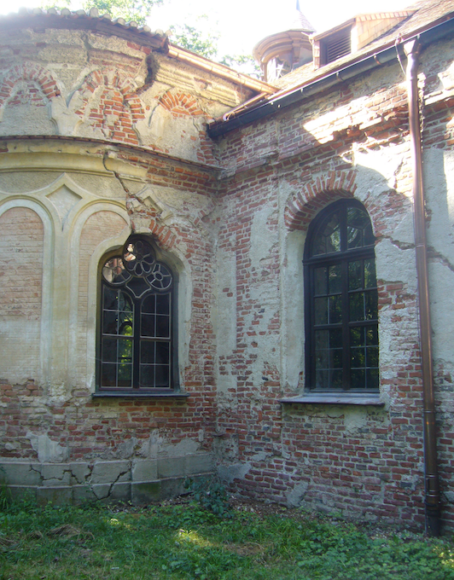

Fig. 3. München , Nymphenburg, Magadalenenklause

The Magdalenenklause is not without predecessors. Hermitages, places that invite meditation on the vanity of life, had long played a part in the life of the Baroque court. The inconspicuous location of the building, tucked away in a corner of the park, the rustic simplicity of the interior, and the rock and shell work that transform its chapel into an artificial grotto, had become standard elements of such buildings. What is new and forward looking, however, is that the building is now given the look of a ruin: in places plaster seems to have fallen off; the walls are furrowed by very visible cracks.
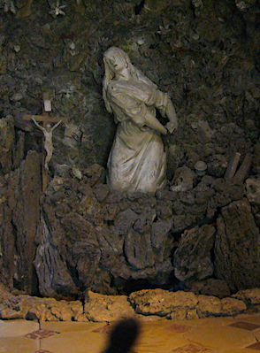

Fig. 4. München, Nymphenburg, Magdalenenklause, St. Magdalen, Giuseppe Volpini, 1726

At first there may seem nothing very surprising in all of this. Ruins had long been experienced as "the trophies of time" and as signs of the limits placed on human work. As thus, they had long appeared in paintings, especially as providing a suitable space for the birth of the Savior. Here a Nativity by Hans Baldung Grien (1520) (Fig. 5).
The decision to actually build a ruin is, however, remarkable. Architecture here turns self-consciously against architecture, and it does so in a number of different ways.
First of all, it subjects architecture to the logic of painting. Architecture becomes a picturesque motif. As I pointed out last time, this also happens in Rococo architecture. Think of the importance of point of view, which invites the category of the picturesque.
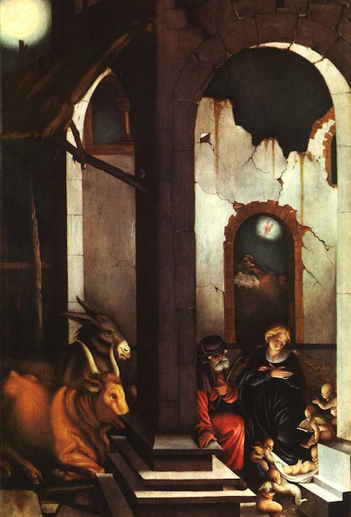

Fig. 5. Hans Baldung Grien, Nativity

The ruin also challenges architecture by its incompleteness. Time and nature appear to have triumphed over what human work can accomplish.
And yet this appearance is itself managed by man. It is just theater. The ruin beckons the aristocrat who has grown tired of his aristocratic existence to a more natural life. Thus from the very beginning the Magdalenenklause was placed in a "jardin sauvage," which avoided the geometry of the French park and offered the delights of serpentine paths and the natural look that were to become characteristic of the English park.
We should also keep in mind that the Magdalenenklause in its artificially natural setting remained, spiritually and literally, on the periphery of courtly life. Members of the court, and especially the tired elector, enjoyed playing here the part of hermits, as later at Versailles they enjoyed playing the part of peasants. In such games, too, a contradictory attitude to the artificiality and ceremonial of court life finds expression.
Significant is the way the Magdalenenklause plays with history (Fig. 6). Not only the Italian baroque, but Moorish and Romanesque motifs are quoted. This play with the architecture of the past presupposes that architecture is beginning to lose its place in the architectural tradition.

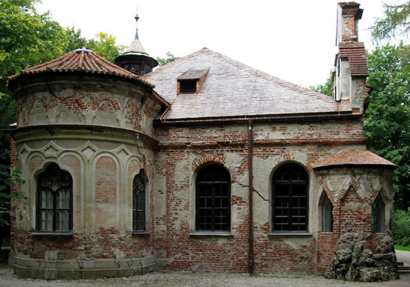

Fig. 6. Magdalenenklause

3. In its theatricality the Magdalenenklause belongs to the Baroque. The Baroque is the age of the theater. Heidegger called our modern age the Age of the World Picture. In that sense the Middle Ages may be called the Age of the World Building, in which the cosmos is experienced as the work of the divine architect, a work that assigns each person his place. And in that sense the Baroque, I want to suggest, can be called the Age of the World Theater.
Here we should keep in mind that the theater, as we have it today, with an auditorium with galleries and a stage, is an essentially Baroque building type. But more important in this context is the way a church such as Diessen is built as a Theatrum Sacrum, in which the mass is performed week after week. Just in this respect it is a Baroque church. Countless churches follow that general scheme. The Bavarian Rococo church is indeed considered by many art historians and with good reason as simply a late Baroque church. (Fig. 7, 13)
This approach to architecture again presupposes a profoundly theatrical understanding of the world that continues to find expression in such fundamentally Baroque expressions as theater of war or scene of the crime — we can add the anatomical theater. The Baroque is the age of the world-theater. Here just a few lines from Hofmann von Hofmannswaldau’s poem “Lust der Welt,” “Pleasure of the World.”

Was ist die Lust der Welt? Nichts als ein Fassnachts-Spiel,
So, lange Zeit gehofft, in kurzer Zeit verschwindet,
Da unsre Masken uns nicht haften, wie man will
Und da der Anschlag nicht den Ausschlag recht empfindet.
Es gehet uns wie dem, der Feuerwerke macht,
Ein Augenblick verzehrt oft eines Jahres Sorgen;

What is the pleasure of the world? Nothing but a carnival play
That long anticipated, quickly vanishes,
Since our masks don’t stick, as one might wish
And the beginning fails to rightly match the end.
We are like those who set off fireworks,
A moment often eats up a year’s cares;

Like the dream, the theater is metaphor of a world that is experienced as unreal. We say, don’t be so theatrical! We sense that pretense here does not correspond to reality. Something of this Baroque understanding of reality is still alive in Kant’s understanding of experience, which denies us access to things in themselves. The metaphor of the world-theater, too, invites us to think of a reality concealed behind what we experience first of all and most of the time. Presupposed is knowledge about the distance that separates what is familiar to us from what is truly real. So understood, we find the concept of the world-theater already in Plato.
But knowledge about and painful awareness of the way our reality is subjected to time and therefore dreamlike is only one side of the Baroque understanding of reality. We have to think also of the festal culture of the Baroque, the pleasure it took in spectacles of all sorts, especially in fireworks. Here the moment did indeed often devour a year’s cares, but that means not only that huge sums were spent on such fleeting pleasures, but also that such festivities ate up the year’s cares, and that means: allowed human beings to forget them. In time the beautiful fleeting illusions, whose production was so much a concern of the festal culture of the Baroque, allowed human beings to forget, at least for a time, the suffering that was part of their act in the theater of the world. Did Nietzsche not say that we were given art so that we would not perish over the truth?
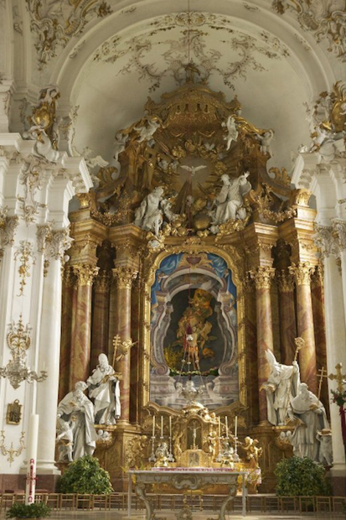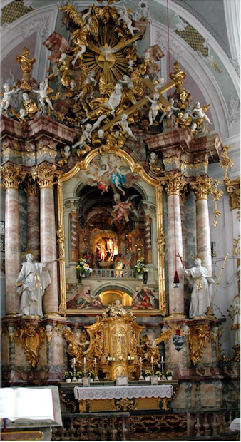

Fig. 7. Diessen, Bühnenaltar Fig. 8. Dillingen, Bühnenaltar

The theatrical quality of the Rococo church is most readily apparent in its altar compositions: here once more Diessen. The architecture of the church already is theatrical. Likening wall-pillars to the wings of a theatrical set is more than a simile. To enter a Bavarian Rococo church is to step onto a splendid stage, although, as we take our place in the nave, this stage is transformed into the orchestra; the stuccoed curtain that so often decorates the choir arch and loges that establish the antechoir as a proscenium transform the altar room into a stage. Upon that stage the high altar appears as yet another stage: a stage within a stage within a stage. In Diessen the high altar, as I mentioned last time, can function quite literally as a stage (Fig. 7). The stage altar in Diessen has its counterpart in the Studienkirche in Dillingen (ca. 1760) (Fig. 8).

4. The most important contributors to the theatricality of the Bavarian rococo church were the Asam brothers, Cosmas Damian (1686-1739) and Egid Qurin (1692-1750). When we look at Bavarian Rococo churches, three architects, or rather, two pairs of brothers and one architect stand out. We have already encountered one such pair: the brothers Zimmermann, Johann Baptist and Dominikus, who created Steinhausen, and in a later session we shall consider in some detail their other masterpiece, die Wies. Both started out as first of all stuccoers, i.e. as decorators. The older brother Johann Baptist became also a painter, the younger also an architect. But ornament remained at the center of their art.
Then there is Johann Michael Fischer, a mason who depended on others for decoration and frescoes. We have spent some time on his church in Diessen, and considered more briefly his churches in Zwiefalten and Rott am Inn.
And finally there are the Asam brothers. I introduced you already to Cosmas Damian Asam’s extraordinary fresco in Ingolstadt. As I mentioned in an earlier session, after the death of their father the painter Hans Georg Asam, abbot Quirin Millon of Tegernsee made it possible for the two brothers to study in Rome. They had already worked with their father and established a small reputation for themselves. In Rome they became familiar with the high Baroque art of Gaulli (Church of the Gésu), Pozzo (San Ignazio), and Bernini (Fig. 9). On March 23, 1713 Cosmas Damian Asam was awarded

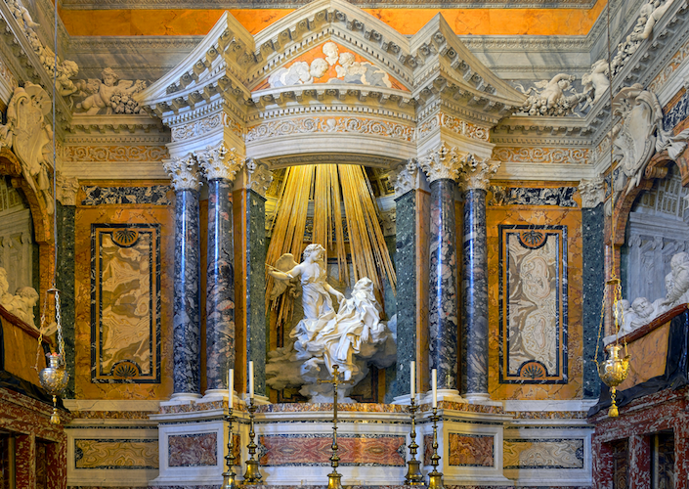

Fig. 9. Bernini, St. Theresa, Cornaro Chapel, Santa Maria della Vittoria, 1652

first prize by the Accademia di San Luca. (Fig. 5, 17).

5. What had impressed the Asam brothers in Rome is apparent in the work they did on their return — and immediately major commissions awaited them. The Asam brothers thus continued to use Gaulli’s device of clouds and devils spilling out of the fresco immediately on their return in 1713. Here a somewhat later example from the Benedictine abbey church in Weingarten, which I discussed before. (Fig. 10)
Even more significant for the evolution of the Bavarian rococo church is Cosmas Damian Asam’s large ceiling fresco in the Cistercian abbey church of Aldersbach (Fig. 11) (1720). Here we have an interesting, and a decade earlier, approach to the problem of mediating between fresco and architecture that the Zimmermann brothers so successfully solved in Steinhausen. Of special importance inb Alderbach are the clouds. In their pasty heaviness they contrast with much of the stucco, which is comparatively flat in the

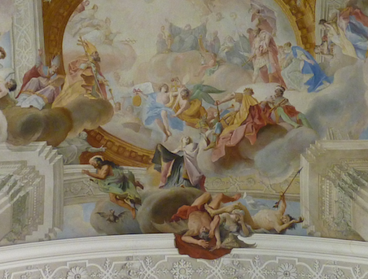

Fig. 10. Weingarten, Ceiling Fresco, Cosmas Damian Asam, ca., 1720

Then newly popular régence mode. But they do relate quite directly to the four cartouches that "support" the fresco, and in their pink pastiness help to establish a transition between ornament and picture. This is done more effectively by the riband weaving in and out of the picture, twining itself around the frame, and by the putti that carry it, riding on stuccoed clouds. Both share in that ambivalence between ornament and picture that will become essential to rocaille. Our sense of ambivalence is further strengthened by the scalloped frame, which is not only frame, weakened as such by its form, but at the same time the pictorial base of the scene presented in Cosmas Damian's fresco. Here, too, a balustrade, here painted, helps to facilitate the transition from framing ornament to picture.
All of these devices deny closure to the fresco and open the realm of St. Bernard’s

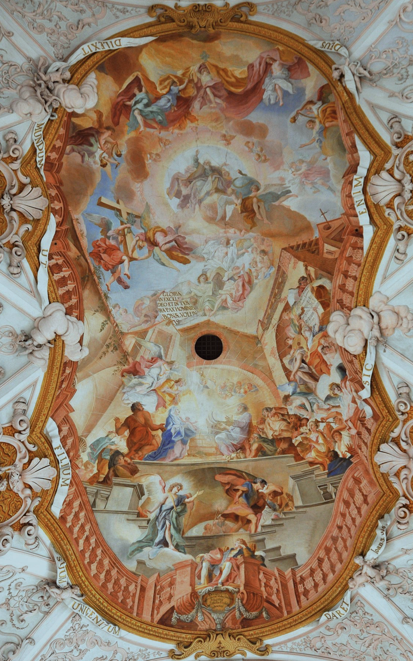

Fig. 11. Cistercian abbey church of Aldersbach, Nave Fresco, 1720
Christmas vision to the space below in which we ourselves stand. Note that iconographically, too, there is an emphasis on mediation. What is represented is not the Christmas event, but the Saint’s vision of it. Pozzo's illusionism has been translated into Bavarian.

6. But let me turn now to the younger brother Egid Quirin Asam’s almost contemporary Augustinian Priory church of Rohr, consecrated to the Assumption of the Virgin (1716-23) (Fig. 12). The inscription on the ceiling invokes her presence: Una

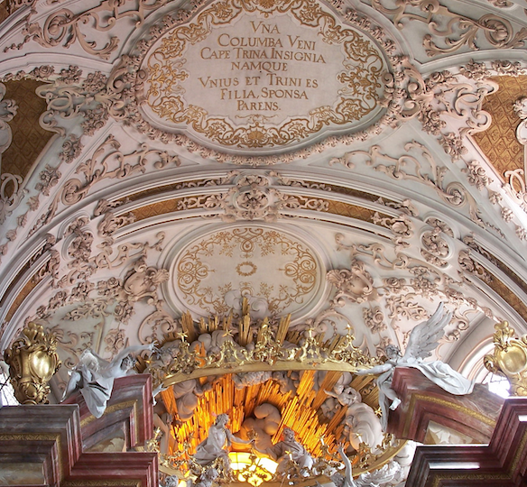

Fig. 12. Rohr, Descoration of Choir Vault, Egid Quirin Asam, 1722-23

Columba Veni Cape Trina Insignia Namque Unius et Trini es Filia, Sponsa, Parens. “Come you unique dove, receive the three signs [crown, scepter and ring as queen of Heaven] because you are daughter, bride and mother of Him Who is One and Three.” Of special importance, given today’s topic is the theatrical high altar (Fig. 13).
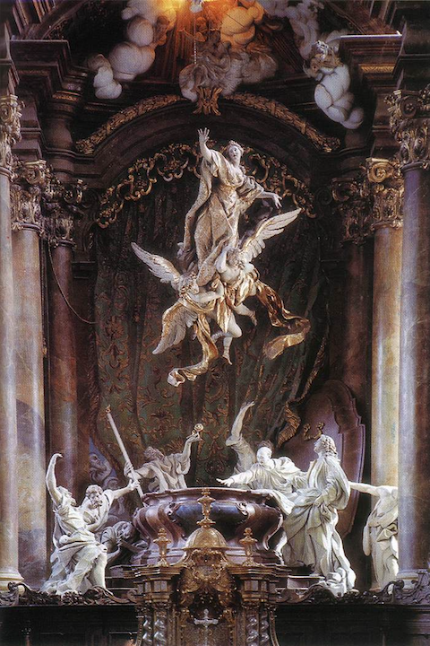

Fig. 13. Rohr, Monastery Church of the Assumption of Mary, High Altar, 1723
Already in Munich's Theatinerkirche the high altar is no longer just a piece of furniture. The altar had become architectural, somewhat like a proscenium. But in the Theatinerkirche the theatrical potential of such integration is not exploited. Given the altar's lack of depth, its paired columns continue to function rather like a picture frame.
In Rohr this frame becomes a stage architecture, complete with a blue drapery that shows the Bavarian coat of arms and functions as a backdrop. The altar's scagliola columns seem to have the same kind of reality as the columns of the crossing; similarly, the entablature continues that of the nave (Fig. 14). Only its darker tonality resists complete integration and establishes some distance, reinforced by the dark choir stalls encircling the means, which help to give the altar the look of a raised stage. Enacted on that stage is the Assumption of the Virgin. Gathered around the empty sarcophagus we see apostles, their dramatic gestures expressing bewilderment and astonishment at what is happening. Above them the Virgin floats upward, supported by two large angels, toward the heavenly realm that fills the altar's broken pediment with its gold and light. Like the dove of the Holy Spirit above, she seems suspended in midair. Her ascent recalls the fantastic flights that the Baroque theatre liked to conjure, often with incredibly elaborate machinery. Here it is only a carefully concealed rod.
Especially theatrical is the use of light. Frontal illumination is provided by the large window broken into the façade. Windows in the apse, concealed from our view, light the composition from the sides, a theatrical effect the younger Asam had learned from Bernini. The large oculus above the altar provides a very visible third source of light. This time, however, light is not used to illuminate the drama, but is itself part of it. To represent the heavenly realm the sculptor fuses stuccoed clouds and a burst of golden rays with the warm light entering through yellow panes. Real light and the golden rays representing light are made part of one pictorial whole. Once again the boundary between art and reality is obscured, or rather becomes the object of artistic play. In this respect Rohr points both forward to the rococo to come and back to the high Baroque of Bernini, particularly to the Cathedra Petri.
Even if the high altar at Rohr is obviously "infected" by the theatre, it is impossible to speak here of illusionism. As Hitchcock remarks, the altar "preserves aesthetic distance, despite all the realism of the astonished apostles' poses and their existence, life-size, in our own space, by the abstract whiteness of the figures, as in the modern work of George Segal." This whiteness recalls the marble whiteness of Bernini's sculptures, although here the material is not marble, but stucco; in this respect the decoration of the Theatinerkirche and the work of the Wessobrunners provide more obvious antecedents. This whiteness, which was to become characteristic of subsequent Rococo sculpture, plays an important part in the play with illusionism that provides one of the keys to the Bavarian Rococo.

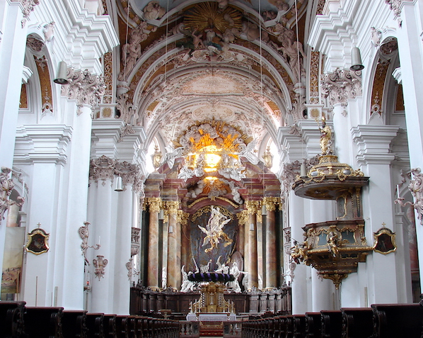

Fig. 14. Rohr, Monastery Church of the Assumption of Mary, Egid Qurin Asam, 1717-1723

7. Even more theatrical is the older brother Cosmas Damian Asam’s roughly contemporary Weltenburg (1716-1724). Theatrical is already the Danube setting. (Fig. 15) The interior presents us with an extreme example of a theatrum sacrtum. In his

Fig. 15. Weltenburg Abbey

Perspectiva pictorum et architectorum Pozzo had recommended opening the apse of a church to a light-filled stage (Fig. 16). The Asam brothers follow that recommendation

Fig. 16. Andrea Pozzo, Altar Design from the Perspectiva pictorum e architectorum

Fig. 17. Weltenburg, High Altar, St. George, Egid Quirin Asam, 1723
(Fig. 17). Cosmas Damian Asam extends it further to the nave vault (Fig. 18), into which an oval has, quite literally, been cut (Fig. 21) that allows us to see the heavenly theater painted on the flat ceiling above (Fig. 20). The nave's darkness contrasts with the light

Fig. 18. Weltenburg, View of the Fresco by Cosmas Danian Asam

Fig. 19. Weltenburg Abbey, Section and Plan

that floods the two "stages" of the main fresco and the high altar from concealed windows. The altar's Bernini columns provide less a stage architecture than a proscenium arch. Similarly the gilded statues of St. Martinus and St. Maurus, which flank the polychromed central group, are not actors in a play, but part of the frame, although they are also speakers, mediating between us and the sacred spectacle (Fig. 17). St. Maurus on the right is also a portrait of Maurus Bächl, the abbot who had called the brothers Asam to Weltenburg and to whom we therefore owe this heavenly theatre.
Cosmas Damian's fresco of the Immaculata furnishes a bright backdrop; the concealed windows, their light intensified by a hidden reflecting mirror, let us experience this image not so much as lit as itself a source of light. Silhouetted against this light, St. George on his charger possesses all the fragile elegance of a rococo knight (Fig. 20). The

Fig. 20. Weltenburg, High Altar, St. George

glittering dragon and the elegant princess hint at fairy tales —magical, but not quite to be taken seriously. Once again it is impossible to speak of illusionism. Aesthetic distance is established by the pedestal that makes this St. George a representation of a statue, recalling a host of such statues, including representations of heroic emperors and kings and of even more heroic Christian saints. A strange kind of play: the princess and the dragon threatening her are separated by a statue that does not possess their kind of reality; their colors contrast with his gold and silver, their engagement, underscored with parallel S-curves, with his seeming disregard of her plight and even of the devilish beast, which is pierced by his flaming sword. This is a remote St. George, in a trance rather than heroic. And indeed, the strength that slays the dragon is not his; the real victory belongs to her whose light illuminates him, light that is intensified by a hidden reflecting mirror, let us experience this image not so much as lit as itself a source of light.

Fig. 21. Weltenburg, Nave Vault. Cosmas Damian Asam at Bottom Center
That the whole is not reality, but just artifice, a theatrical spectacle produced by the two brothers is shown by the way they inserted themselves into their production: here Egid Quirin’s thus shows Cosmas Damian, who appears to have been responsible for the general design and the frescoes, looking down into the church below (Fig. 21) Cosmas Damian reciprocated by portraying his brother in the fresco. The close collaboration of the two brothers here as in so many other churches, can be assumed. (Fig. 22)

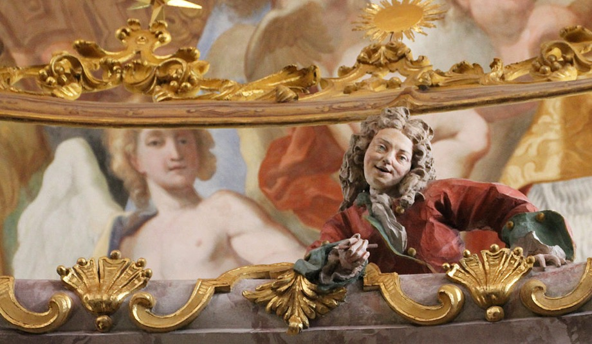

Fig. 22. Weltenburg, The Asam Brothers

8. Dominikus Zimmermann's Johanneskirche in Landsberg (1750-54) (Fig. 23) offers a much more modest high Rococo counterpart to the theater the Asam brothers had staged at Weltenburg (Fig. 24). Once again the darker nave contrasts with a bright choir, illuminated by hidden windows, although in the Landsberg church everything has become lighter. White and pastels dominate. As at Weltenburg, a figural group, here representing Christ's Baptism, is placed before a painted backdrop. Figures and the landscape background both are the rather uninspired work of local artists. Far more interesting is Zimmermann's curious rocaille altar architecture and the choice of colors.

Fig. 23. Landsberg am Lech, Johanneskirche

Fig. 24. Landsberg, Johanneskirehe

9. Let me conclude by returning to Rottenbuch, a fundamentally Romanesque church decorated by Joseph Schmuzer (Fig. 1, 7). The high altar here is the work of the Weilheim sculptor Franz Xaver Schmädl (Fig. 25). Although unusually elaborate, in

Fig. 25. Rottenbuch, High Altar, 1750
keeping with the importance of the Augustinian Rottenbuch, it yet may stand for countless other altars that show the influence of Bernini as mediated by the brothers Asam. Behind the free-standing mensa with the tabernacle, flanked by gilded statues of Peter and Paul, rises a typical column architecture, supported by a massive pedestal and crowned by a broken pediment. Characteristic, too, is the horde of putti who frolic in this altar, as they do throughout this church. The theater is suggested not only by the dramatic placement of the main figures and by the way the altar's columns provide a stage-architecture, but by the curtain motif, which appears here not once, but twice, suggesting once again theater within theater. Putti draw these curtains or rather play with them. Their playfulness makes it difficult to take the theater that they present, and over which they seem to preside, too seriously. In the gable we see God the Father (Fig. 26),

Fig. 26, Rottenbuch, High Altar, Detail
surrounded by more putti, bathed in that golden Bernini light the Asam brothers brought to Bavaria. His right hand raised in blessing. He looks down from His height. Below, before a small, empty bed that forms the painted backdrop, Joachim and Anna, their heads and hands raised in humble expectation, await the imminent birth of the Virgin. (Fig. 27) The central part of the altar attempts to unveil the mystery of that birth. Above

Fig. 27. Rottenbuch, High Altar, Detail

the still empty bed the Virgin as child descends on a cloud, enveloped in gleaming rays. In this child divine grace and human expectation meet; heaven and earth are gathered together. Putti carry the familiar symbols of the antiphon: "Who is this that looks forth like the dawn, fair as the moon, bright as the sun, terrible as an army with Banners?" Another putto points to a pearl in an open shell, the traditional symbol of miraculous conception. The birth of the Virgin is the dawn that announces the coming of the sun, of Jesus Christ. The mensa below reminds us of His redeeming sacrifice.
The curtain of this play within a play is supported by a large half-shell, a familiar Marian symbol, which at the same time functions as God's throne. The Virgin, who bears Him Who bears all things, is the throne of God. A second half-shell in the gable forms a sheltering baldachin. Together these two half-shells enclose the Deity.
Thy Makers maker, and thy Fathers mother; Thou' hast light in darke; and shutst in little roome, Immensity cloysterd in thy deare wombe. (Donne, Annunciation)
The child we see below is the mother of Him Who sent her forth.
To this paradox the theatre cannot do justice. The sculptor's scenic approach has to break down before the central mystery of the Virgin's birth. Just as the fresco painters of the Rococo were often content to express the central mystery of their faith with the geometric symbol of the Trinity, so in the very center of the altar we see no longer theatre, but the monogram of the Virgin, its crown signifying that she, who is both child and mother of God, is also His bride and queen of heaven.
Fascinated as they were by the theatre, those who were responsible for this altar were aware of the inadequacy of all theatrical representations of the mysteries of faith. Despite their fondness for rhetoric, for grand gestures, they remained aware of the superficiality of their art, of their inability to carry us to the core of what matters. In this diffidence born of faith the play with the theatre has its foundation. Emphasis on the theatre's theatricality is a device to prevent us from taking it too seriously. That device is raised to a higher power when the more profound mysteries of faith are presented as theatre within theatre. And further, this second theatre, pushing closer to the central mystery, has to become emblematic and less scenic. The image of the child is thus joined to the symbol of the shell. Together, they point to the mystery that finds expression in the name Maria. (Fig. 28)

Fig. 28. Rottenbuch, High Altar

