Corey Warner
Joan Perisse
ENG170-41
Research Journal
12 April 2020
Argument Research Proposal

General to specific: Social Issue- Ignorance- Hypocrisy- The Church is hypocritical against Homosexaulity.- Depicts as a “love thy all” institution but, shames homosexuals and in all reality is a devoted “god doesn’t like gays” institution.

Research Question: Is the church a hypocritical institution that portrays itself as a benevolent community that advocates love for all of God’s children while leading a crusade against homosexuals and stigmatizing them?
Thesis: The Church is a hypocritical institution and should be held accountable because they preach a dogma of love and acceptance, yet they reject homosexuals.
Three Pro Points:
- The insitution will only accept homsexuals if they “find God,”and get rid of their homsexuality because that’s the only way God will accept them.
- The institution stands as men who know that they can’t judge but still judge other men and women.
- The institution follows a mantra that God Loves us all, then all are homosexuals as well should be loved and not rejected from the church.
Why do I want to write this argument?: I feel very passionately about this because I am a gay man who was raised in a christian household and believe in the faith very much so, but it hardens my heart when I hear my fellow christians bash gay men and woman and tell them that God doesn’t love them when the Universal message that everyone has about God, is that he loves all. I got sick a tired of it and I want to call the church out as both a christian and a gay man because that’s not what our faith is about nor will I sit back and be quiet and take the abuse against me or my LGBTQA+ community.

Visiting Place

The visiting place I decided to focus on is the Movie called: I am Michael. I am Michael is a movie that is perfect for my topic. The movie is a basically about Christianity and Homosexuality and the layers of it and what those layers are and the perspectives on it. This movie showcases the idea that the Church is a hypocritical institution, and it’s a different type of perspective as well. This movie is based on a true story, it’s about a gay activist and his boyfriend clashing with the church, and the gay activist actually turned to anti-gay christian pastor. I feel like this movie is perfect because it’s takes you into the setting of the church and gay people. And what that dynamic looks like.

Interview

The person I’m interviewing is a fellow student named Brianna Hicks.

What is your role in the Church?
-I am a youth minister

What is a youth minister r?
- A youth leader is a leader of the church who reaches out to millenials or the world outside the church to get other youths to the church and teach them the modern way of God’s word.

What do you do as a Youth minister?
- Outreach of new youths.

How long have you been a youth minister?
-3 years

Would you say that the church and being a youth leader plays a prominent part in your lifestyle?
-Yes, I try to be an example of the church inside of the church’s wall and outside of their walls by representing them.

Being a product of the church, have you ever found any challenges when it comes to outreach of youths?
-Yes, because there is a trust gap. Because a lot of people live a certain way, and since me being the role that I play I feel like there is conflict. And me being the type of person I am, I don’t want people to feel that the church is going to judge the youths I bring in for their lifestyle.
Have you ever found yourself a youthful lifestyle?
Not intentionally. And in the bible God doesn't give us that power to judge. And that’s not who I am as a person.

Have you ever experienced any type of judgement from the church towards individuals?
-Yes, all the time. I have experienced young and older people leave the church because they were in the church.

Do you think that the Church’s holier than thou persona is real or hypocritical?
-I think it is hypocritical because those certain individuals have gone through bad things and done bad things before they found God. If they were perfect then there wouldn’t be no reason for god.

Are you familiar with the dogma that God loves all his children?
-yes

Do you stand by that dogma?
-yes

Does the church stand by that dogma?
Yes. to an extent.

What's the extent?
They feel like God made their children a particular certain way.

Are you familair with homosexuality?
-Yes

Is the church familair with homosexuality?
- “All too well.”

Would you consider homosexuals to be God’s children?
- I feel like we are all god’s children before we title ourselves.

So since homosexuals now title themselves as “homosexuals.” are they still under the umbrella of God’s children?
-I would say that yes they are. God isn’t happy with their actions but he still loves them.

Since the church stands by the dogma that God loves all his children, do you think it’s hypocritical for the Church to be leading a crusuade agaist homiosexuals?
-No because they are following God’s word and that’s the faith.

So leading a crusade against homosexuals is God’s word?
-No.

Do you find it ignorant for men to interpret God’s non acceptance of homosexuality as leading a crusade against homosexuals?
-No because I think the bible is for one’s interpretation.

Do you personally accept homosexuals?
-I don’t , I have respect for them but I do not agree with what they do.

So you would reject homosexuals?
-No, they're people as well.

Do you think the church would accept homosexuals?
-it depends

Do you find it ignorant that as an institution a part of the society preaches and pleads a word that is interpreted by man?
No, because I believe that your faith can’t correlate as ignorance.

Is the church a hypocritical institution that portrays itself as a benevolent community that advocates love for all of God’s children while leading a crusade against homosexuals and stigmatizing them?
-I don’t think that they are leading a crusade of them, they’re not isolating them. I find it is that they don’t treat them as any different and that they just don’t accept what they do?

Is having homosexuals as your friends corrupt your belief?
-No.

Is it ignorant of you to only accept your beliefs and no one else's?
-No. It’s my decision. I’m willing to hear it, but not accept it.

Artifacts

Bible: The Bible is a book consisting of Christian scriptures, which is held in both of the Old and New Testaments of the Bible. It is similar to the Torah which is a book consisting of Jewish Cultures. The reason why I chose this as an artifact to resemble my topic, well because the bible is a major influence on how ministers, popes, etc. express the “word” of God. and in this Bible there are scriptures that discriminate against homosexuals but then they say in the Bible that everyone on this Earth is God’s children and that he loves everybody. So that being said the bible is a major influence in the discrimnation of homsexuals but then it’s also a major influence in the hypocrisy of the institution that they call a church. So it relates to my argument that the Church is a hypocritical institution by leading a halt against homosexuals while preaching that God loves all his people and it’s due to the word of man that is the Bible.

Rainbow Flag: The rainbow flag is a flag that resembles Gay Pride and all the colors of the pride represent each category of the LGBTQ community. The Lgbtq community is the biggest element of this argument, so I chose an artifact that resembles the esscence of the Lgbtq community. The reason I chose this as an artifact because it represents the Lgbtq culture and what they believe ion and since they are being ostracized by the church and others they have no choice to build their own community and stand for who they are and demand equality as a persona and demand respect in a society they are a part of.

Cathedral/ Church: The church is another major key in this whole argument. And for this artifact I chose the place of worship of christians and christianity : the cathedral. The church resembles a lot of things, one of the things it resembles itself as an institution and unified front against anything that they believe is associated with the devil, and if you want to be accepted then you must turn towards God and compromise your own beliefs, take theirs as yours and be a different person. The reason why I chose the church as an artifact is because it shows that this holy institution is said to be a safe place but, it’s not a safe place for homosexuals, for them it’s a place of condemnation. So it will exemplify that it’s a hypocritical institution.

Electric Chair: The electric chair is the next artifact that I chose to resemble what my topic is about and what I plan to show and convey in this as a whole. The electric chair resembles the conversion therapy that back in the old times, they held comversion camps in churches and they tried to shock the “gay” out of homosexuals. So the reason I chose this artifact is because it resembles the history of the decades of feuding that homosexuals and chrisitiaity has run into, and that acceptance was never the first response, and that the first response was to change homosexuals because they didn’t understand who homosexuals are.

Gay Marriage Certificate: For the next and last artifact, I chose is a gay marriage certficate. The reason why I chose this as an artifact is because it shows what homosexuals want, and that they want the same as straight people and that is to be allowed to have a marriage certificate. This also shows what the church and christianity is really against that, and that is for two men or two women to join in a union and commitment and that’s because they take marriage as a holy union so anyone of the lgbtq community does it, it’s against that. This is another example of their unfair, and hypocritical beliefs, and that the institution as a whole is full of hypocrisy.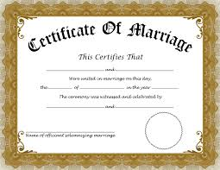
Archives

The first Archive is a scripture or text from the Bible. “Homosexuality refers to relations between men or between women who experience an exclusive or predominant sexual attraction toward persons of the same sex. It has taken a great variety of forms through the centuries and in different cultures. It’s psychological genesis remains largely unexplained. Basing itself on sacred scripture, which presents homosexual acts as acts of grave depravity, tradition has always declared that “homosexual acts are intrinsically disordered.” They are contrary to natural law. They close the sexual act to the gift of life. They do not proceed from a genuine affective and sexual complementarity. Under no circumstances can they be approved.”
~This represents my topic because it’s a scripture and it’s a belief that Christiamity has on Homosexuality.
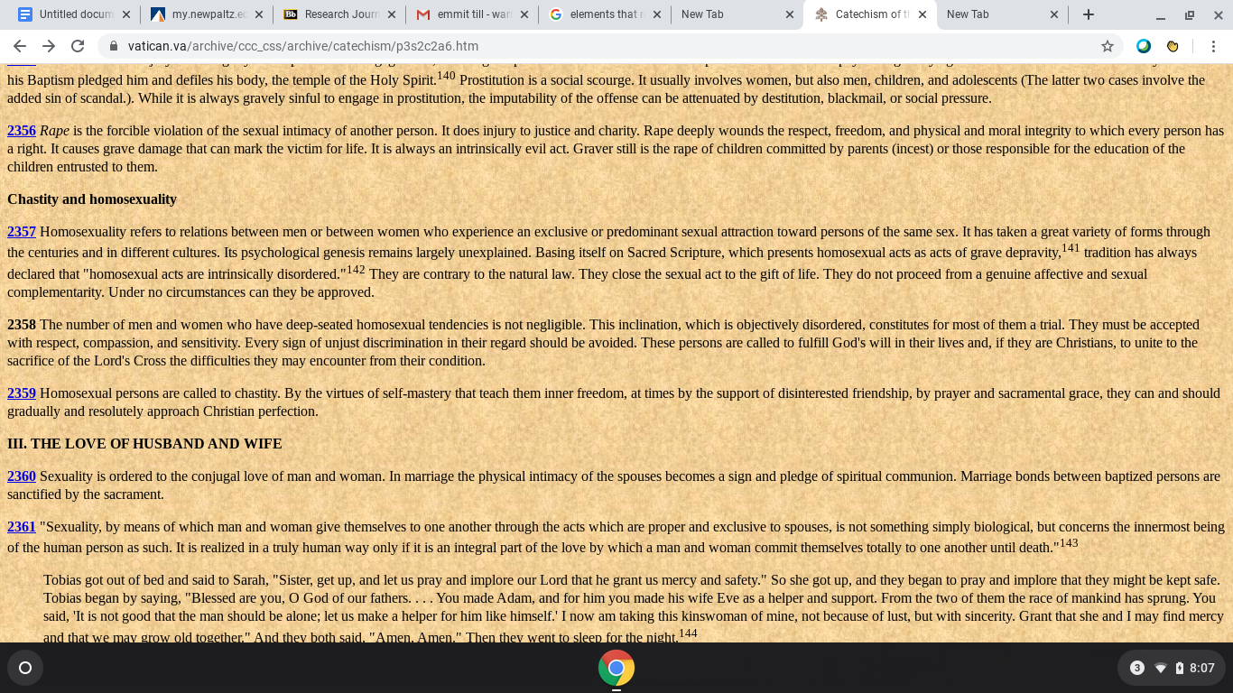

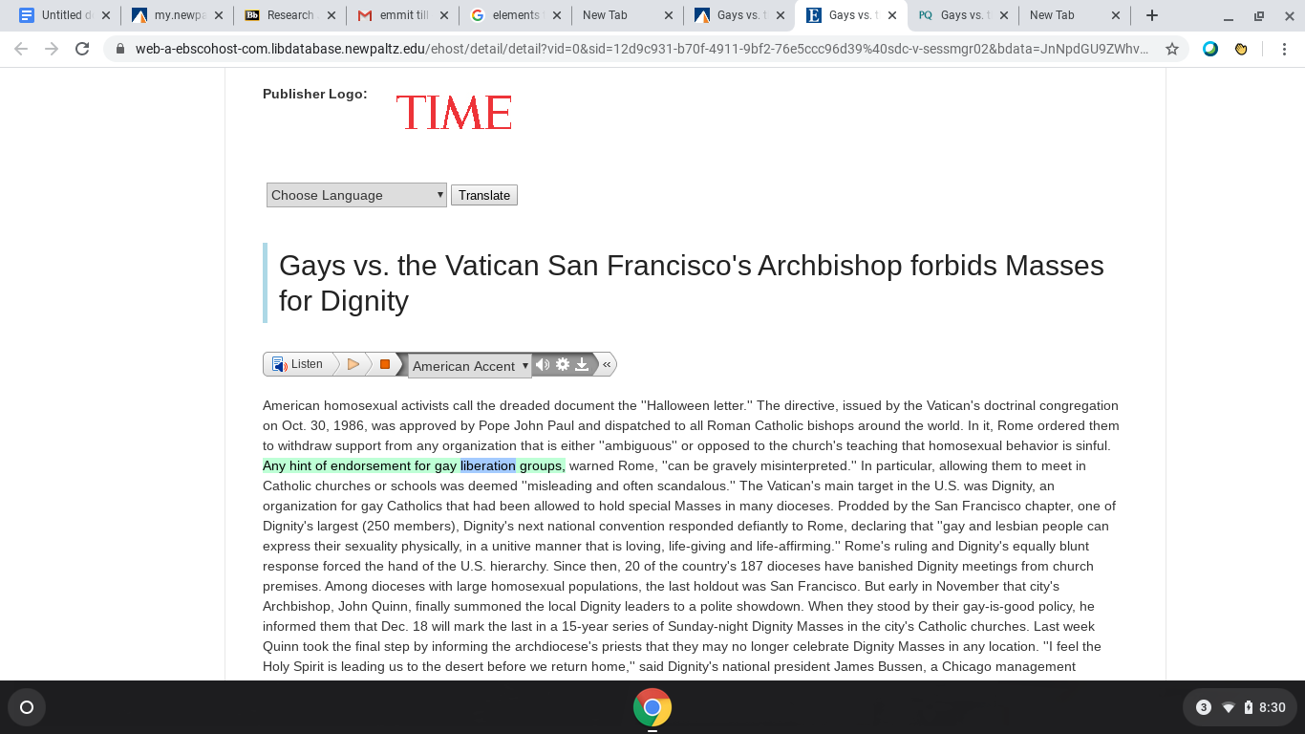
The next archive is an article that was published back in 1988. The article is referencing the Roman Catholic Church. Basically it’s talking about that the Roman Cattholi Church is withdrawing any support from any organization that is opposed to the church’s teachings that homosexual behavior is sinful, and any endorcement of that behavior their support will be with drawn from the company and organization. This represents my topic because it shows that the back then they had the same views of homosexual behavior to the point that they will stop supporting any organization that is affiliated with homosexuality and endorces that “sinful” behavior. It supports their leading a crusade against homosexuals part of my topic.

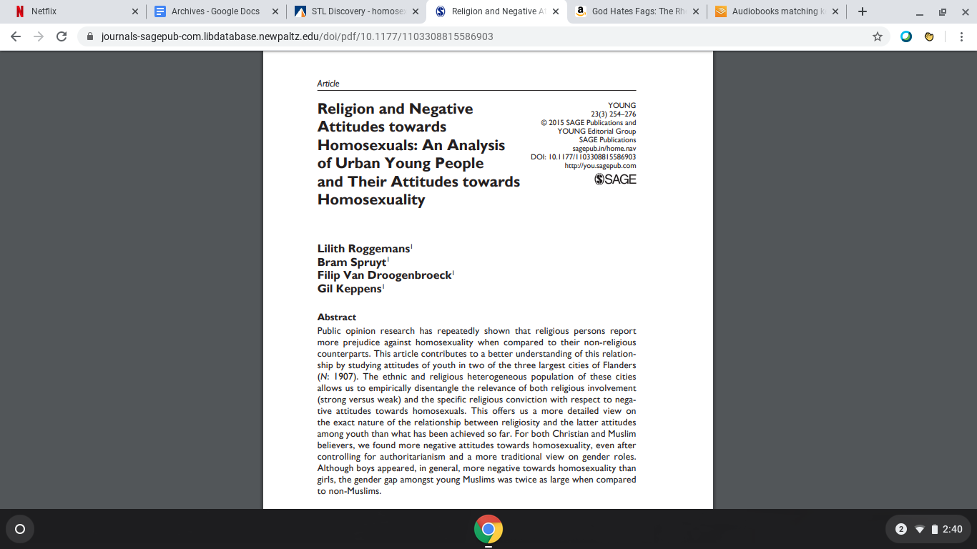
This archive is a peer reviewed article from 2015. The article is explaining what or making us understand the relationship between religion and homosexuals, and why religion and religious officials hold hatred and prejudice against homosexuals. And even they also get the standpoints of other people who are non religious or don’t identify themselves as one who doesn’t believe in power or even people who don’t practice religion very seriously to show the contrast between the church’s standpoint. The reason I chose this article is because it's yet another article that emphasizes that the church is leading a war against homosexuals but still stands for the dama that God loves us all, but yet immediately deem homosexuals as the devil and not God’s children. So I found this article to be the perfect one for my topic.

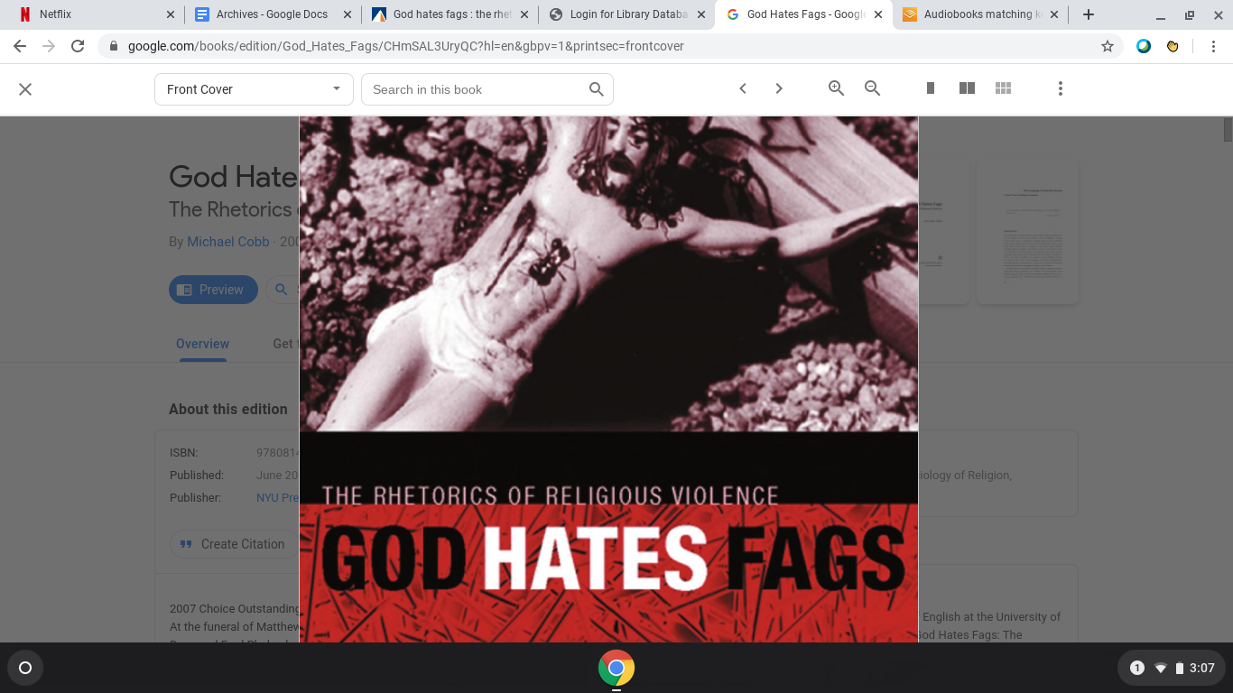
The next archive that I chose for my topic is a book. The title of the book is called “God hates Fags” there you can assume what this book is about. This book is going to show how the holy church masks their religious violence behind this holier than thou persona.

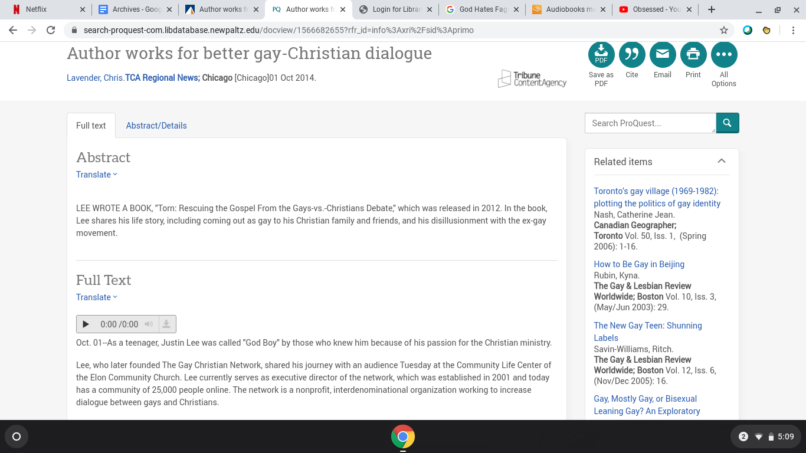
For my last archive, I have choses a newspaper article, that is about an open gya christian male, and he talks about what his role is in the gay community while still be present in the church, and how he recieves backlash and hatred from the church because he is gay and refuses to conform, so this matches perfectly with my topic, because it’s interesting to get the point of view from a man who is both gay and religous and how you can be both, and how the church’s hypocrisy stops that process from happening.

Annotated Bibliography

1st Source: Interview with Brianna Hicks.
Summarization: The interview with Brianna Hicks was overall very insightful. She symbolized the Church as an institution in her standpoint. She was very pro Church, but at the same time she said some things that resembled my points and standpoints. She is a youth minister, so her role in the church is prominent, and especially because what she is teaching other youths matters, if or if not they want to align with the church and be a part of that community.
Validity: The validity is something shouldn’t be questioned. I conducted this interview myself, and came up with the questions myself. And for all of Brianna’s responses they come from personal testimony and experience that she can talk on. She has knowledge of what the Church believes and what she believes, since being a youth minister, and she is very active in making the Church a part of her lifestyle.
Evaluation: I think this is honestly relevant to my topic, yes she stands with the church is she basically in favor of them and arguing against them but I want to use the information that she has told me and counterclaim it. Her points will be very good for me to argue against and make my argument stronger.

2nd Source: Newspaper Article
Citation: Lavender, Chris. “Author Works for Better Gay-Christian Dialogue.” TCA Regional News, Tribune Content Agency LLC, 1 Oct. 2014, http://search.proquest.com/docview/1566682655/.
Summarization: This newspaper is basically summarizing that the person who wrote this article wants a better relationship between homosexuals and the christians. The author is an open gay man who also identifies as a christian male. And he is basically talking about the relationship in general and his own personal relationship, while also showing how the Church preaches one thing but does another when it comes to homosexuals.
Validity: This is yet another personal testimony, and experience. And it gives both sides of the views since therefore he is on both sides of the spectrum, so I consider this newspaper article to be valid.
Evaluation: I think this newspaper will be different and add another layer to my argument since he is both christian/religious plus being homosexual. So if I were to evaluate this, it wouldn't be my strongest source but it would be a layer that I don't have and it will support my argument in this topic.

3rd Source: Book
Citation: Cobb, Michael L. God Hates Fags : the Rhetorics of Religious Violence . New York University Press, 2006.
Summarization: I haven’t fully read the book, but the details I can give you is that talks about the presecne of the Church and how the Church presents themselves as a community that hates homosexuals to the point that they use terminology like “fags” and they persecute them for being who they are. And it’s about a gay man who was murderd because he was gay and tried to cover it behind the Church and claim it was God’s plan and that he was doing God’s work.
Validity: I think this source is very much reliable, this book is known and published and it’s based on a real life true story.
Evaluation: This will be one of my strongest sources. It’s showing me how the Church or someone who resignates as the church and murder a gay man and get his followers to help him because the man is homosexual and them trying to cover it up and say they are doing God’s work and masking themselves as this holier than thou persona.

4thSource: A “Time” Article
Citation: Ostling, Richard N. “Gays Vs. the Vatican; San Francisco’s Archbishop Forbids Masses for Dignity. (Archbishop John Quinn).” Time, vol. 132, no. 23, Time, Inc., Dec. 1988.
Summarization: This article is about The roman catholic Church withdrawing their support from any company or organization that is opposed to the teachings that homosexual behavior is “sinful,” and that anyone who endorses that behavior will lose their support.
Validity: I consider this to be a valid source, because this is the Catholic’s decision and they are making it known and public. So I consider this to be very much valid.
Evaluation: This is a good source for my argument that will allow me to show that the church can’t live by this dogma while they are punishing anyone who supports homosexuals just to spite homosexuals.

5th Source: Peer Reviewed Article
Citation: Roggemans, Lilith, et al. “Religion and Negative Attitudes Towards Homosexuals: An Analysis of Urban Young People and Their Attitudes Towards Homosexuality.” Young, vol. 23, no. 3, SAGE Publications, Aug. 2015, pp. 254–76, doi:10.1177/1103308815586903.
Summarization: This article is about the making of the relationship between religion, the church and homosexuals and why it’s toxic.
Validity: This a valid source. It’s peer evaluated.
Evaluation: The points in this piece will help my argument stronger when it comes to my topic, and expose the church for their hypocrisy and negativity.

6th Source: Article
Citation: Van Keuren, Graham. “Gays and the Church.” The Christian Century, vol. 118, no. 9, The Christian Century Foundation, Mar. 2001.
Summarization: This about gays and homosexuals identifying that if they want a relationship with the church they are going to have to undergo spiritual abuse, because the Church rejects them as homosexuals and people.
Validity: This is a valid source.
Evaluation: This is good for me and useful to me because this falls right into my points for my argument on this topic.

