Building an Electromagnet
Grade 4
Marci Howdyshell and Lisa Ruman

This lesson consists of two 30-minute stations: Electromagnetics and the Emergency Flashlight. It would be best to divide the class into two and switch after 30 minutes.

Materials: (students should be in groups of 3-5 students each):

Electromagnetic:
1 three foot long wire (per group)
1 nail (per group)
2 batteries in holders (per group)
metal paper clips (10 per group)
1 worksheet per student

Emergency Flashlight:
Foil
Pencils
D-Cell Batteries
Light Bulbs
Rubber Bands
Toothpicks (as a tool)
Sandwich bags (to distribute supply kits to students)

Content Standards/Benchmarks:

- Energy transfers from hot objects to cold objects as heat, resulting in a temperature change.
- Electric circuits require a complete loop of conducting materials through which an electrical energy can be transferred.
- Electricity and magnetism are closely related.

- Note 3: Knowing the specifics of electromagnetism is not appropriate at this grade level. At this point, the connections between electricity and magnetism are kept strictly experiential and observational.

Initial Introduction:

Begin by introducing yourself to the students in your group. Tell them a little bit about what you study and give them an opportunity to ask you questions.

Discuss terms related to this experiment. (For example: current, circuit, battery, wire, conductor, magnet). Ensure that they understand how a basic circuit works and what components it needs. Talk about what they know about magnets. Tell them that they will be making an electromagnet.

Procedure:

- The students work in groups, but take them through the process step by step. Ask them many questions such as “What do you think will happen when you do this?” before the step and “What are your observations?” or “What happened?” after the step
- Each group should begin by attempting to pick up paperclips by touching the nail to the paperclips. They should record their observations on their lab worksheet. This is a histogram, so help them to fill it out as they go.
- They must then wind a piece of wire (about 1-2 feet long) around their nail, tightly coiled with a few inches sticking out from each end. Have them wrap it 10 times, and record the results.
- Have the students complete the bar graph by recording their results after wrapping the wire 20, 30, then 40 times.
- If time allows, show them how to use alligator clips to connect the end of the coil to the end of the battery holder. The key point here is that metal had to touch metal; otherwise the electrons wouldn’t be able to flow through the circuit and create a current.
- Once the circuit is complete, they should again attempt to pick up the paperclips by touching the nail to the paperclips. All observations should be recorded.
- If there is remaining time, A volunteer can fill out a large bar graph on a white or chalk board with the whole class’s observations.

Target Observations:

- Students should notice that the circuit they made had to be a complete loop, there had to be a conductor making up that loop for the electrons to travel through, and there must be a battery to push the electrons through the circuit.
- Students should notice that when the nail is not connected to the circuit, it does not pick up paperclips. However, when it is connected to the circuit, an electromagnet is created.
- Students should conclude that electricity and magnetism are related.
- Electromagnets may be turned on and off by simply disconnecting and reconnecting the circuit.
- The students may relate this to life outside of school in a number of ways. One example is a large electromagnet that is used to pick up scrap metal in junkyards.

Emergency Flashlight
Split up the students into groups of two and hand each group 4 Hershey’s kisses and the “Emergency Flashlight” bag (which contains a pencil, a D cell battery, a small bulb, 3 rubber bands and a tooth pick)
- Ask the students what they think they can make out of this
- Ask the students how they would make it
- Once they get the idea that they can turn the light on, explain that once the circuit is connected that electricity is flowing through it and that they must be careful – stress that they must use the “tool” (the toothpick) to close the circuit so that they are being safe
- Tell the students that they must use everything in their emergency flashlight kit bag (using the toothpick as a tool) and let them work in pairs to make their flashlight.
  - If more foil is needed than the Hershey’s Kisses has you can give them extra foil from the roll. Each student can eat 2 of the kisses after they figure out they need to use the foil.
- When it’s time to move to the next station, take apart the kits and return to baggies to be reused by the next group – pass out 1 pencil and 4 kisses per group Let each student take a pencil (there are extras in the box)

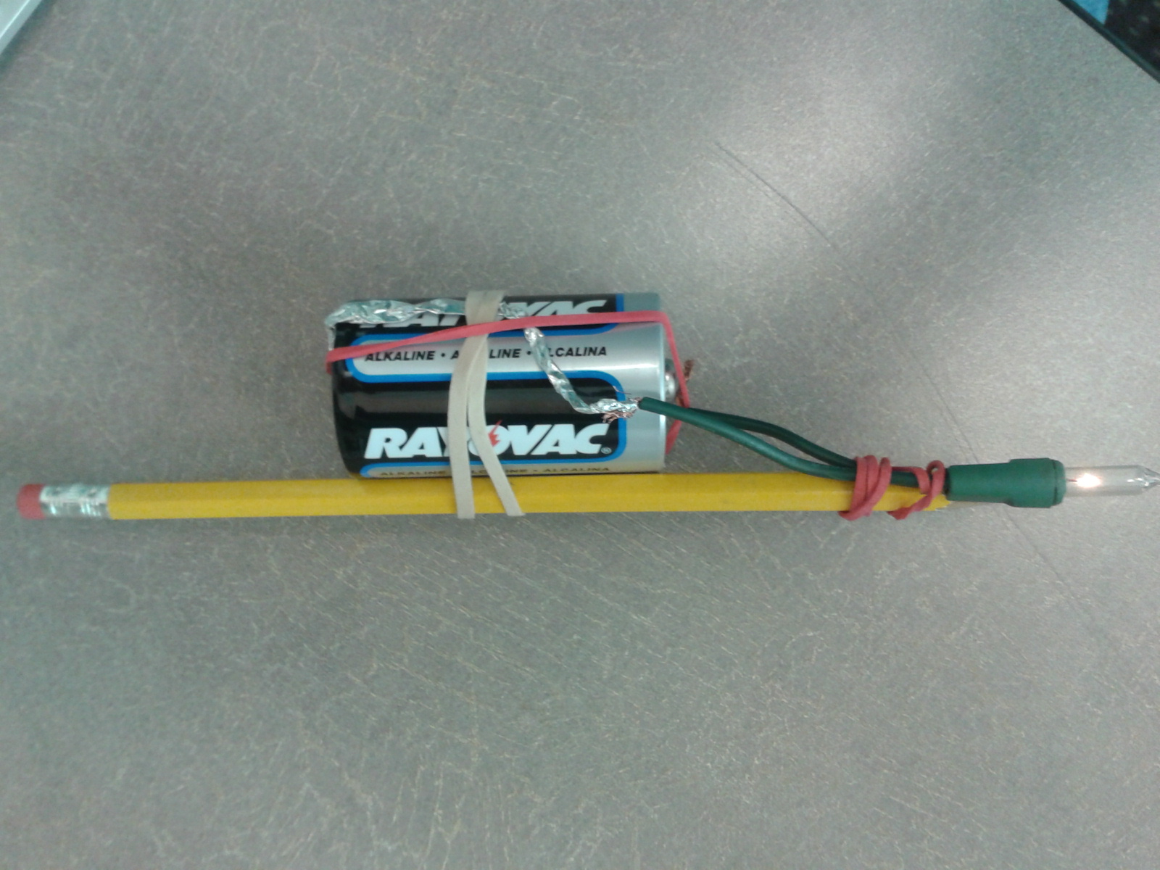
The point of this station is to allow the students to use their knowledge of circuits to build a circuit with the provided materials.

**It is very important to teach electrical safety with this lesson. Explain to the students that they should NOT touch any hot wires; ensure that they use the toothpick as a tool to close the circuit**

Worksheet: Creating an Electromagnet Name____________________

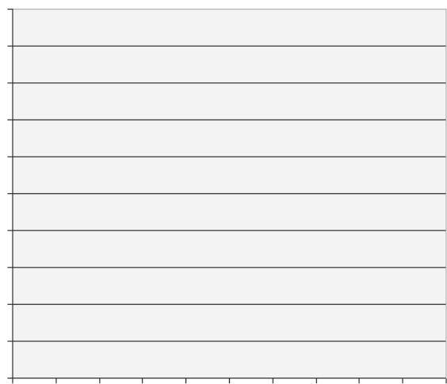
Electromagnet wrapped 40 times with wire

Electromagnet wrapped 20 times with wire

Electromagnet wrapped 30 times with wire

Nail Only

Electromagnet wrapped 10 times with wire

Instructions: Create a bar graph. Label the Y (up and down) axis with the number of paperclips picked up (from 1 to 10). Run an experiment for each number of wraps. Draw bars to show how many paperclips were picked up with each. What information does the graph show you about your experiment? Write your answer below.

