Planting
1st grade
http://www.saps.org.uk/primary/teaching-resources/639-growing-seeds-in-a-plastic-bag
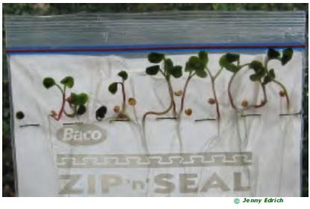

Materials:
- Seeds
- Water
- Pre-stapled sandwich bags
- Tape

Procedure:
- Students will be divided into smaller groups. Each group will have 1 sandwich bag. The students can write their names on the bag, and the type of seeds they will be planting.
- Students will add water to the sandwich bag. Add enough water to the bag so that the paper towel soaks up the water and there is a small 2 – 3 cm reservoir of water at the bottom.
- Students will add the seeds to the bag above the stapled line.
- Seal up the bag tight so that there is little to no air in the bag.
- Teachers can decide where to put the seed bags (can be taped to a window or a wall)
- Volunteers will have a discussion with the students about the different parts of a plant.
- Within a few days, the students will be able to see the plants germinate and grow.

