Hello MSW Students,
You may come across the terms “asynchronous” and “synchronous." on your course schedule. Please be sure to thoroughly review your schedule on Buckeyelink to confirm the delivery method of each course. Please refer to this article ( https://odee.osu.edu/news/2020/06/23/whats-difference-between-asynchronous-and-synchronous-learning ) and the examples provided below to determine if your course is asynchronous” and “synchronous." Also please be aware fee structures may look different depending on the delivery method so refer to your statement of account on Buckeyelink for costs.
What is Asynchronous Learning?
Asynchronous learning allows you to learn on your own schedule, within a certain timeframe. You can access and complete lectures, readings, homework and other learning materials at any time during a one- or two-week period. Students in the online program should be in asynchronous courses. Asynchronous class will have Days & Time “TBA”, room “Online” , and Instruction Mode” Distance Learning”
EXAMPLE
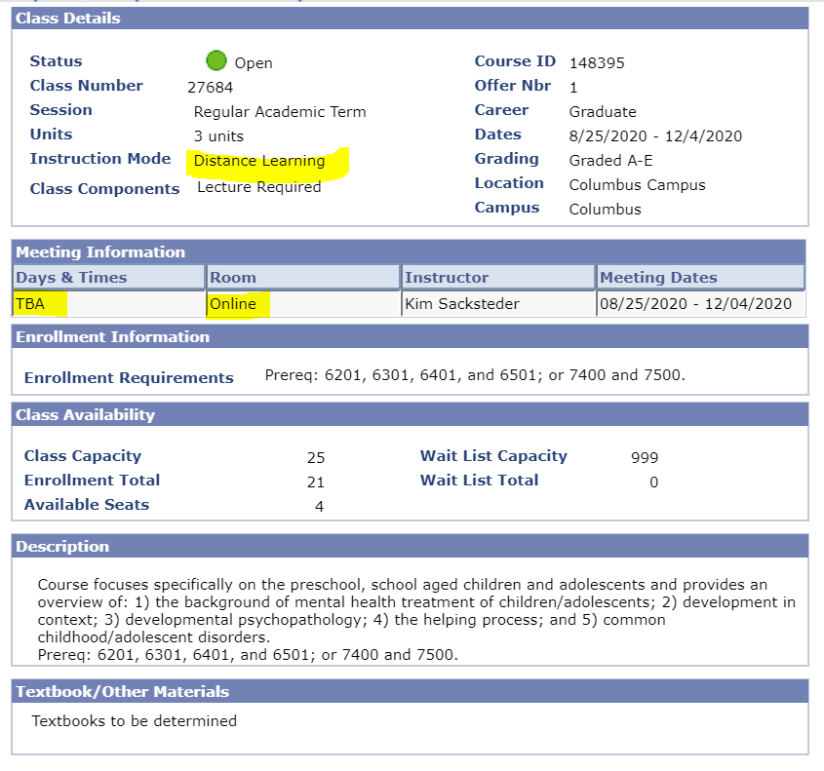

What is Synchronous Learning?
Synchronous learning means that although you will be learning from a distance, you will virtually attend a class session each week, at the same time as your instructor and classmates. Synchronous classes will have a “Days & Times” listed, room is “Online”, Instruction Mode” Distance Learning” and class note, “Synchronous”
EXAMPLE

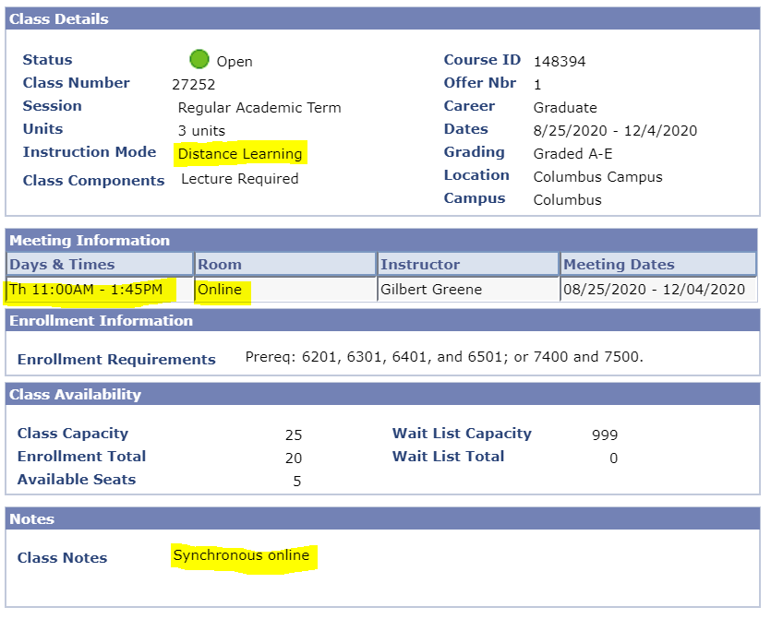
I am an online student which course delivery method should I select?
Most Online students should in asynchronous online class. There will not be a set meeting time. Please see the example provide above.
I am an on-campus student which course delivery method should I select?
Most on-campus student should be in synchronous (example provided above) and/or hybrid courses. Hybrid courses will have “Days & Times” listed, “Room” listed and Instruction Mode” Hybrid Delivery”
EXAMPLE
