**Transfer of Graduate Credit**

**In this document, you will be able to access information and instructions for the following types of graduate transfer credit.**

**Click the hyperlink to be taken to that section of the document.**

**1. Transferring a non-Ohio State Master’s Degree as a block of 30 credits to Your PhD Program (p. 1)**

**2. Transferring a non-TCHLRN-MA Ohio State Master’s Degree as a block of 30 credits to Your PhD Program (p. 4)**

**3. Transferring Credit from an External Institution OR Non-degree (GNDG) Credit earned at OSU to your Graduate Program (P. 8)**

*Note: PhD students with a TCHLRN-MA degree from Ohio State (Teaching and Learning Master of Arts) do not need to perform a procedure to transfer their master’s degree as a block of 30 credits to their PhD program.*

Graduate students can transfer credit earned at another institution provided that they attended as a graduate student and the courses completed were at the graduate level. There are three common scenarios in which transfer credit could be awarded:

* Incoming doctoral students who are transferring their master’s degree credits as a block of 30 credits toward their Ph.D. program
* Master’s or doctoral students who have completed credit at ***another institution*** either prior to, or during their program.
* Master’s or doctoral students who earned graduate non-degree credit (GNDG) and want to apply up to 9 of those credit hours toward their program

**Please note that:**

* Doctoral students can only transfer in one master’s degree.
* If doctoral students have additional credit hours beyond 30 to transfer, those credit hours must be at the doctoral level and the student must demonstrate that they attended a Ph.D. program at that institution.
* Ph.D. students must complete (at least) 24 credit hours at Ohio State.
* Master’s students must complete 80 percent of the degree requirements over at least two semesters.

**1. Transferring a non-Ohio State Master’s Degree to Your PhD Program**

To transfer a Master’s degree earned outside of Ohio State to your Ph.D. program, please submit a **Transfer of Graduate Credit Form**. (You must have submitted transcripts showing degree confirmation to be awarded the transfer of credit request.)

**Please follow the steps below to complete the Transfer of Graduate Credit form to transfer a Master’s degree earned outside of Ohio State.**

1. Log into gradforms.osu.edu (must be an active student) and select “View Enrollment Forms.”

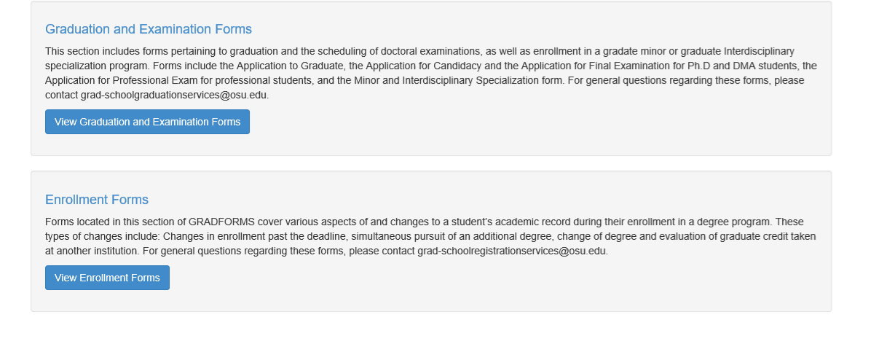



1. Select “Create New Transfer of Graduate Credit Form.”

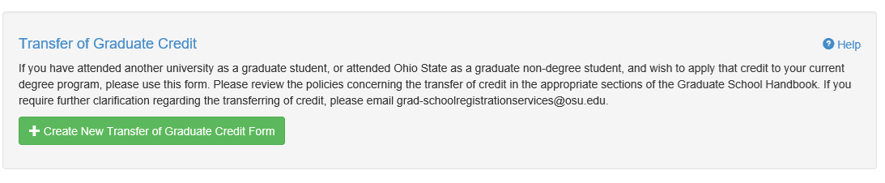



1. At the top of the form, you will need to select your ***current program*** and the type of credit (e.g., outside institution, or graduate non-degree).
2. As you scroll down, you will see the “Transfer Courses” section. If you select “Graduate non-degree”, Ohio State University will automatically populate in institution field. Please note that you may only transfer ten credit hours of graduate non-degree credit to your degree program.
3. If you completed a master’s degree at another university, type in the name of the **university** and indicate **“all courses”** and **list the number of credit hours (30)** and select the “add” button.

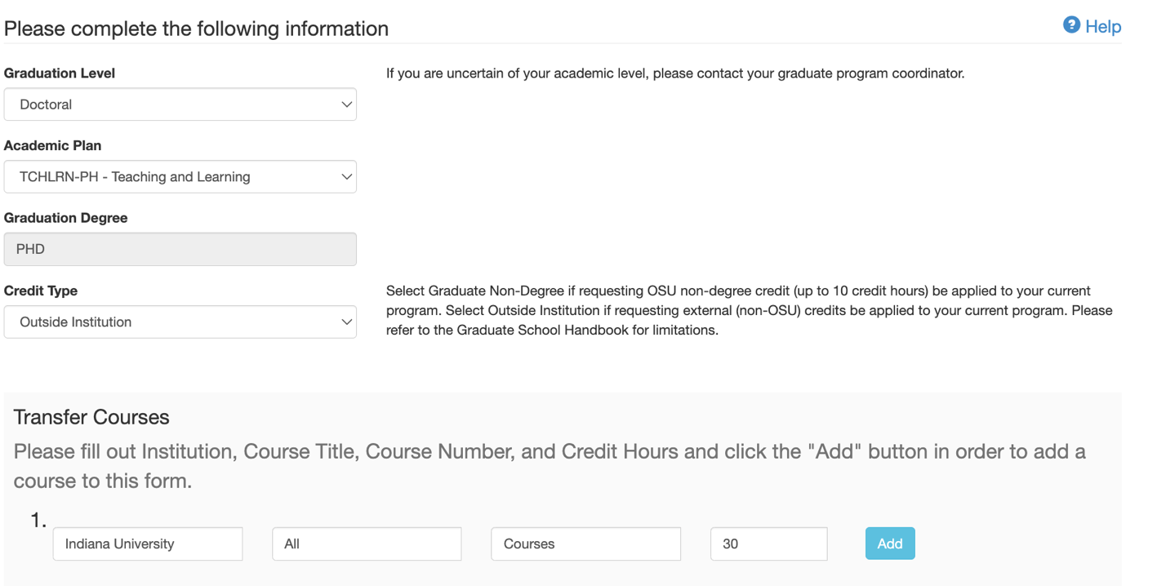

**M.A. Students select: TCHLRN-MA**

**Ph.D. Students select: TCHLRN-PH**

1. Below, “Transfer Courses,” *the advisor field is required*. Please input your assigned faculty advisor by using their **lastname.#**. Your advisor will be included as an approver of this request.



1. After submitting all of the necessary information, please select: “Save and Continue”

page3image59019120

1. The following screen should then appear. You have the option to review your request prior to submitting and are able to edit if there are errors. If there are no errors, please select “submit request.”

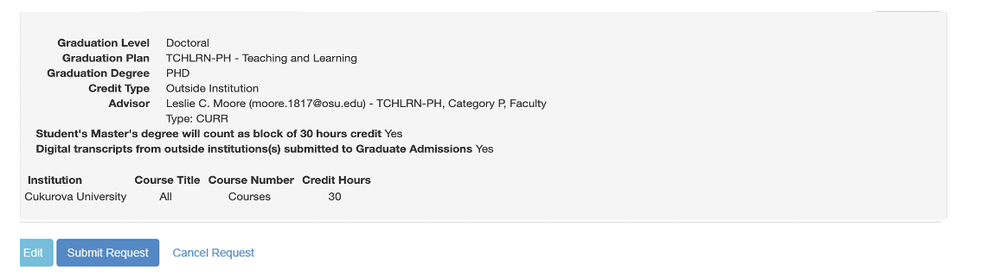



1. You will see the following notification that your form has been submitted and your Transfer of Graduate Credit form will then be sent your faculty advisor for approval. You can track the approval status by selecting “View Status.”





**2. Transferring a non-TCHLRN-MA Ohio State Master’s Degree to Your PhD Program**

OSU Graduate Students who have completed a non-TCHLRN-MA degree (a non-Master of Arts in Teaching & Learning) at The Ohio State University must transfer their master’s credit to their Ph.D. program as well. Graduates of the M.A. in Teaching & Learning, do not need to complete a credit transfer form. Graduates of the Master of Education (EDUTL-ME) and all other OSU master’s level graduates must complete their master’s degree transfer through the Committee and Examination Petition form located in Graduation Forms in gradforms.osu.edu.

**Please follow the steps below to complete the Committee and Examination Petition form to transfer a master’s degree earned at Ohio State.**

1. Log into gradforms.osu.edu (must be an active student) and select “View Graduation and Examination Forms.”





2. Click “Create New Committee and Examination Petition.”

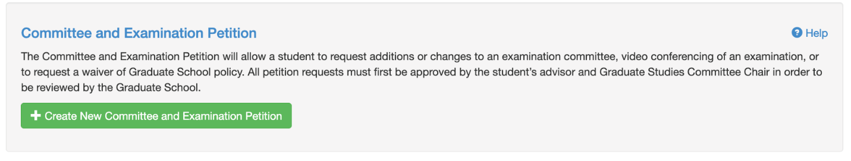



3. Under “Please fill in the following information,” select “Other,” and in the Reason for Petition field, type “Transfer [Your OSU degree plan] as a block of 30 hours to TCHLRN-PH.”

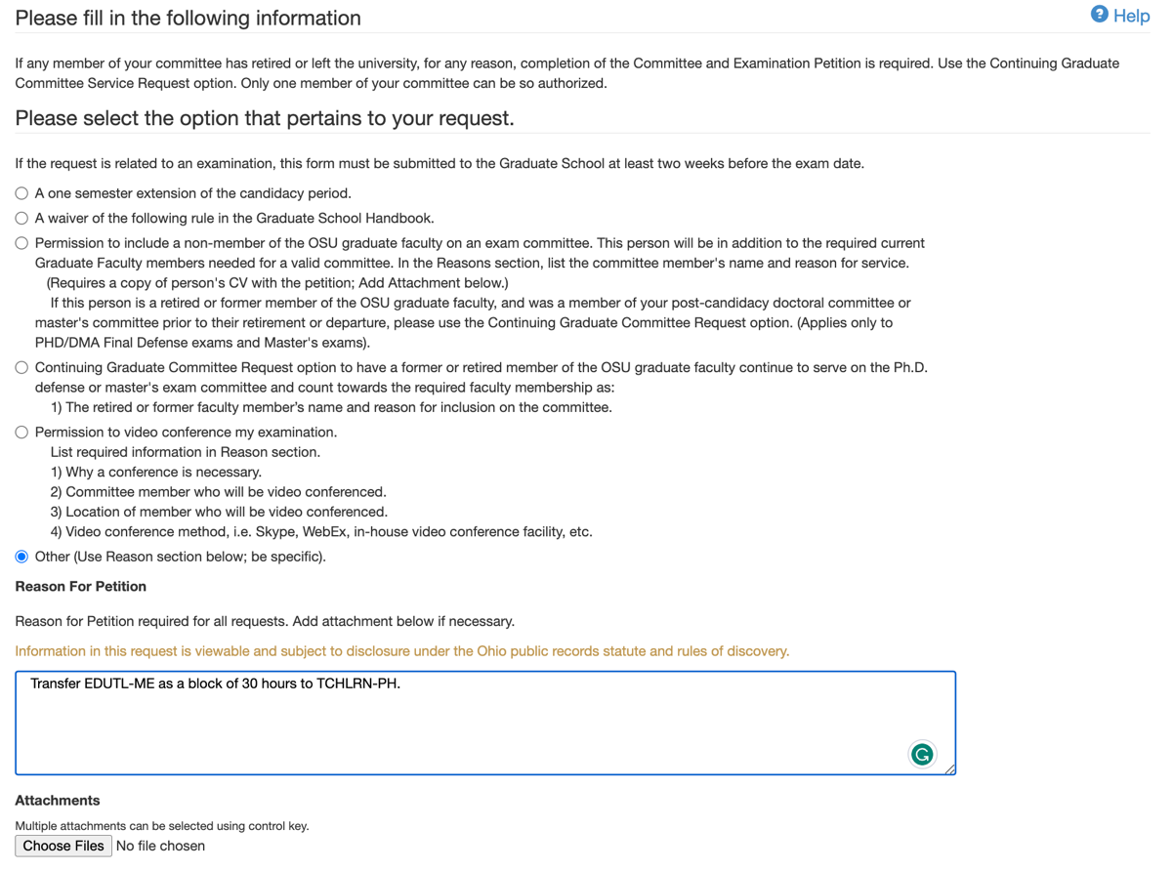

4. For ApplicationType, please choose “Application to Graduate”



5. Below, “Transfer Courses,” *the advisor field is required*. Please input your assigned faculty advisor by using their **lastname.#**. Your advisor will be included as an approver of this request.



1. After submitting all of the necessary information, please select: “Save and Continue”

page3image59019120

1. The following screen should then appear. You have the option to review your request prior to submitting and are able to edit if there are errors. If there are no errors, please select “submit request.”

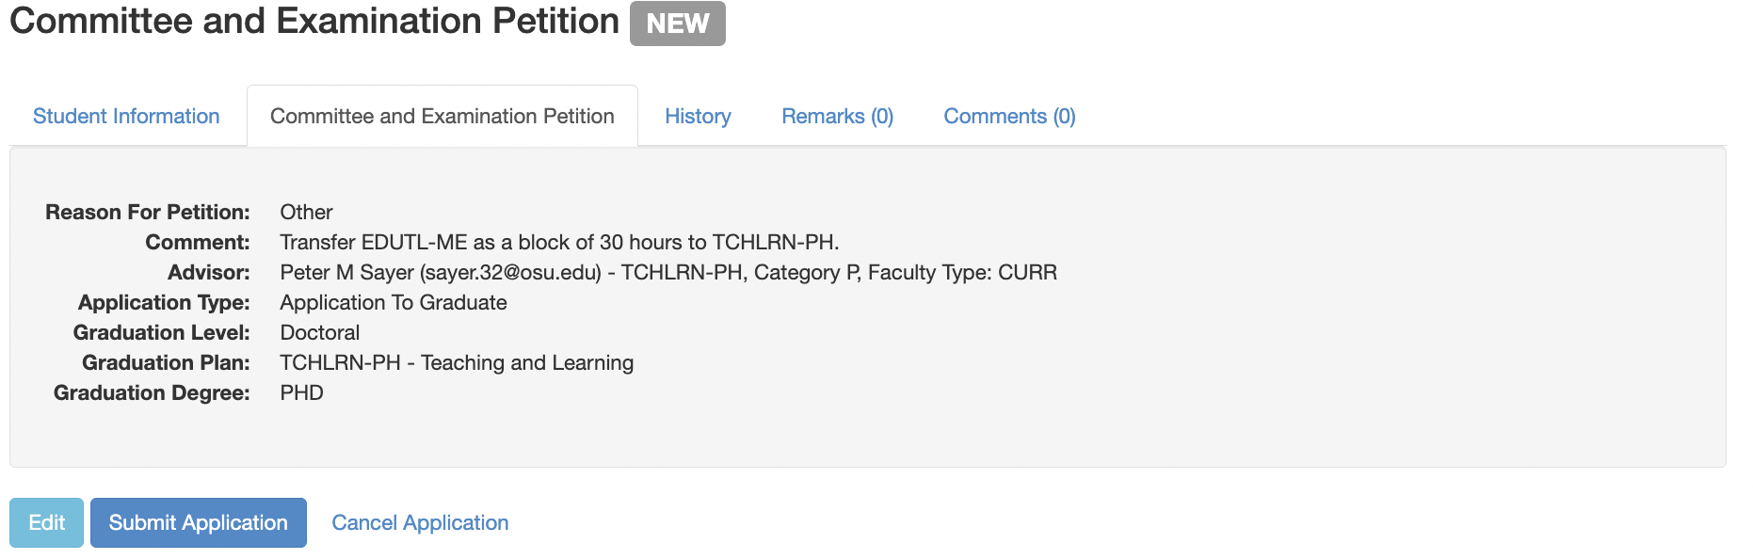



1. You will see the following notification that your form has been submitted and your Committee and Examination Petition form will then be sent your faculty advisor for approval. You can track the approval status by selecting “View Status.”





**3. Transferring Credit from an External Institution OR Non-degree (GNDG) Credit earned at OSU to your Graduate Program**

1. Log into gradforms.osu.edu (must be an active student) and select “View Enrollment Forms.”





1. Select “Create New Transfer of Graduate Credit Form.”





1. At the top of the form, you will need to select your ***current program*** and the type of credit (e.g., outside institution, or graduate non-degree).
2. As you scroll down, you will see the “Transfer Courses” section. If you select “Graduate non-degree”, Ohio State University will automatically populate in institution field. Please note that you may only transfer ten credit hours of graduate non-degree credit to your degree program.
3. Please fill out Institution, Course Title, Course Number, and Credit Hours and click the "Add" button in order to add a course to this form.
4. Type your advisors name into the last field, then click save and continue.

