Responsible Conduct of Research Curriculum
- Access BuckeyeLearn
- Search for Training
- Request Training
- Access Your Transcript
- Link to Training

Access BuckeyeLearn
- Access BuckeyeLearn: https://buckeyelearn.osu.edu
- If you are prompted to do so, log in using your name.# credentials

Search for and Request Training
- Type Responsible Conduct into the search box. When search results begin to appear, press Enter on the keyboard.
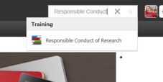
- Observe that the course term you searched for is/are listed
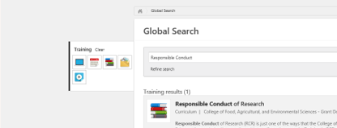
- Click on the course name, Responsible Conduct of Research
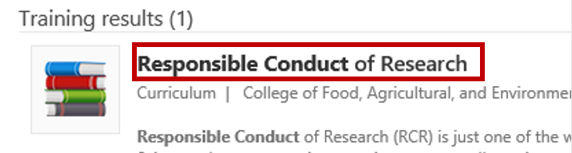
- Observe that the Training Details page opens
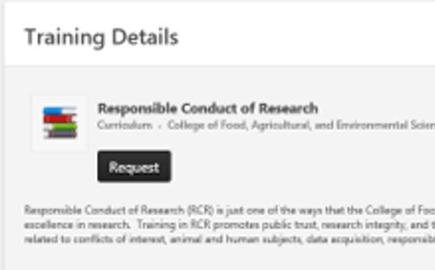
- Click Request
- Once on your transcript, click Open Curriculum to begin the training
- Complete each training section listed
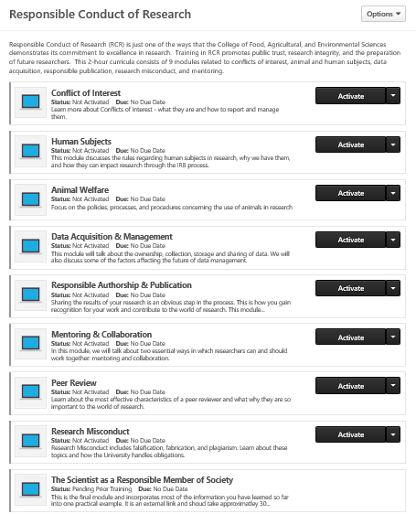

Access Your Transcript
You may not be able to finish training all at once. You can leave and come back to your training. You can access your view you progress and completed training from your transcript. To access your transcript:
- Log into BuckeyeLearn (see Access BuckeyeLearn)
- Hover over Learning, then click View Your Transcript
- Click on Open Curriculum
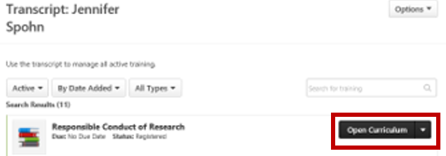
- Continue work on completing the training
- When complete, the training will automatically move to the Completed section of your transcript

Link to Training Directly
The links below will prompt you to login, and then, will launch the curriculum for you:
- Responsible Conduct of Research
This will take you to the Event Training Details page

