The Civic Culture Structure: Neighborhood Organizational Presence and Voter Turnout*

Traci Burch, Ph.D.
Assistant Professor, Political Science, Northwestern University
Research Professor, American Bar Foundation
t-burch@northwestern.edu

* Paper prepared for the American politics workshop at the University of Chicago. Draft. Please do not cite without author’s permission.
Medical and scientific researchers are slowly coming to the conclusion that population differences in health outcomes are caused, in part, by inequities in the neighborhood contexts in which people live. For instance, research shows that living in food deserts or in neighborhoods without safe green spaces for outdoor activities can increase obesity and other metabolic diseases, particularly among the poor (Alwitt and Donley 1997; Auchincloss, Diez Roux, Mujahid, Shen, Bertoni, and Carnethon 2009; Jacobs, Cook, and Delli Carpini 2009; Lopez 2007; Schafft, Jensen, and Hinrichs 2009). Likewise, the neighborhood environment has been linked to race and class differences in coronary disease (Diez-Roux, Nieto, Muntaner, Tyroler, Comstock, Shahar, Cooper, Watson, and Szklo 1997; Diez Roux, Merkin, Arnett, Chambless, Massing, Nieto, Sorlie, Szklo, P.H., Tyroler, and Watson 2001; Warren-Findlow 2006) and even mental health outcomes (Ross 2000; Sampson, Morenoff, and Gannon-Rowley 2002). Thus, at least with respect to physical and mental health, the growing consensus among experts is that neighborhood structural inequality matters for outcomes.
However, neighborhood structural explanations are less popular with respect to the political health of the United States. Instead, scholars blame many other factors for the decline in political engagement among Americans such as declining party mobilization or increasing television viewing (Putnam 2000; Rosenstone and Hansen 1993). The decreasing extent to which Americans join local membership organizations is also a prominent explanation for the decrease of political participation and engagement (Putnam 2000; Skocpol and Fiorina 1999). In particular, as Putnam and others have argued, the decline of membership in organizations led to a decline in social connectedness; social connectedness or social capital helps facilitate democracy by facilitating social trust and cooperation (Brehm and Rahn 1997; Putnam 2000). Another line of argument asserts that local membership organizations are important to participation because these organizations often engage in political activity such as organizing voter registration drives or attempting to shape legislation, so declining membership means that fewer people have the opportunity to engage in politics through these organizations (Skocpol and Fiorina 1999). Still others point out that membership in local organizations is important because organizations function as “the great free schools of democracy,” training Americans in the civic skills needed to engage in politics (Tocqueville 2000; Verba, Schlozman, and Brady 1995).
Missing from this debate, however, is a consideration of how the places in which people live can foster unequal participation in the membership organizations that are believed to be so beneficial to political engagement. In particular, I would argue that, in the same way that they differ in the extent to which they provide amenities like grocery stores and parks, neighborhoods also differ in the extent to which they provide safe, convenient opportunities to join organizations. This paper explores differences across neighborhoods with respect to organizational capacity, or the number of organizations per capita within each neighborhood. I hypothesize that neighborhoods that provide residents with fewer opportunities to join social or recreational groups will experience lower voter turnout that those neighborhoods that provide a healthier civic life, even after accounting for many other qualities of neighborhoods such as median income, racial diversity, and home ownership.
To test this claim, I introduce 2008 election and demographic data on nearly 10,000 block groups in two states, Georgia and North Carolina. These data are combined with data on organizations from the 2008 IRS Master Lit of Exempt Organizations. For this paper, only social or recreational membership organizations, or those defined as “Recreation Sports Leisure Athletics,” “Youth Development,” “Community Improvement Capacity Building,” or “Religion Related Spiritual Development” are included in the analysis. Such richly detailed data allow for the precise description of neighborhood organizational capacity across different cities, suburbs, and rural areas and allow potentially confounding factors such as neighborhood economic conditions or neighborhood racial diversity to be ruled out.
The findings indicate that neighborhoods vary greatly in the extent to which they provide residents with opportunities to engage in social and recreational organizations. The number of these kinds of organizations located within neighborhoods across the sample ranged from none to as many as 27 in Georgia and none to a maximum of 24 in North Carolina. Per capita, those figures translate into a maximum of .021 organizations per person in North Carolina and .028 organizations per person in Georgia. In Georgia, the average neighborhood contained about 1.056 social and recreational organizations, while in North Carolina, the average neighborhood contained about .725 social and recreational organizations.
Further, the findings indicate that this variation in organizational presence matters for voter turnout. Analyzing the relationship between neighborhood voter turnout and the presence of social and recreational organizations separately for each state using hierarchical linear models shows that the presence of social and recreational organizations has a big effect on turnout: in Georgia, turnout in neighborhoods with the highest number of organizations per capita is 20.3 percentage points higher than turnout in neighborhoods with no organizations. In North Carolina, this gap is 20.5 percentage points. The findings hold despite the inclusion of controls for many neighborhood-level factors, including high school completion rates, poverty rates, home ownership rates, homicide rates, racial diversity, the neighborhood median income, the presence of other institutions such as churches and colleges, and the presence of young adults.
The theory and results articulated in this paper contribute a great deal to the understanding of American politics. First, this paper ties together two explanations for political behavior that have developed separately: neighborhood effects and civic engagement. In doing so, the findings here provide strong empirical support for the importance of a lively civic culture and the opportunity to engage in thriving civic organizations. Second, as will be discussed in more detail below, the paper demonstrates the value of considering the effects of structural or contextual features of neighborhoods, rather than just the population concentrations of certain traits, on political behavior. The research shows that neighborhoods provide many amenities, such as safety, discussion partners, organizations, retail, adequate housing, and affordable education, unequally. This paper raises the possibility that these structural features of neighborhoods might affect politics in many different ways that have yet to be explored.
The following pages contain arguments and evidence to test these claims. First, the theory section unifies the two distinct literatures on neighborhood effects and membership in voluntary organizations in order to advance the idea that neighborhoods provide unequal access to organizations as amenities and that such inequality could matter for politics. After generating hypotheses based on the literature, the next section introduces the data on neighborhoods, voter turnout, and organizational presence that will be used in the analysis. The methods and results are presented in greater detail thereafter. Finally, the end of the paper will highlight some areas for future inquiry into the neighborhood effects of political participaton.
Theory
Despite the growing belief among the public that voting does not matter (Bernstein 2012), many political scientists still think that voting, and inequality in voting, still matters for politics. If for no other reason, voting matters because voting is the primary way by which most Americans communicate their needs to the government and is the first recourse to ensure that representatives act according to popular will. As Hamilton writes in Federalist 35, “Is it not natural that a man who is dependent on the suffrages of his fellow-citizens for the continuance of his public honors should take care to inform himself of their dispositions and inclinations?” Studies have shown that public policy does indeed track public opinion closely, but other scholars contend that politicians are becoming less constrained by citizens.
However, even if one does not believe that voting affects policy outcomes, there are other benefits of voting that make it worth encouraging. Voting confers status and sends important signals of belonging and acceptance to those who are permitted to do so. As Shklar writes:
It was the denial of the suffrage to large groups of Americans that made the right to vote such a mark of social standing. To be refused the right was to be almost a slave, but once one possessed the right, it conferred no other personal advantages. Not the exercise, only the right, signified deeply. Without the right, one was less than a citizen. Once the right was achieved, it had fulfilled its function in distancing the citizen from his inferiors, especially slaves and women (Shklar 1991: 27).

Voting also engenders patriotism. Tocqueville writes, “The most powerful means . . . of interesting men in the fate of their native country is to make them participate in its government” (Tocqueville 2000: 226). Finally, voting is also thought to build character and virtue (Rousseau 1987).
Because voting is associated with so many positive effects, political scientists have spent many hours trying to figure out why some people vote while others do not. Rational choice theory posits that individuals choose to participate in or abstain from politics based on whether or not they believe the benefits they receive from participation will outweigh the associated costs of activity (Downs 1957). Most acts of participation are costly in that the tasks of acquiring political information, attending meetings, registering, or donating to campaigns require time and money (Downs 1957; Verba and Nie 1972; Verba, Schlozman, and Brady 1995). Because the likelihood than one individual will make a difference is small, calculations based solely on this expected benefit mean that no one would ever participate (Downs 1957). However, social, economic, emotional, and other institutional factors also can enter the calculus and make the decision to participate more or less rational for a given individual. Such factors tend to have the effect of increasing or decreasing the benefits and costs of political activity (Uhlaner 1995).
The literature also recognizes that neighborhood context matters for voting behavior. A citizen’s participation is a function of “the nature of the polity within which he lives” (Verba and Nie 1972: 229). While Verba and Nie primarily test whether the size of the polity itself decreases participation, other factors such as voting registration rules and other institutional barriers vary across localities and may also affect participation rates (Nagler 1991; Piven and Cloward 2000; Wolfinger and Rosenstone 1980).
Where a person lives affects political behavior not just through institutions, but also through social interactions. For some citizens, living in an area in which their views are in the minority, or having friends with different viewpoints, may discourage participation(Gimpel, Dyck, and Shaw 2004; Huckfeldt 1979; Lazarsfeld, Berelson, and Gaudet [1944] 1968; Tam-Cho, Gimpel, and Dyck 2006). Citizen inactivity may result from living around others who “undervalue participation” (Verba and Nie 1972b: 229). Huckfeldt argues that being around others who participate may “encourage participation through the informal transmission of group based norms which turn participation into a social obligation” (Huckfeldt 1979a: 581).
Neighborhood Amenities and Access to Goods, Services, and Resources
As the research discussed above has shown, neighborhood context shapes voter participation in many important ways. However, when thinking about the ways in which neighborhood context matters for voting, it may be useful to “distinguish the effects of neighborhoods from the effects of neighbors (Mayer and Jencks 1989: 1442).” That is, one should differentiate between contextual effects, which are based on the characteristics of an area’s structural or institutional environment, and concentration effects, which result from having a large number people with similar personal characteristics in a single area or demographic group (Johnson, Shively, and Stein 2002). The presumption of concentration effects implies a “difference in behavior between a person who is alone in being exposed to certain macrostructural constraints, on the one hand, and a person, on the other hand, who is influenced both by these constraints and by the behavior of others who are also affected by them” (Hannerz [1969] 2004: 384). For instance, all other factors being equal, people who are poor are likely to adopt different behaviors if they live around affluent people than if they lived around other poor people.
Although some research considers how the institutional context of neighborhoods such as variation in registration laws affects voting (Rosenstone and Wolfinger 1978), most neighborhood context research considers how concentration effects (such as living around partisans or other minorities) affect turnout (Gimpel, Dyck, and Shaw 2004; Huckfeldt 1979; Tam-Cho, Gimpel, and Dyck 2006; Tam Cho and Rudolph 2008). Very few studies actually look at the structural features of neighborhoods—that is, neighborhood amenities, in shaping politics (Talen 2003). Of course, a notable exception includes studies that look at polling locations and their effect on turnout (Dyck and Gimpel 2005).
Talen argues that it is important to consider how well neighborhoods provide residents with facilities, goods, and services (Talen 2003). As noted briefly in the introduction, neighborhood variation in facilities and services can shape any number of health outcomes (Alwitt and Donley 1997; Auchincloss et al. 2009; Diez-Roux et al. 1997; Lopez 2007; Schafft, Jensen, and Hinrichs 2009; Warren-Findlow 2006). Economic outcomes also are shaped by neighborhood structural conditions. Wilson’s spatial mismatch hypothesis argues that urban unemployment is exacerbated by the lack of jobs in poor neighborhoods (Wilson 1987). Immergluck also highlights the benefits of working locally rather than commuting (Immergluck 1998).
The provision of services and amenities at the neighborhood level is important for health, economic, and as I argue, political outcomes because for many people, proximity is an important determinant of accessibility, defined by Talen as “the ease with which a resident can reach a given destination” (Talen 2003: 181). Even for people with access to cars, transportation is becoming ever more costly and time consuming, so traveling long distances to buy groceries, get to the doctor, or travel to work is less appealing. Moreover, for people without cars, some areas of the city may be inaccessible altogether (Talen 2003). People with less disposable income and free time are less able to reach services and facilities that are far away, creating important inequities across space in terms of access to resources (Talen 2003). Thus, it is increasingly important that people live in neighborhoods that provide facilities, goods, and services within walking or biking distance (Talen 2003).
The extant research supports the notion that people are more likely to take advantage of resources when they are in their neighborhoods. Proximity matters, particularly among the socially and economically disadvantaged: welfare recipients are more likely to use mental health services (Allard, Tolman, and Rosen 2003) and to patronize nongovernmental social service organizations (Rebecca Joyce Kissane 2010) when they are close by. Similarly, research on food deserts links access to low-cost fruits and vegetables to the presence of food retailers in different neighborhoods (Walker, Keane, and Burke 2010).
Since the extent to which people use facilities and services depends so much on their proximity, examining the extent to which such resources are available to different segments of society is important, especially since many facilities and services are critical for achieving positive outcomes with respect to health, the economy, and other arenas. In particular, I argue that social and recreational organizations are a key amenity or service that neighborhoods can provide to residents. The next section highlights the importance of individual participation in organizations for political participation. Based on this discussion, it should become clear why the differing opportunities that neighborhoods provide for participating in social and recreational organizations is important for political equality.
The Importance of Membership in Social and Recreational Organizations
The literature suggests that membership in social and recreational organizations can have a positive effect on political participation, including voter turnout (Cassel 1999; Verba, Schlozman, and Brady 1995). These positive effects on participation occur for many reasons. First, many of the benefits associated with organizational membership, even apolitical ones, are based on the fact that attending meetings or events provide citizens with opportunities for face-to-face interactions. For instance, scholars of public deliberation show that deliberation increases voter turnout (Jacobs, Cook, and Delli Carpini 2009). Civic organizations are important because they provide opportunities for such public deliberation to take place (Jacobs, Cook, and Delli Carpini 2009: 46). Putnam, in Bowling Alone, also stresses the importance of organizations in building social capital, which itself is important for being asked to participate in politics (Putnam 2000). Putnam argues, “A social-capital-creating formal organization includes local chapters in which members can meet each other” (Putnam 2000: 51). Brady, Schlozman, and Verba also find that members of organizations are more likely to be mobilized by strangers than are people who do not join groups (Brady, Schlozman, and Verba 1999). Participating in organizations also facilitates the development of social trust and a cooperative spirit. As Brehm and Rahn argue, “Responsdents who participate extensive in their communities are likely to have highly positive beliefs about the helpfulness, trustworthiness, and fairness of others. The (unstandardized) coefficient on the effect of civic engagement to interpersonal trust is one of the strongest relationships of the entire model” ((Brehm and Rahn 1997: 1014).
Second, participating in organizations educates and trains citizens, providing them with civic skills that can be used to participate in politics. Tocqueville calls associations “great schools, free of charge, where all citizens come to learn the general theory of associations” (Tocqueville 2000: 497). Skocpol further lists the lessons that organizations teach their members:
Each year a new set of officers and committee members learned how to run meetings, keep record books, make speeches, and organize events. People going to the Grange or the weekly women’s club gathering or the lodge on Wednesday night gained the kinds of organizational skills that, today, ordinary people are likely to gain only in church groups, if at all (Skocpol 1999: 68).

Brady, Verba, and Schlozman confirm the link between organizational membership and civic skills, demonstrating empirically that the performance of skill-acts such as writing letters or organizing meetings in churches and other nonpolitical organizations can teach citizens lessons that can then be used for political action (Brady, Verba, and Schlozman 1995).
Third, organizations can help spark political participation because they provide resources that make participation less costly. Organizations and other institutions can encourage civic engagement primarily by rebalancing the calculus of individual civic participation, making civic engagement and volunteering easier and more beneficial (Olson 1965; Skocpol and Fiorina 1999). These groups can encourage participation by taking on the costs of navigating the political process and learning about candidates’ positions so that the individuals do not have to undertake these activities themselves (Hansen 1985; Skocpol 1992). Many organizations also sponsor or organize civic forums in which community members can participate (Jacobs, Cook, and Delli Carpini 2009: 72). Organizations also can encourage participation by demystifying bureaucracies, solving legal problems, and dispelling rumors for potential voters (Burch 2013).
Finally, organizations can encourage political participation by providing selective incentives for participation. Organizations also may provide additional selective benefits to members such as t-shirts, lunches, discounts or insurance in order to reward participation (Hansen 1985; Olson 1965). They may impose social pressure to participate or remind people of their duty to participate (Aldrich 1993). Simply the invitation to participate itself has beneficial qualities, making individuals feel like welcome members of the community rather than irrelevant outcasts (Verba, Schlozman, and Brady 1995).
Summary
To summarize the argument, voter participation is an important component of a thriving democracy. A number of individual-level and neighborhood-level factors can affect whether an individual participates in politics, including neighborhood structural inequality. One aspect of neighborhood inequality, and the one at issue in this paper, is the extent to which social and recreational organizations are present in neighborhoods. Social and recreational organizations facilitate voting by providing citizens with opportunities for face-to-face interactions, providing education, training , and civic skills, providing resources for mobilization, and providing solidary benefits and rewards for participating. Thus, because people are more likely to take advantage of resources such as services and facilities that are close by, neighborhoods that provide fewer opportunities for people to participate in social and recreational organizations should exhibit lower voter turnout because residents of those neighborhoods are less likely to experience the participatory benefits of organizational membership.
Hypotheses and Alternative Explanations
Based on the theory presented above, this paper will test two hypotheses. The first is that neighborhoods differ in the extent to which they provide their residents access to social and recreational organizations. The second hypothesis is that differences across neighborhoods with respect to organizational presence matters for politics: I hypothesize that a positive, statistically significant relationship exists between the presence of social and recreational organizations in a neighborhood and that neighborhood’s voter turnout, even after accounting for potentially confounding factors such as racial diversity, residential mobility, and the median income.
However, some might argue that no causal relationship between neighborhood organizational presence and neighborhood voter turnout exists and would attribute any association between the two phenomena in the data to other factors that might cause both. One such factor might be the socioeconomic status of the residents of the neighborhood. People with money and education find participation in politics less burdensome; voting is highly correlated with SES at the individual level (Campbell, Converse, Miller, and Stokes 1960; Verba and Nie 1972; Verba, Schlozman, and Brady 1995). Likewise, people with more education and money are better able to organize and provide the logistical and financial support that would sustain organizations over time (Olson 1965). Similarly, other qualities of neighborhood residents, such as racial diversity (some groups might organize more and vote more than others because of group consciousness) (Miller, Gurin, Gurin, and Malanchuck 1981; Shingles 1981), also could explain how organizational presence and voter turnout could covary. Residents of group quarters, such as nursing homes, might also be less politically active. Controlling for the demographic characteristics of the neighborhood, such as socioeconomic status of neighborhood residents, should help mitigate this concern.
Structural factors introduce another set of alternative explanations. Neighborhoods vary in terms of their stability and safety, both of which tend to promote both political and civic engagement (Peterson and Krivo 2010; Putnam 2000; Sampson and Groves 1989; Sampson, Raudenbush, and Earls 1997; Squire, Wolfinger, and Glass 1987). The presence of colleges and their multiplicity of student groups also might account for a relationship between organizational presence and voter turnout.
Finally, as is the case with most neighborhood effects research, sorting is a concern (Dietz 2002). The problem arises because individuals choose their neighborhoods (under constraints such as income or race) (Dietz 2002). It could be the case that some underlying dimension of individuals, such as love of participation, accounts for both political and broader types of civic engagement. If these particpators prefer to move to neighborhoods that provide a rich civic life, then an apparent relationship between organizational presence and neighborhood voter turnout would be spurious.
Data
One of the most exciting facets of this study is that it tests these claims about the relationship between organizational presence and neighborhood voter turnout using administrative data on organizations and voters maintained by various government agencies. Combining voter registration and history records, IRS organizational data, and geographic data into a dataset on which spatial analyses can be performed allows this study to overcome many of the limitations faced by previous researchers who might have investigated neighborhood contextual effects. As a reminder, block groups constitute neighborhoods throughout this article and are the units of analysis.

Neighborhood Voter Turnout and Organizational Presence
Addresses for organizations and voters were converted to points with latitudes and longitudes and then to census blocks by geocoding with ArcGIS. The dependent variable, neighborhood voter turnout, was obtained by geocoding the addresses of voters obtained from the North Carolina and Georgia State Boards of Elections and represents the number of people from the block group who voted in the November General Election divided by the 2008 adult population of the block group. The key causal variable, per capita organizational presence, was constructed by geocoding valid street addresses or nine-digit zip codes for organizations with National Taxonomy of Exempt Organizations codes N, O, S, and X from the Internal Revenue Service list of tax exempt organizations. As noted previously, the codes N, O, S, and X correspond to religious, community improvement, youth development, and recreational, sports, leisure, and athletic organizations. This variable represents the number of N, O, S, and X organizations present in each block group, divided by the block group adult population.

Control Variables
Estimates for the 2008 demographic characteristics of block groups were obtained from Scan/US and Geolytics. Because of population changes since the decennial census, population data at the block group level from the 2000 census may be inaccurate (2010). Scan/US produces updated estimates of block group populations each year using U. S. Postal Service delivery statistics, direct marketing databases, credit bureau reporting agencies, and other data sources (Scan/US 2008). Geolytics produces profiles of the relative economic characteristics of block groups using similar methods (Geolytics 2011).
The proportion of each block group who were Black, Hispanic, other minority, in group quarters, and between the ages of 18 and 34 were obtained from Scan/US, as were the proportion of households that were owner occupied and made less than $15,000. Scan/US also provided the total population, adult population, population density, and median household income. The relative proportion of U. S. born residents, the relative proportion of unemployed residents, and female high school completion rates for each block group were provided by Geolytics. The number of colleges and churches present in the block group were obtained from ArcGIS. Two hundred seventy-five block groups were excluded from the data because they contained large numbers of ineligible adults based on the group quarters and citizenship measures. An additional 181 block groups were excluded from the data because the number of voters exceeded the estimated adult population size due to errors in the population estimates. Finally, 109 block groups were excluded because they contained no household populations (either no people or all members in group quarters).
Uniform data on violent crimes are not available at the block group level. Instead, data on 2008 homicides were obtained from the Georgia and North Carolina Departments of Public Health. The Homicide rate for each block group is defined as the number of fatal intentional injuries sustained among residents living in the block group, divided by the block group adult population. The count of fatal intentional injuries excludes self- and state-inflicted injuries (such as suicides, executions, and police shootings).
The descriptive statistics for the independent and dependent variables can be found in Table 1.
[TABLE 1 ABOUT HERE]
Methods
Hierarchical linear modeling is used to analyze the relationship between neighborhood organizational presence and turnout because the data are arranged in multiple levels, as block groups situated in counties (Gelman and Hill 2007). All models include a random intercept for the county in which the block group is located. The dependent variable for all models, organizations per capita, is a measure of the number of social and recreational organizations located in the block group, divided by the block group adult population. The analyses control for the demographic (race, median income, poverty, home ownership, unemployment, U. S. born, educational attainment, and group quarters population) and structural (crime rates, the presence of churches and colleges, and population density) characteristics of neighborhoods that might also explain both organizational presence and turnout as described above.
Regression coefficients are not easily interpreted so it is easier to discuss the predicted block group turnout using simulations (King, Tomz, and Wittenberg 2000). The expected turnout rate at different levels of organizational presence will be presented for neighborhoods with various demographics in order to give the reader a better sense of the effect sizes.
Results
The evidence supports both of the hypotheses presented above. With respect to the first hypothesis, that neighborhoods differ with respect to organizational presence, the data indicate clear inequities across neighborhoods with respect to organizational presence. This difference exists whether the metric uses raw numbers of organizations or organizations per capita. Figures 1 and 2 present maps of Charlotte and Atlanta divided into block groups. The block groups are shaded by the per capita number of social and recreational organizations present in each block group. The maps illustrate the great variation across neighborhoods with respect to organizational presence: some neighborhoods provide residents with opportunities to participate, while others contain no organizations within their boundaries. Statewide, the pattern shown in these urban areas persists. In Georgia, the per capita social and recreational organizational capacity ranges from 0 to .028 organizations per adult, while in North Carolina, the social and recreational organizational capacity ranges from 0 to .021 organizations per adult. The descriptive evidence also suggests that this variation is correlated with voter turnout: for North Carolina, Pearson’s R = .113; for Georgia, Pearson’s R = .095.
[FIGURES 1 & 2 ABOUT HERE]
Does organizational presence across neighborhoods vary based on the demographic characteristics of neighborhoods? Race does play a role in both Georgia and North Carolina: the correlation between the black percent of the neighborhood population and the number of social and recreational organizations per capita is .179 and .199, respectively. Ethnic variation is less of a factor: the correlation between the Hispanic percent of the population with organizational presence is only -.002 in Georgia and .016 in North Carolina. Surprisingly, the socioeconomic characteristics of neighborhood residents also are less correlated with organizational presence. In Georgia, the correlation between neighborhood organizational presence and neighborhood median income is .029, between organizational presence and poverty rates is .021, and between organizational presence and female high school completion rates is .025. In North Carolina, a different story exists: the neighborhood organizational presence is slightly negatively correlated with neighborhood median income (Pearson’s R = -.035) and female high school completion rates (Pearson’s R= -.028). Likewise, in North Carolina, neighborhood poverty is slightly positively correlated with organizational presence (Pearson’s R = .068).
Multivariate analyses using hierarchical linear models provide further evidence that organizational presence shapes voter turnout at the neighborhood level. The results are presented in Table 2. As shown in the table, the coefficient on the number of exempt organizations per capita is positive and statistically significant, despite controls for many other neighborhood characteristics such as socioeconomic factors, racial diversity, group quarters populations, the presence of colleges and churches, home ownership, and homicide rates. In Georgia, county level differences account for 39.78 percent of the remaining variation in turnout, while in North Carolina, county level differences account for 62.70 percent of the remaining variation in turnout.
[TABLE 2 ABOUT HERE]
In order to better understand the effect of the presence of social and recreational organizations on turnout, simulated effect sizes were calculated using Clarify (King, Tomz, and Wittenberg 2000; Kosuke, King, and Lau 2009). Using the models in Table 2 to predict the voter turnout rate for neighborhoods with no organizations shows that these neighborhoods are expected to have a turnout rate of 60.9 percent in North Carolina and 48.33 percent in Georgia. However, neighborhoods with the maximum organizations per capita (.021 for North Carolina and .028 for Georgia) are expected to have turnout rates that are 20.5 percentage points and 20.3 percentage points higher respectively.
Turning to Figures 3 and 4, the lines surrounded by light gray vertical bars shows the predicted range of turnout for typical North Carolina and Georgia neighborhoods with different levels of organizational presence. These predictions were made using the results reported in Table 2, varying organizational presence but holding all other variables constant at their medians. It is clear from the gradient in the estimates that the expected turnout rate increases as organizational presence increases, suggesting that the extent to which neighborhoods provide access to organizations helps determine voter turnout.
[FIGURES 3 & 4 ABOUT HERE]
With respect to the alternative hypotheses, controlling for many of the structural and demographic features that might also account for both organizational presence and voter turnout at the neighborhood level helps rule out the theory that the demonstrated relationship between organizational presence and voter turnout is spurious. However, the analysis cannot address directly the sorting hypothesis. Some evidence refutes the notion that sorting—in this case, people prone to participate migrating to neighborhoods with lots of opportunities to participate—caused this relationship. The curious relationship between church presence—either per capita or in raw numbers—and turnout provides some evidence. One might have noticed in the model presented in Table 2 that the presence of social and recreational organizations still produced positive effects on voter turnout even after controlling for the presence of churches. What’s more, separate analyses of church presence (in models that exclude recreational and social organizational presence) suggests that church density exerts a negative effect on turnout (these results are statistically significant for Georgia, but not for North Carolina). If it were the case that people who were generally prone to join and participate flocked to neighborhoods with opportunities to join and participate, then there should also be a relationship between neighborhood church density and neighborhood voter turnout because churches also provide ample participation opportunities to people who would like to do so. However, the data do not bear that argument out, suggesting that sorting based on pure participatory tendencies is not at work.
Conclusion
The results presented above support the hypothesis that neighborhoods, by providing greater opportunities for residents to participate in social and recreational organizations, can shape voter turnout. Neighborhoods with higher number of social and recreational organizations per capita achieved higher voter turnout rates in the 2008 general election than did neighborhoods with few social and recreational organizations. These results support the claims of previous research that highlights civic engagement as a key factor shaping political engagement. However, rather than focusing on individual levels of membership in organizations, this study focuses on the importance of the opportunity to participate. Structural inequality at the neighborhood level makes social and recreational organizations and their participatory benefits more accessible to some people than to others.
This research raises important issues that should be addressed by future research. The data presented in this paper argue for the importance of studying neighborhoods as important sources of political inequality, not just because of the concentration effects of living around poor people or strong partisans, but also because amenities such as schools, organizations, retail, and safety can have political effects as well. The consensus among public health scholars, anthropologists and sociologists is that communities matter. As Massey and Denton argue with respect to neighborhoods, “Identical individuals with similar family backgrounds and personal characteristics will lead very different lives and achieve different rates of socioeconomic success depending on where they reside” (Massey and Denton 1993: 149). This study demonstrates that they will achieve different rates of success politically as well.

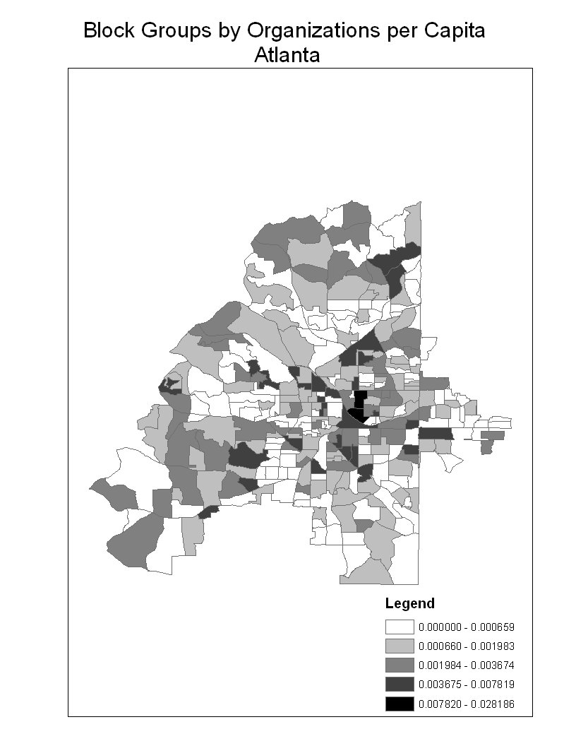
Figure 1 Organizations per capita, city of Atlanta, Georgia.
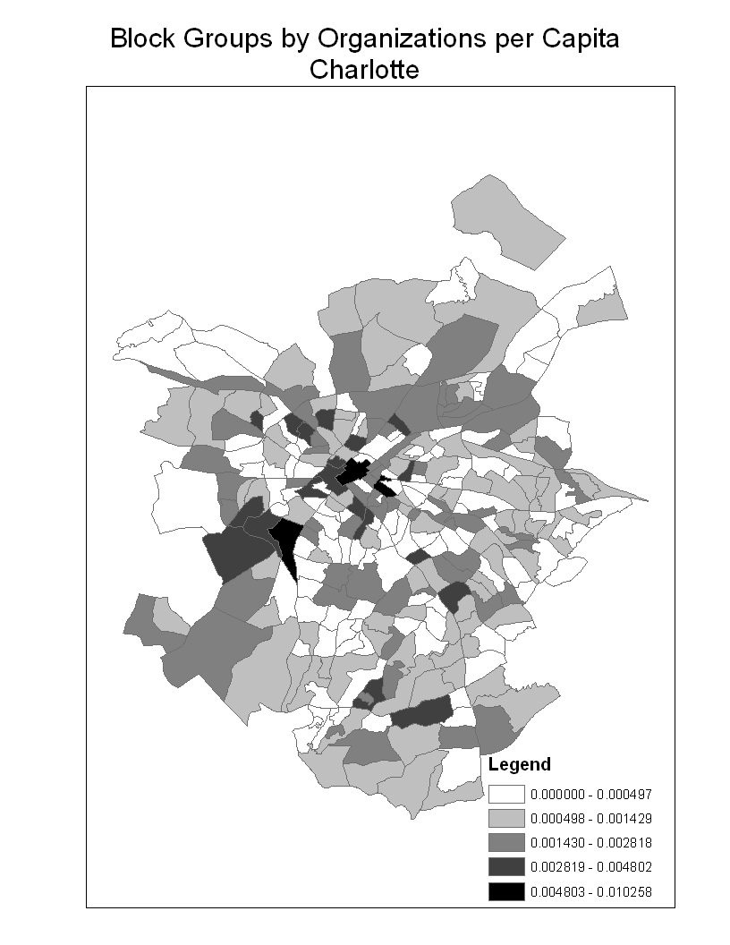
Figure 2: Organizations per capita, city of Charlotte, North Carolina.

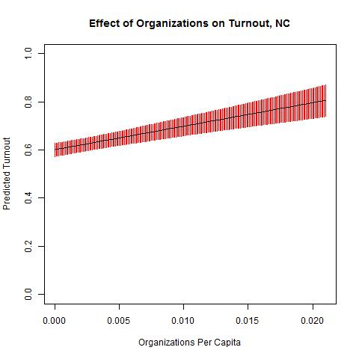
Figure 3 Predicted Turnout by Organizations Per Capita, North Carolina. Estimates calculated using Clarify based on model in Table 2 (King, Tomz, and Wittenberg 2000). The solid vertical lines represent the confidence intervals for the predicted turnout rate.

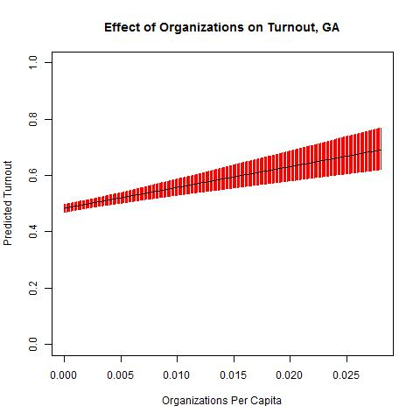
Figure 4: Predicted Turnout by Organizations Per Capita, North Carolina. Estimates calculated using Clarify based on model presented in Table 2 (King, Tomz, and Wittenberg 2000). The solid vertical lines represent the confidence intervals for the predicted turnout rate.

North Carolina: | Min | Median | Average | Std. Dev | Max | N
Neighborhood Voter Turnout | 0.010 | 0.628 | 0.614 | 0.165 | 0.998 | 4948
Number of Organizations per Capita | 0.000 | 0.000 | 0.001 | 0.001 | 0.021 | 4948
Proportion Owner Occupied | 0.000 | 0.627 | 0.579 | 0.185 | 0.919 | 4948
Relative Proportion US Born | 0.570 | 1.090 | 1.071 | 0.066 | 1.120 | 4948
Relative Proportion Unemployed | 0.000 | 0.750 | 0.909 | 0.751 | 10.000 | 4948
Median Income (in 1000s) | 4.999 | 44.596 | 48.279 | 21.911 | 500.001 | 4948
Relative Proportion Female HS Grads | 0.189 | 0.773 | 0.770 | 0.126 | 1.009 | 4948
Proportion age 18 - 34 | 0.061 | 0.275 | 0.282 | 0.083 | 0.850 | 4948
Homicides per capita | 0.000 | 0.000 | 0.000 | 0.000 | 0.006 | 4948
Proprotion Other Minority | 0.000 | 0.000 | 0.000 | 0.000 | 0.001 | 4948
Proportion Black | 0.000 | 0.141 | 0.225 | 0.229 | 0.995 | 4948
Proportion Hispanic | 0.000 | 0.039 | 0.069 | 0.092 | 0.861 | 4948
Proportion in Group Quarters | 0.000 | 0.000 | 0.012 | 0.031 | 0.199 | 4948
Proportion of Households under $15,000 | 0.000 | 0.046 | 0.049 | 0.031 | 0.221 | 4948
Population Density | 3.848 | 499.148 | 1185.358 | 1514.525 | 16245 | 4948
Number of Colleges | 0.000 | 0.000 | 0.021 | 0.150 | 2.000 | 4948
Number of Churches | 0.000 | 1.000 | 1.560 | 2.011 | 17.000 | 4948
Georgia: | Min | Median | Average | Std. Dev | Max | N
Neighborhood Voter Turnout | 0.011 | 0.486 | 0.489 | 0.152 | 0.992 | 4536
Number of Organizations per Capita | 0.000 | 0.000 | 0.001 | 0.001 | 0.028 | 4536
Proportion Owner Occupied | 0.000 | 0.620 | 0.573 | 0.206 | 0.961 | 4536
Relative Proportion US Born | 0.500 | 1.090 | 1.062 | 0.085 | 1.120 | 4536
Relative Proportion Unemployed | 0.000 | 0.810 | 0.998 | 0.826 | 7.980 | 4536
Median Income (in 1000s) | 4.999 | 45.329 | 51.722 | 29.395 | 500.001 | 4536
Relative Proportion Female HS Grads | 0.061 | 0.762 | 0.756 | 0.148 | 1.017 | 4536
Proportion age 18 - 34 | 0.020 | 0.300 | 0.306 | 0.090 | 0.897 | 4536
Homicides per capita | 0.000 | 0.000 | 0.000 | 0.000 | 0.006 | 4536
Proprotion Other Minority | 0.000 | 0.000 | 0.000 | 0.000 | 0.003 | 4536
Proportion Black | 0.000 | 0.238 | 0.340 | 0.291 | 0.997 | 4536
Proportion Hispanic | 0.000 | 0.032 | 0.067 | 0.100 | 0.881 | 4536
Proportion in Group Quarters | 0.000 | 0.000 | 0.011 | 0.031 | 0.196 | 4536
Proportion of Households under $15,000 | 0.000 | 0.043 | 0.050 | 0.038 | 0.422 | 4536
Population Density | 1.341 | 1120.000 | 1778.227 | 2173.961 | 23970 | 4536
Number of Colleges | 0.000 | 0.000 | 0.021 | 0.153 | 2.000 | 4536
Number of Churches | 0.000 | 1.000 | 2.183 | 2.871 | 21.000 | 4536
Table 1: Descriptive statistics.

Variable | North Carolina |  | Georgia
Organizations per capita | 9.761 | *** | 7.192 | ***
 | (1.487) |  | (1.253)
Proportion owner occupied | -0.047 | *** | 0.108 | ***
 | (0.013) |  | (0.013)
Relative Proportion US Born | 0.047 |  | 0.176 | ***
 | (0.041) |  | (0.036)
Relative Proportion Unemployed | -0.007 | ** | -0.007 | **
 | (0.002) |  | (0.002)
Median Income (in 1000s) | 0.001 | *** | 0.001 | ***
 | (0.000) |  | (0.000)
Relative Proportion Female HS Grads | 0.198 | *** | 0.283 | ***
 | (0.019) |  | (0.018)
Proportion age 18 - 34 | -0.270 | *** | -0.324 | ***
 | (0.024) |  | (0.026)
Homicides per capita | 2.129 |  | 11.020 | **
 | (3.775) |  | (3.632)
Proprotion Other Minority | -53.300 | * | -16.970
 | (26.710) |  | (22.000)
Proportion Black | 0.077 | *** | 0.097 | ***
 | (0.011) |  | (0.009)
Proportion Hispanic | -0.334 | *** | -0.181 | ***
 | (0.031) |  | (0.031)
Proportion in Group Quarters | -0.415 | *** | -0.310 | ***
 | (0.048) |  | (0.050)
Proportion of Households under $15,000 | 0.010 |  | -0.135 | *
 | (0.068) |  | (0.063)
Population Density | 0.000 |  | 0.000 | *
 | (0.000) |  | (0.000)
Number of Colleges | 0.021 | * | 0.004
 | (0.010) |  | (0.010)
Number of Churches | -0.002 |  | -0.003 | ***
 | (0.001) |  | (0.001)
Intercept | 0.488 | *** | 0.068
 | (0.052) |  | (0.045)
N | 4948 |  | 4536
Counties | 100 |  | 159
Table 2: Estimates of effects of organizational capacity on block group turnout. Hierarchical linear models. Standard errors in parentheses * significant at 5%; ** significant at 1%; ***significant at 0.1%.

Works Cited
2010. "Resident Population Data 2010." vol. 2012: U. S. Census Bureau.
Aldrich, John H. 1993. "Rational Choice and Turnout." American Journal of Political Science 37:246-278.
Allard, Scott W., Richard M. Tolman, and Daniel Rosen. 2003. "Proximity to Service Providers and Service Utilization among Welfare Recipients: The Interaction of Place and Race." Journal of Policy Analysis and Management 22:599-613.
Alwitt, Linda F. and Thomas D. Donley. 1997. "Retail Stores in Poor Urban Neighborhoods." Journal of Consumer Affairs 31:139-164.
Auchincloss, Amy H., Ana V. Diez Roux, Mahasin S. Mujahid, Mingwu Shen, Alain G. Bertoni, and Mercedes R. Carnethon. 2009. "Neighborhood Resources for Physical Activity and Healthy Foods and Incidence of Type 2 Diabetes Mellitus: the Multi-Ethnic Study of Atherosclerosis." Arch Intern Medicine 169:1698-1704.
Bernstein, Jonathan. 2012. "Your Vote Doesn't Matter." in Salon.com.
Brady, Henry E., Kay Lehman Schlozman, and Sidney Verba. 1999. "Prospecting for Participants: Rational Expectations and the Recruitment of Political Activists." The American Political Science Review 93:153-168.
Brady, Henry E., Sidney Verba, and Kay Lehman Schlozman. 1995. "Beyond SES: A Resource Model of Political Participation." American Political Science Review Vol. 89, No. 2 (Jun. 1995):271-294.
Brehm, John and Wendy Rahn. 1997. "Individual-Level Evidence for the Causes and Consequences of Social Capital." American Journal of Political Science 41:999-1023.
Burch, Traci. 2013. Trading Democracy for Justice: Criminal Convictions and the Decline of Neighborhood Political Participation. Chicago: University of Chicago Press.
Bursik, Robert J. and Harold G. Grasmick. 1993. Neighborhoods and Crime. New York: Lexington.
Burstein, Paul. 2003. "The Impact of Public Opinion on Public Policy: A Review and an Agenda." Political Research Quarterly 56:29-40.
Campbell, Angus, Philip E. Converse, Warren E. Miller, and Donald E. Stokes. 1960. The American Voter. Chicago: The University of Chicago Press.
Cassel, Carol A. 1999. "Voluntary Associations, Churches, and Social Participation Theories of Turnout." Social Science Quarterly (University of Texas Press) 80:504-517.
Chou, Yue Hong. 1997. Exploring Spatial Analysis in Geographic Information Systems. Santa Fe: OnWord.
Delhey, Jan and Kenneth Newton. 2005. "Predicting cross-national levels of social trust: global pattern or Nordic exceptionalism?" European Sociological Review 21:311.
Dietz, Robert D. 2002. "The estimation of neighborhood effects in the social sciences: An interdisciplinary approach." Social Science Research 31:539-575.
Diez-Roux, Ana V., F. Javier Nieto, Carles Muntaner, Herman A. Tyroler, George W. Comstock, Eyal Shahar, Lawton S. Cooper, Robert L. Watson, and Moyses Szklo. 1997. "Neighborhood Environments and Coronary Heart Disease: A Multilevel Analysis." American Journal of Epidemiology 146:48-63.
Diez Roux, Ana V., Sharon Stein Merkin, Donna Arnett, Lloyd Chambless, Mark Massing, Javier Nieto, Paul Sorlie, Moyses Szklo, P.H., Herman A. Tyroler, and Robert L. Watson. 2001. "Neighborhood of Residence and Incidence of Coronary Heart Disease." New England Journal of Medicine 345:99-106.
Downs, Anthony. 1957. An Economic Theory of Democracy. New York: Harper and Row.
Dyck, Joshua J. and James G. Gimpel. 2005. "Distance, Turnout, and the Convenience of Voting." Social Science Quarterly (Wiley-Blackwell) 86:531-548.
Gelman, Andrew and Jennifer Hill. 2007. Data analysis using regression and multilevel/hierarchical models. Cambridge ; New York: Cambridge University Press.
Geolytics. 2011. "Annual Estimates for 2001-2007 Methodology."
Gimpel, James G., Joshua J. Dyck, and Daron R. Shaw. 2004. "Registrants, Voters, and Turnout Variability Across Neighborhoods." Political Behavior 26:343-375.
Hannerz, Ulf. [1969] 2004. SoulSide: Inquiries into Ghetto Culture and Community. Chicago: University of Chicago Press.
Hansen, John Mark. 1985. "The Political Economy of Group Membership." American Political Science Review 79:79-96.
Huckfeldt, R. Robert. 1979. "Political Participation and the Neighborhood Social Context." American Journal of Political Science 23:579-592.
Immergluck, Daniel. 1998. "Neighborhood Economic Development and Local Working: The Effect of Nearby Jobs on Where Residents Work." Economic Geography 74:170-187.
Jacobs, Lawrence R., Fay Lomax Cook, and Michael X. Delli Carpini. 2009. Talking Together: Public Deliberation and Political Participation in America. Chicago: University of Chicago.
Johnson, M., W. Phillips Shively, and R. M. Stein. 2002. "Contextual Data and the Study of Elections and Voting Behavior: Connecting Individuals to Environments." Electoral Studies 21:219-233.
King, Gary, Michael Tomz, and Jason Wittenberg. 2000. "Making the Most of Statistical Analyses: Improving Interpretation and Presentation." American Journal of Political Science 44:314-355.
Kornhauser, Ruth Rosner. 1978. Social Sources of Delinquency. Chicago: University of Chicago Press.
Kosuke, Imai, Gary King, and Olivia Lau. 2009. "Zelig: Everyone's Statistical Software." http://gking.harvard.edu/zelig.
Lazarsfeld, Paul F., Bernard Berelson, and Hazel Gaudet. [1944] 1968. The People's Choice. New York: Columbia University Press.
Levitt, Steven D. 1996. "The Effect of Prison Population Size on Crime Rates: Evidence from Prison Overcrowding Litigation." The Quarterly Journal of Economics 111:319-351.
Lopez, Russ P. 2007. "Neighborhood Risk Factors for Obesity." Obesity 15:2111-2119.
Massey, Douglas S. and Nancy A. Denton. 1993. American Apartheid. Cambridge: Harvard.
Mayer, Susan E. and Christopher Jencks. 1989. "Growing Up in Poor Neighborhoods: How Much Does it Matter?" Science 243:1441-1445.
Miller, Arthur H., Patricia Gurin, Gerald Gurin, and Oksana Malanchuck. 1981. "Group Consciousness and Political Participation." American Journal of Political Science Vol. 25, No. 3 (Aug. 1981):494-511.
Nagler, Jonathan 1991. "The Effect of Registration Laws and Education on US Voter Turnout." American Political Science Review 85:1393-1405.
Olson, Mancur. 1965. The Logic of Collective Action. Cambridge: Harvard University Press.
Peterson, Ruth D. and Lauren J. Krivo. 2010. Divergent Social Worlds: Neighborhood Crime and the Racial-Spatial Divide. New York: Sage.
Piven, Frances Fox and Richard A. Cloward. 2000. Why Americans Still Don't Vote. Boston: Beacon Press.
Putnam, Robert D. 2000. Bowling alone: The collapse and revival of American community. New York: Simon and Schuster.
Rebecca Joyce Kissane. 2010. "“We call it the badlands”: How Social‐Spatial Geographies Influence Social Service Use." Social Service Review 84:3-28.
Rosenstone, Steven J. and John Mark Hansen. 1993. Mobilization, Participation, and Democracy in America. New York: MacMillan.
Rosenstone, Steven J. and Raymond E. Wolfinger. 1978. "The Effect of Registration Laws on Voter Turnout." American Political Science Review 72:22-45.
Ross, Catherine E. 2000. "Neighborhood Disadvantage and Adult Depression." Journal of Health and Social Behavior 41:177-187.
Rousseau, Jean Jacques. 1987. "The Social Contract." in The Basic Political Writings of Jean-Jacques Rousseau, edited by D. A. Cress. Indianapolis: Hackett.
Sampson, Robert J. 1988. "Local Friendship Ties and Community Attachment in Mass Society: A Multilevel Systemic Model." American Sociological Review 53:766-779.
Sampson, Robert J. and W. Byron Groves. 1989. "Community Structure and Crime: Testing Social-Disorganization Theory." American Journal of Sociology 94:774-802.
Sampson, Robert J., Jeffrey D. Morenoff, and Thomas Gannon-Rowley. 2002. "Assessing "Neighborhood Effects": Social Processes and New Directions in Research." Annual Review of Sociology 28:443-478.
Sampson, Robert J., Stephen W. Raudenbush, and Felton Earls. 1997. "Neighborhoods and violent crime: A multilevel study of collective efficacy." Science 277:918.
Schafft, Kai A., Eric B. Jensen, and C. Clare Hinrichs. 2009. "Food Deserts and Overweight Schoolchildren: Evidence from Pennsylvania*." Rural Sociology 74:153-177.
Shaw, Clifford R. and Henry D. McKay. 1942. Juvenile Delinquency and Urban Areas. Chicago: University of Chicago Press.
Shingles, Richard D. 1981. "Black Consciousness and Political Participation: The Missing Link." The American Political Science Review Vol. 75, No. 1 (Mar. 1981):76-91.
Shklar, Judith. 1991. American Citizenship: The Quest for Inclusion. Cambridge: Harvard University Press.
Skocpol, Theda. 1992. Protecting Mothers and Soldiers. Cambridge: Harvard University Press.
Skocpol, Theda. 1999. "How America Became Civic." in Civic Engagement in American Democracy, edited by T. Skocpol and M. Fiorina. Washington, D.C.: Brookings Institute.
Skocpol, Theda and Morris Fiorina. 1999. "Making Sense of the Civic Engagement Debate." Pp. 1-25 in Civic Engagement in American Democracy, edited by T. Skocpol and M. Fiorina. Washington, DC: Brookings Institute.
Squire, Peverill, Raymond E. Wolfinger, and David P. Glass. 1987. "Residential Mobility and Voter Turnout." The American Political Science Review 81:45-65.
Talen, Emily. 2003. "Neighborhoods as Service Providers: A Method for Evaluating Pedestrian Access." Environment and Planning: Planning and Design 30:181-200.
Tam-Cho, Wendy K., James G. Gimpel, and Joshua J. Dyck. 2006. "Residential Concentration, Political Socialization, and Voter Turnout." Journal Of Politics 68:156-167.
Tam Cho, Wendy K. and Thomas J. Rudolph. 2008. "Emanating Political Participation: Untangling the Spatial Structure Behind Participation." British Journal of Political Science 38:273-289.
Tocqueville, Alexis 2000. "Democracy in America." edited by H. C. Mansfield and D. Winthrop. Chicago: University of Chicago Press.
Uhlaner, Carole Jean. 1995. "What the Downsian Voter Weighs: A Reassessment of the Costs and Benefits of Action." in Information, Participation, and Choice: An Economic Theory of Participation, edited by B. Grofman. Ann Arbor: University of Michigan Press.
Uslaner, Eric M. and Mitchell Brown. 2005. "Inequality, trust, and civic engagement." American politics research 33:868.
Verba, Sidney and Norman H. Nie. 1972. Participation in America. New York: Harper and Row.
Verba, Sidney, Kay Lehman Schlozman, and Henry Brady. 1995. Voice and Equality: Civic Voluntarism in American Politics. Cambridge: Harvard University Press.
Walker, Renee E., Christopher R. Keane, and Jessica G. Burke. 2010. "Disparities and Access to Healthy Food in the United States: A Review of Food Deserts Literature." Health and Place 16:876-884.
Warren-Findlow, Jan. 2006. "Weathering: Stress and Heart Disease in African American Women Living in Chicago." Qualitative Health Research 16:221-237.
Wilson, William Julius. 1987. The truly disadvantaged: The inner city, the underclass, and public policy. Chicago: University of Chicago Press.
Wolfinger, Raymond E. and Steven J. Rosenstone. 1980. Who Votes? New Haven: Yale University Press.

Defined by the United States Department of Agriculture as urban neighborhoods and rural towns without ready access to fresh, healthy, and affordable food.
With National Taxonomy of Exempt Entities codes N, O, S, X,
See (Burstein 2003) for a review of this literature.
Social disorganization research is another exception. Social disorganization theories recognize that individual behaviors are shaped by those around them not only through the transmission of cultural ideals but also through their enforcement. Disorganized communities cannot exert informal controls over their members because they lack informal ties such as friendships and formal social ties such as stable families and membership organizations that help socialize people into desirable behavior (Bursik and Grasmick 1993; Kornhauser 1978; Sampson 1988; Shaw and McKay 1942).
However, Uslaner and Brown (2005) employ instrumental variables regression to maneuver around the endogeneity problem and find support for this critique. Likewise, a cross-national aggregate analysis conducted by Delhey and Newton (2005) provides further support for the null hypothesis that engagement is not likely to cause an increase in generalized trust, or, at least, will only lead to a minimal rise.
Block groups are the smallest level of aggregation for which data on population size were available for 2008 and thus represent “communities” in this analysis. According to the Census Bureau, block groups typically contain 300 to 3,000 people, with an optimum size of 1,500 ("Glossary of Geographic Terms" 2007). The choice of block groups as the unit of analysis matters in spatial analysis because of three well-known problems: boundary, scale, and modifiable area units (Chou 1997). The boundary problem refers to how different choices with respect to boundaries (block groups instead of blocks) can lead to different statistical relationships depending on the data. For instance, a pattern may appear dispersed if one is looking at one block, but clustered if one enlarges the picture to include four other blocks. The scale problem refers to the fact that spatial descriptive statistics can vary as increasingly aggregated units are used. Thus, a statistic for an area may be different when calculated at the census tract level as opposed to the block group level. The modifiable units problem refers to the fact that units may be aggregated differently (for instance, the assignment of census blocks to block groups may be arbitrary, although they are contiguous) and that different patterns of aggregation may result in different statistical results.
Some might argue that the overall crime rate should be used rather than the homicide rate. However, there are reasons to think of the homicide rate as superior to other crime measures because homicides are not usually subject to reporting or other biases (Levitt 1996). However, the homicide rate is also superior for reasons that are specific to measuring crime at sub-county and sub-city levels. The homicide rate is the only crime measure that is collected in a consistent manner at a sub-county level across an entire state (or even the nation). For instance, there are hundreds of different agencies that collect and count different things (calls for service vs. incident reports vs. Uniform Crime Report crimes), some jurisdictions overlap (so that some crimes may be reported twice if two different agencies or a multi-agency task force are involved—think of the county sheriff vs. the state troopers vs. the local police). In contrast, public health data on homicides are collected nationally based on guidelines from the Centers for Disease Control in a way that allows researchers to produce uniform estimates across jurisdictions at a sub-county level.
Factor analysis indicates that only two of the control variables, U. S. born and percent Hispanic, load on the same factor. For this reason, all controls are included in the models separately.
All predicted probabilities and expected values in this paper were simulated using the Clarify module in Zelig. Briefly, Clarify uses the coefficients and variance matrix estimated by statistical packages to draw (in this case 10,000) sets of simulated coefficients, each of which is multiplied by values chosen by the researcher for each variable (in most cases set to the median but some variables, such as segregation, may be set differently as noted) to generate 10,000 values for the dependent variable (turnout rate). The predicted values reported in the text and figures represent the means of these simulated values. See (King, Tomz, and Wittenberg 2000) for more information.
Beta regression (which is for dependent variables bounded by 0 and 1) with county fixed effects also yields positive, statistically significant results for both states.
The relationship persists in both states when raw organizational presence is included in the models instead.
The residuals do not demonstrate spatial autocorrelation. Moran’s I for Georgia = .008; for North Carolina= .
The vertical bars represent confidence intervals in this figure.
Models that include the democratic proportion of block group registered voters and the presence of disfranchised probationers and parolees serving their sentences in the block group (available for North Carolina only) do not diminish the effect size (model available upon request).
Models available upon request.

